Eagle Class Homework Autumn 2 week 5 – Y5
Homework due: Tuesday 16th December 2025

Next week we are learning:
Maths | Literacy | Science | RE
We will be looking at multiples and common multiples. | We will be focusing on coordinating conjunctions. | We will explore reversible and irreversible reactions. | We will be exploring different ways different ways Purim is celebrated and the symbolism of some traditions.

Helpful Websites:
Log on to NumBots or hit the button to practice arithmetic skills.
https://play.numbots.com/#/account/school-login-type
https://www.topmarks.co.uk/maths-games/hit-the-button
Purple Mash also have some lovely Maths and spellings activities.

Spellings:
Practise spellings ready for weekly spelling test- see below for your child’s spelling group – These groups are subject to change as they are based on their current spelling ages.

Reading:
Read every day for 30 minutes. Please log this in Reading Records.

Maths: common multiples

Challenges are optional – although please have a go if you can

Spellings:
Words marked with an asterisk (*) are common exception words or statutory spellings highlighted in the national curriculum.

Group 1  The /i/ sound spelt ey | Group 2  Double the constant before adding a suffix | Group 3  Words with the /i/ sound spelt ei after c and other consonants
key*  donkey*  monkey*  money*  valley | hopping  swimming  sitting  clapping  skipping  getting  putting  shopping  planning  sitting | deceive*  receive*  perceive*  ceiling*  receipt*  conceit*  deceit*  counterfeit*  seize*  neither*

Challenge: Can you write two sentences that include one of your spelling words?

Common multiples
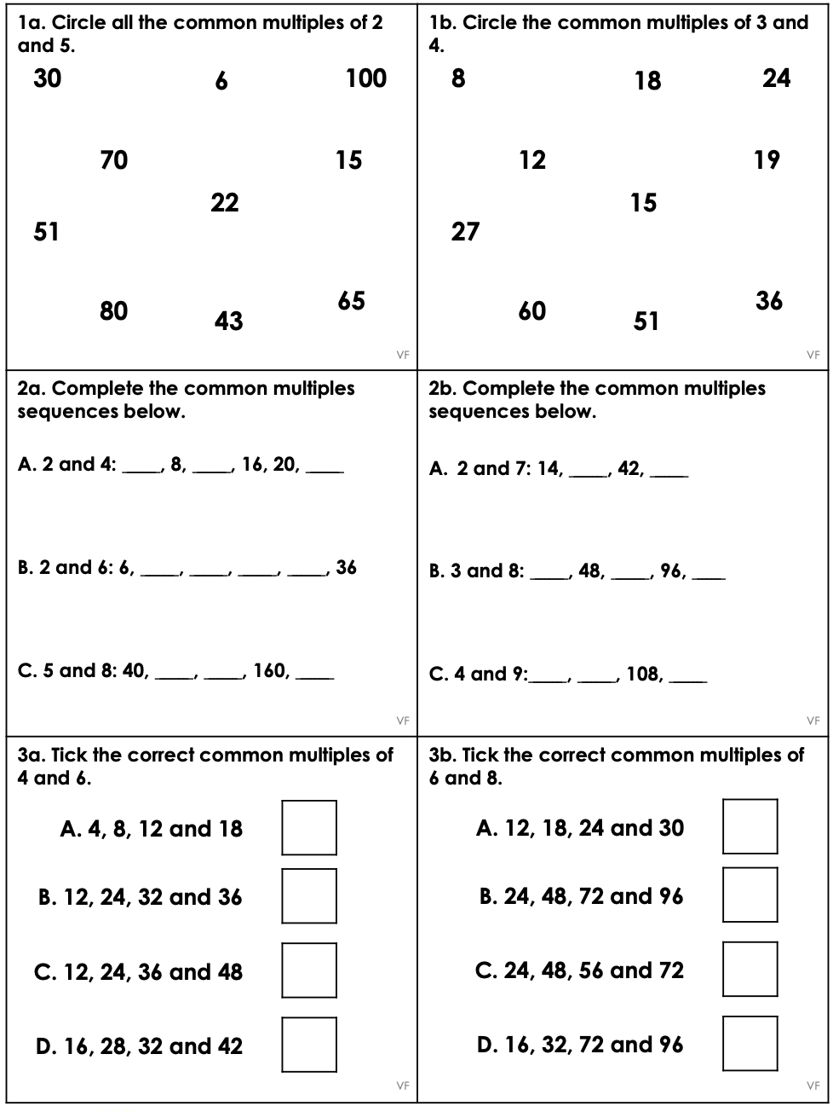
Reading Comprehension
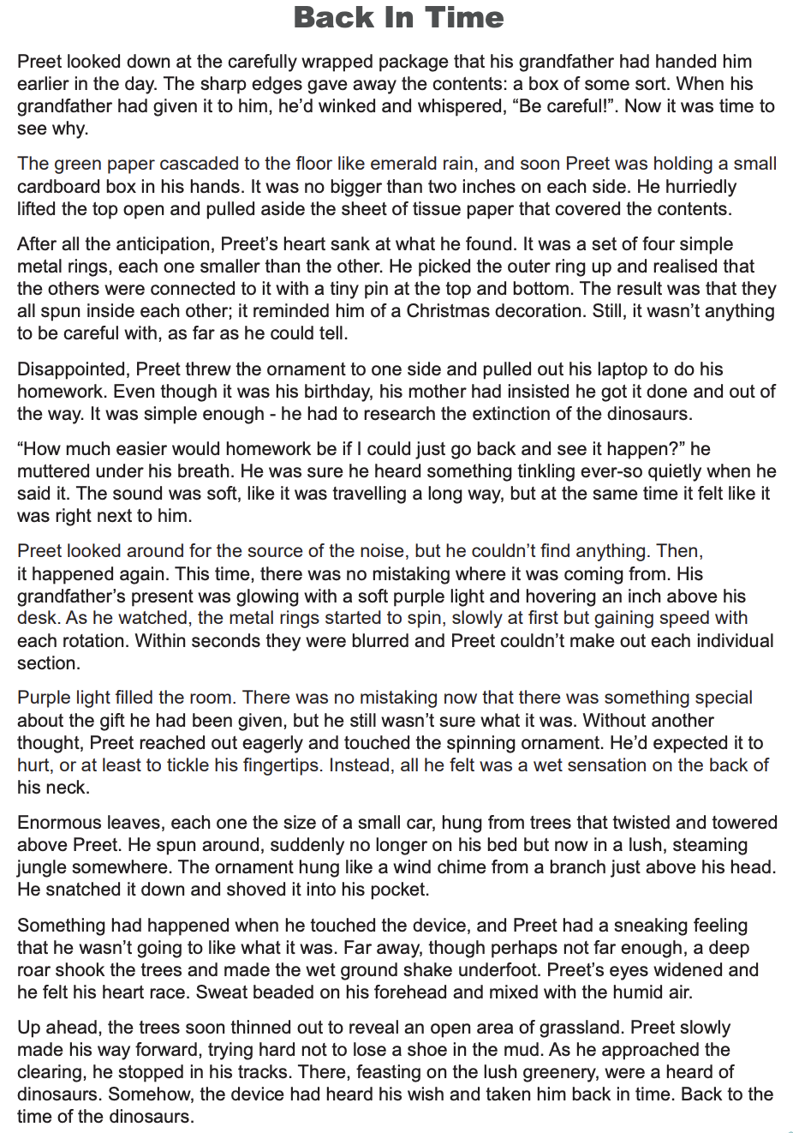
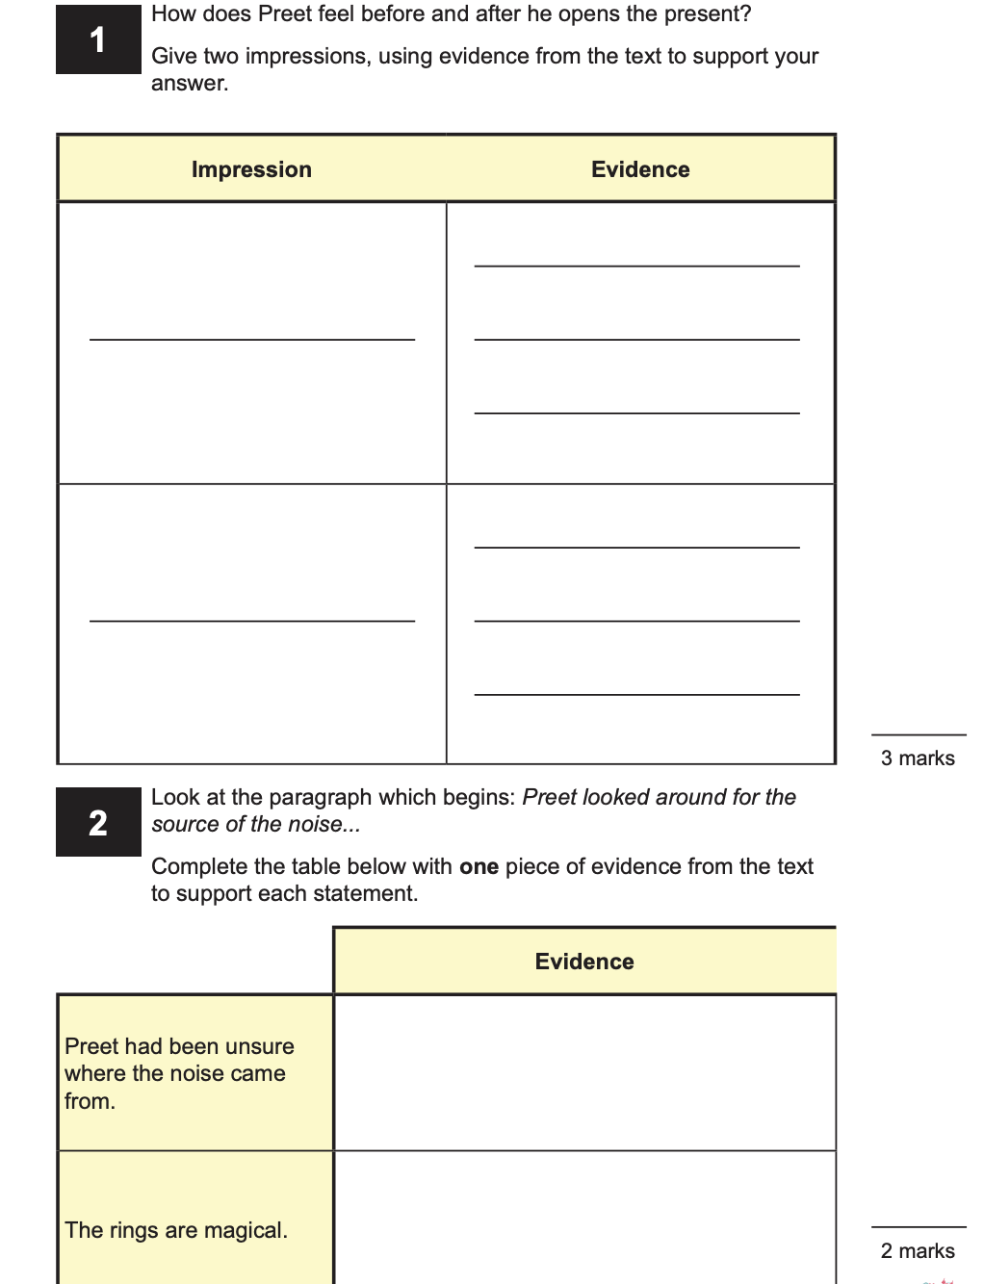
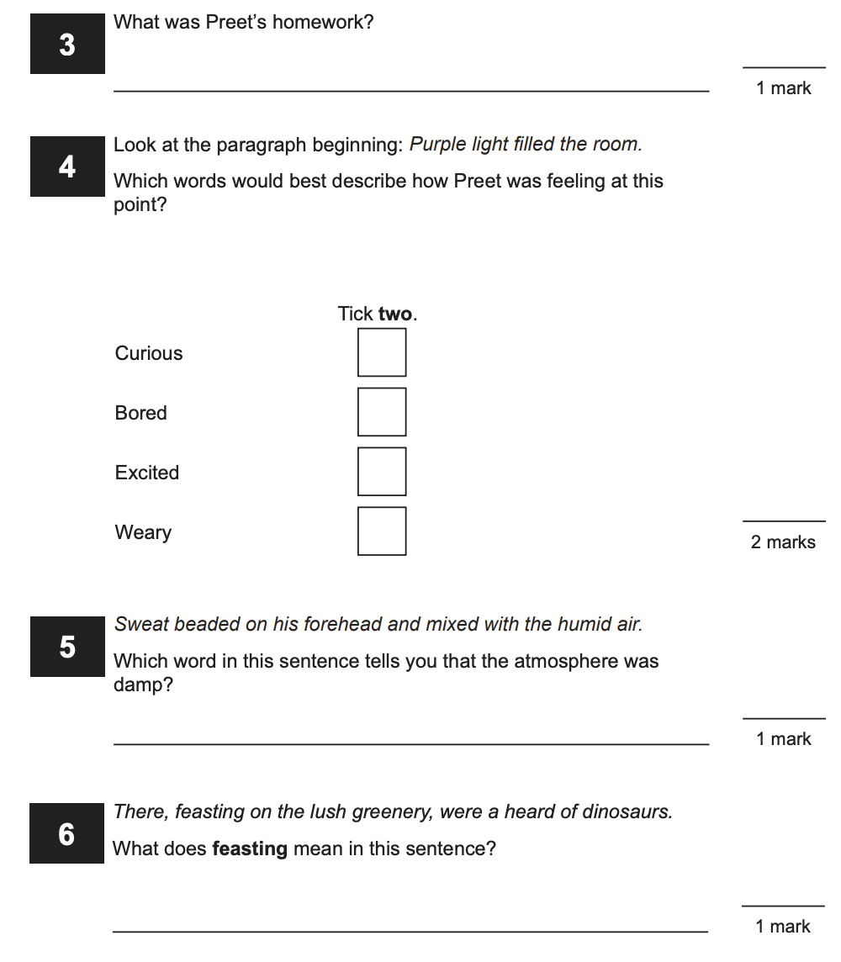

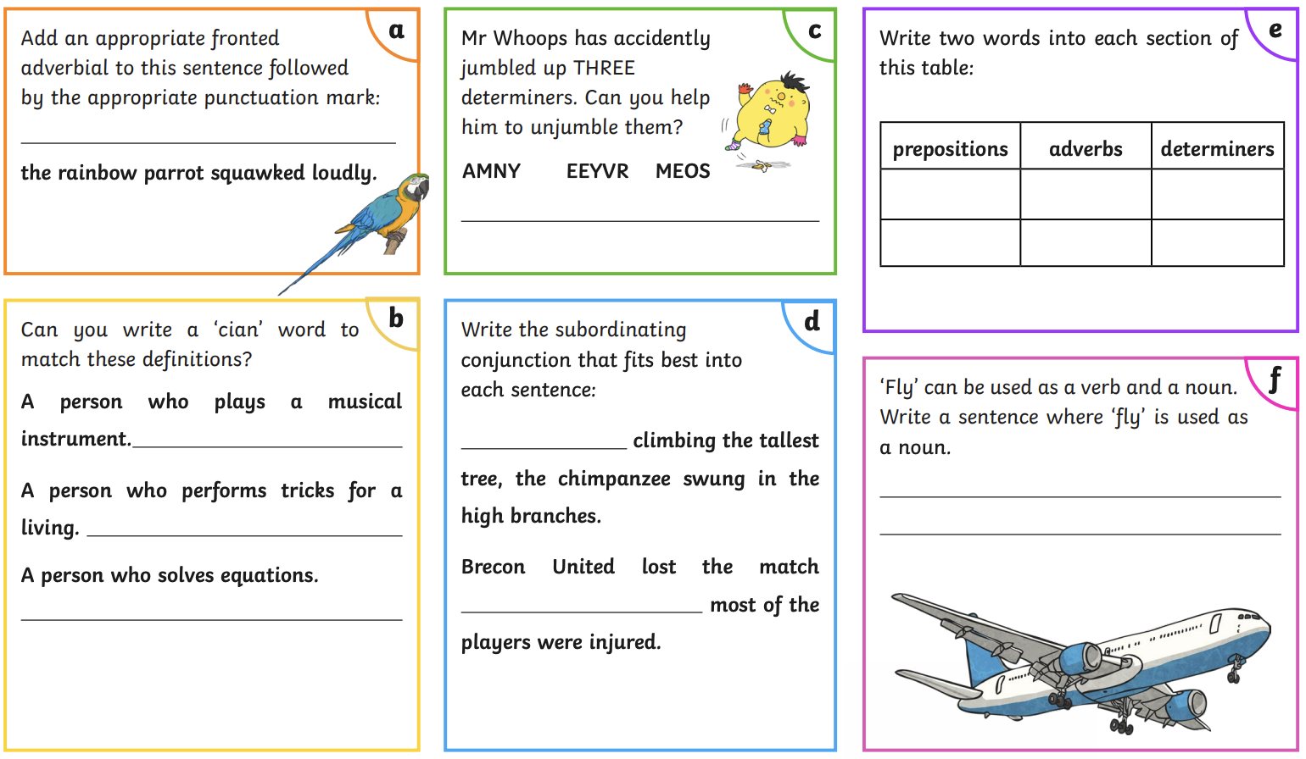
Challenge

Improve this sentence:
(Think DADWAVERS)

The snowman melted.

