Rabbit Class Homework Spring 1 week 1 – Y2
Homework due: Tuesday 13th January 2026
Next week we are learning:
Maths | Literacy | Science | RE
We will be refreshing multiplication and methods for multiplying and dividing numbers. | We will be starting our new topic – Castles and Dragons. We will be learning about information texts and researching information to write our own. | We will be starting our unit of work on Uses of Everyday Materials. | We will be learning about differing views of God.

Log on to timestables.co.uk to practise your times tables skills
https://www.timestables.co.uk/
Purple Mash also have some lovely Maths and spellings activities
Or use other websites/ways that you enjoy .

Spellings:
Practise spellings ready for weekly spelling test- see below for your child’s spelling group – These groups are subject to change as they are based on their current spelling ages.

Reading:
Read every day for 20 minutes. Please log this in Reading Records.

SPaG: Year 2 SPaG mat

Maths: times tables

Spellings:
Group 1 | Group 2  /ai/ /ay/ and /a-e/
old  told  whole  gold  cold  because  every  everybody  most  only | mail  snail  trail  play  stay  today  array  cake  flake  mistake
……………………………………………………………………………………………………………………………………………………………………………………………………………………………………………………………………………………………………………………………………………………………………………………………………………………………………………………………………………………………………………………………………………………………………………………………………………………………………………………………………………………………………………………………………………………………………………………………………………………………………………………………………………………………………………………………………………………………………………………………………………………………………………………………………………………………………………………………………………………………………………………………………………………………………………………………………………………………………………………………………………………………………………………………………………………………………………………………………………………………………………..…………………………………………………………………………………………………………………………….…………………………..
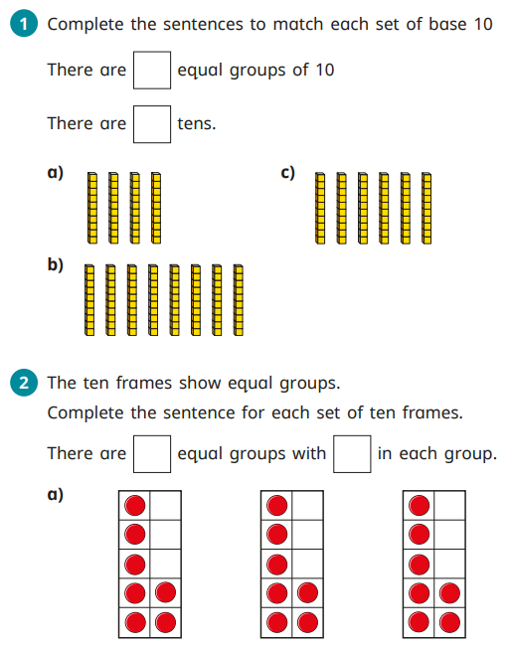
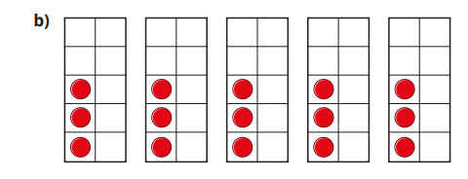
Draw arrays to show the following groups:
4 groups of 2 | 5 groups of 2
2 groups of 5 | 3 groups of 5
6 groups of 10 | 4 groups of 10


