Eagle Class Homework Spring 1 week 1 – Y4
Homework due: Tuesday 13th January 2026
Next week we are learning:
Maths | Literacy | Science | RE
In Maths this week, Year 4 will be focusing on multiplication by identifying factor pairs and practising multiplying by 10 and 100 to build fluency and confidence with number. | In English this week, Year 4 will explore the character of Vesper by using evidence from the text to understand thoughts and feelings. They will also retell a scene from the story from a character’s perspective. | In Science this week, Year 4 will be learning about burning reactions and exploring the fire triangle to understand what is needed for a fire to start and keep burning. | In RE this week, Year 4 will explore Jesus’ teachings and discuss how they challenge ideas about what really matters in life, encouraging thoughtful reflection and discussion.

Helpful Websites:
Log on to Purple Mash and practice your timetable fluency on ‘Multiplication Tables Check’.
Ask your grown up to sign your diary to record your practice and earn some class points!

Spellings:
Practise spellings ready for weekly spelling test- see below for your child’s spelling group – These groups are subject to change as they are based on their current spelling ages.

Reading:
Read every day for 30 minutes. Please log this in Reading Records.

Maths: factor pairs

Challenges are optional – although please have a go if you can

Spellings:
This week’s spellings are key geography topic words.
Words marked with an asterisk (*) are common exception words or statutory spellings highlighted in the national curriculum.

Group 1 | Group 2 | Group 3
America  Mexico  climate  desert  river | continent  country  atlas  globe  equator  climate  weather  mountain  rainforest  biome | hemisphere  latitude  longitude  vegetation  temperature*  population*  environment*  sustainability*  resources  international*

Challenge: Can you write two sentences that include one of your spelling words?

Factor Pairs
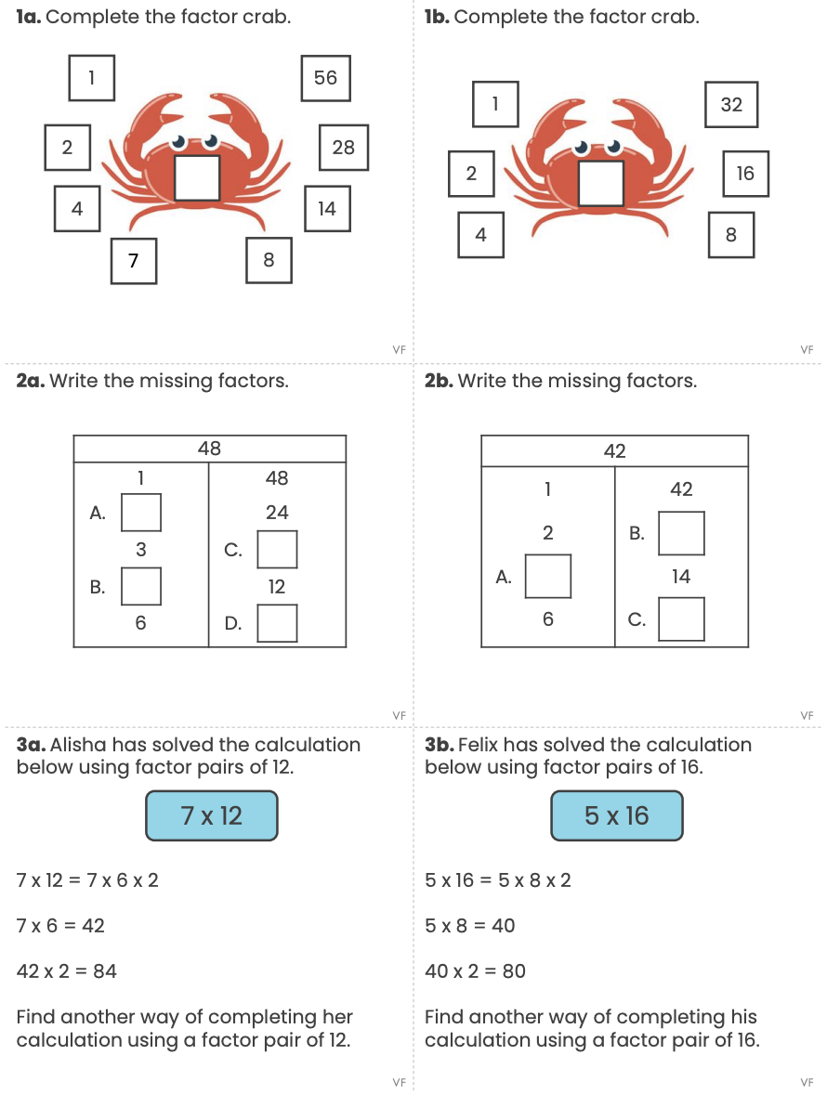
Reading Comprehension

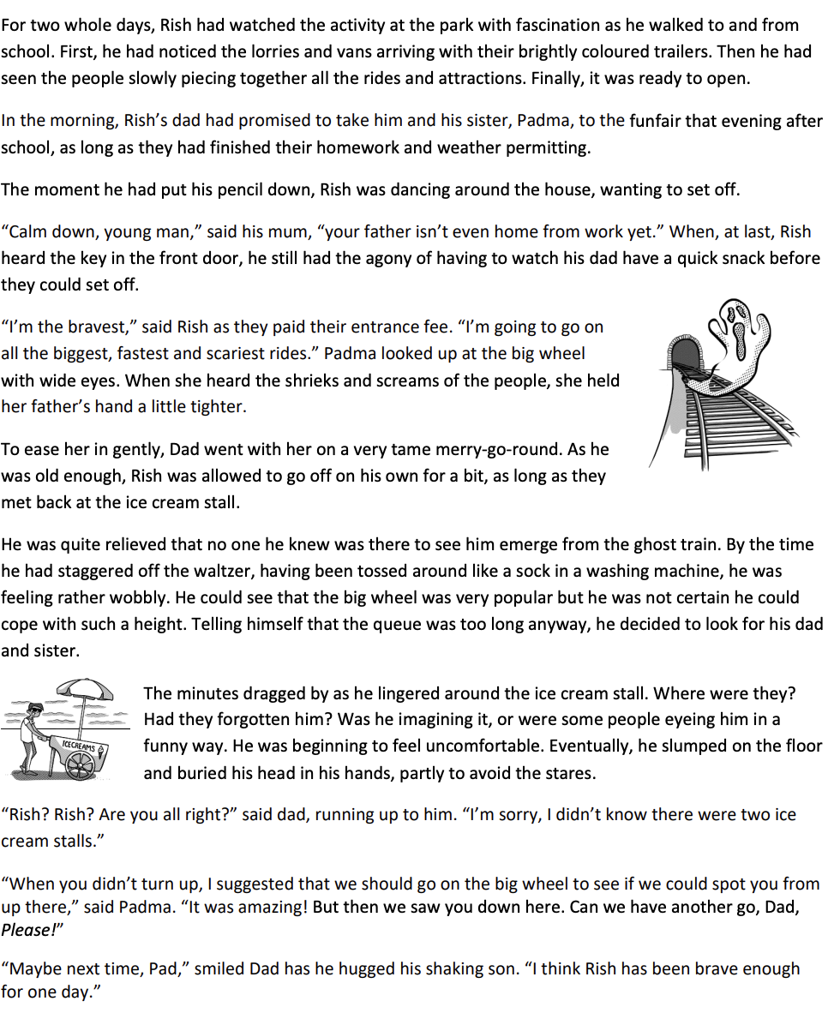
Funfair

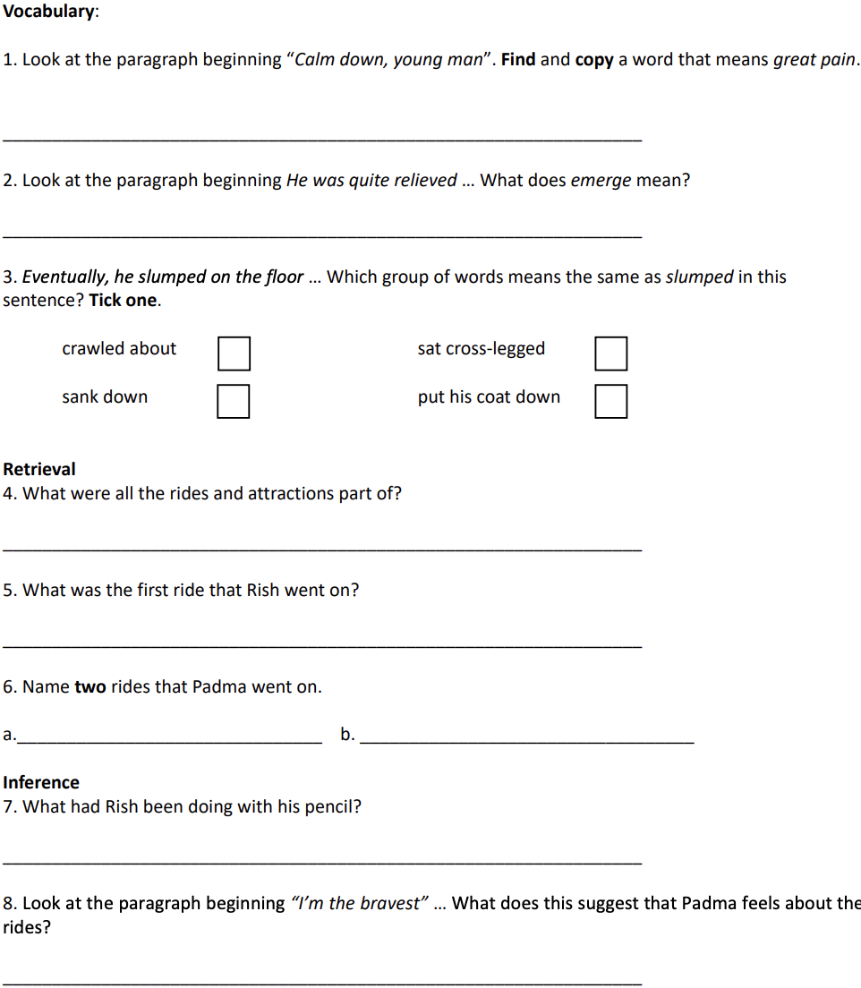

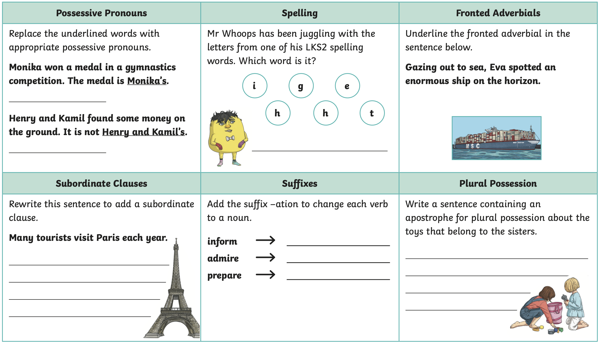
Challenge



