Eagle Class Homework Spring 1 week 1 – Y5
Homework due: Tuesday 13th January 2026
Next week we are learning:
Maths | Literacy | Science | RE
In Maths this week, Year 5 will deepen their understanding of multiplication by identifying factors and prime numbers and practising multiplying by 10, 100 and 1,000 using place value reasoning. | In English this week, Year 5 will analyse the character of Vesper in depth, using evidence from the text to infer thoughts, feelings and motivations. They will also develop their writing by using relative clauses to add extra detail and clarity. | In Science this week, Year 5 will investigate burning reactions in more detail, using the fire triangle to explain the conditions needed for combustion and how fires can be prevented. | In RE this week, Year 5 will explore Jesus’ teachings and reflect on how they challenge people’s values and priorities, considering how these beliefs influence choices and behaviour today.

Helpful Websites:
Log on to Purple Mash and practice your timetable fluency on ‘Multiplication Tables Check’.
Ask your grown up to sign your diary to record your practice and earn some class points!

Spellings:
Practise spellings ready for weekly spelling test- see below for your child’s spelling group – These groups are subject to change as they are based on their current spelling ages.

Reading:
Read every day for 30 minutes. Please log this in Reading Records.

Maths: Prime numbers

Challenges are optional – although please have a go if you can

Spellings:
This week’s spellings are key geography topic words.
Words marked with an asterisk (*) are common exception words or statutory spellings highlighted in the national curriculum.

Group 1 | Group 2 | Group 3
America  Mexico  climate  desert  river | continent  country  atlas  globe  equator  climate  weather  mountain  rainforest  biome | hemisphere  latitude  longitude  vegetation  temperature*  population*  environment*  sustainability*  resources  international*

Challenge: Can you write two sentences that include one of your spelling words?

Prime numbers
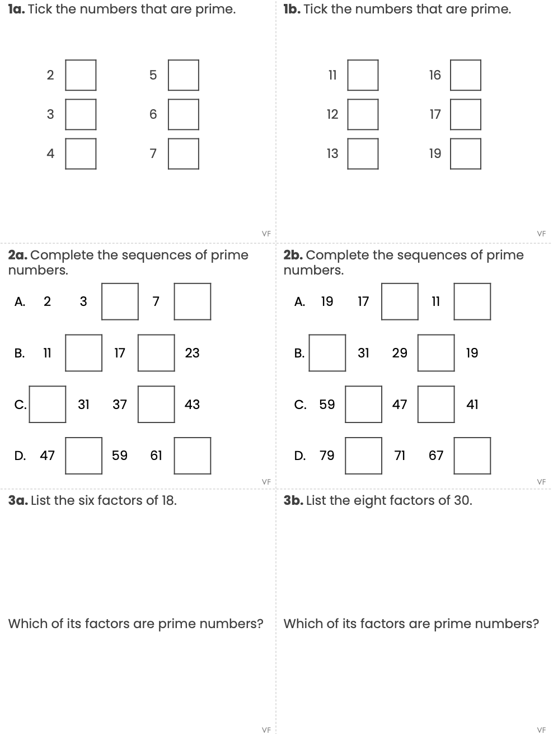

Reading Comprehension

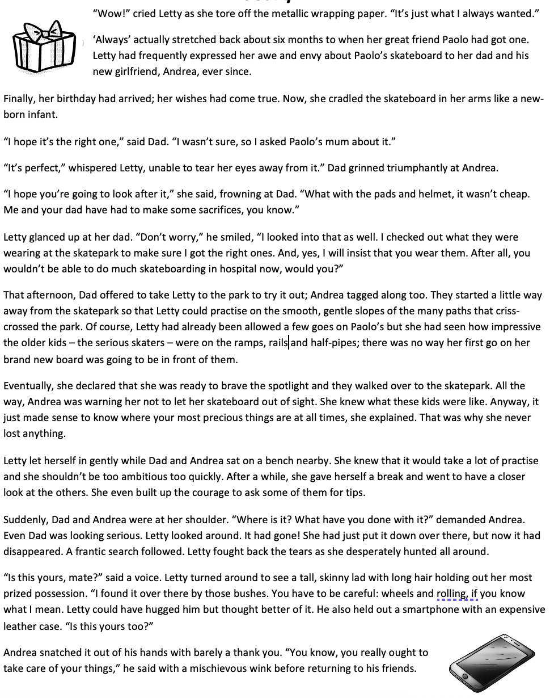
Take Care
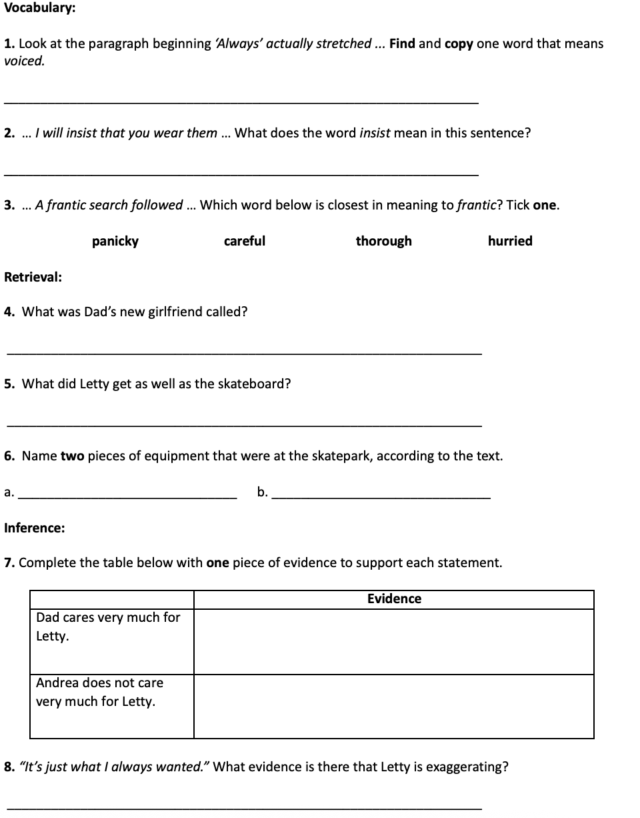

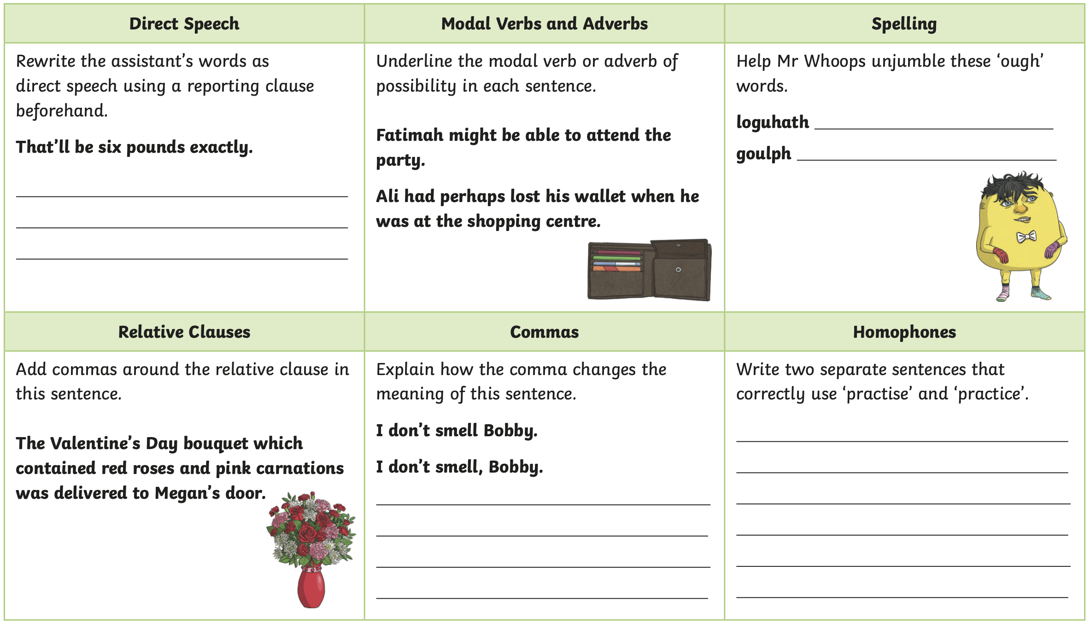
Challenge


