Eagle Class Homework Spring 1 week 2 – Y5
Homework due: Tuesday 20th January 2026
Next week we are learning:
Maths | Literacy | Science | RE
In Maths this week, Year 5 will be dividing numbers by 10, 100 and 1,000 and multiplying larger numbers using efficient written and informal methods. | In English this week, Year 5 will develop their use of relative clauses and deepen character understanding by writing, acting out and planning play scripts using stage directions. | In Science this week, Year 5 will investigate burning reactions through practical experiments, explaining what is needed for combustion to occur. | In RE this week, Year 5 will evaluate whether Jesus’ teachings are possible or practical to live by today, using discussion and reflection to support their ideas.

Helpful Websites:
Log on to Purple Mash and practice your timetable fluency on ‘Multiplication Tables Check’.
Ask your grown up to sign your diary to record your practice and earn some class points!

Spellings:
Practise spellings ready for weekly spelling test- see below for your child’s spelling group – These groups are subject to change as they are based on their current spelling ages.

Reading:
Read every day for 30 minutes. Please log this in Reading Records.

Maths: Multiplying 4-digit numbers by 1-digit numbers

Challenges are optional – although please have a go if you can

Spellings:
Words marked with an asterisk (*) are common exception words or statutory spellings highlighted in the national curriculum.

Group 1  The /l/or /ɘl/ sound spelt -le at the end of words | Group 2  Words ending with the /g/ sound spelt – gue and the /k/ sound spelt -que | Group 3  Words containing the letter string ough
table  apple  bottle  little  middle | league  tongue  antique  unique  fatigue  intrigue  rouge  vague  opaque  plaque | through  thorough  borough  enough  bough  though  although  dough  thoroughness  ought

Challenge: Can you write two sentences that include one of your spelling words?

Multiple 4-digit by a 1-digit
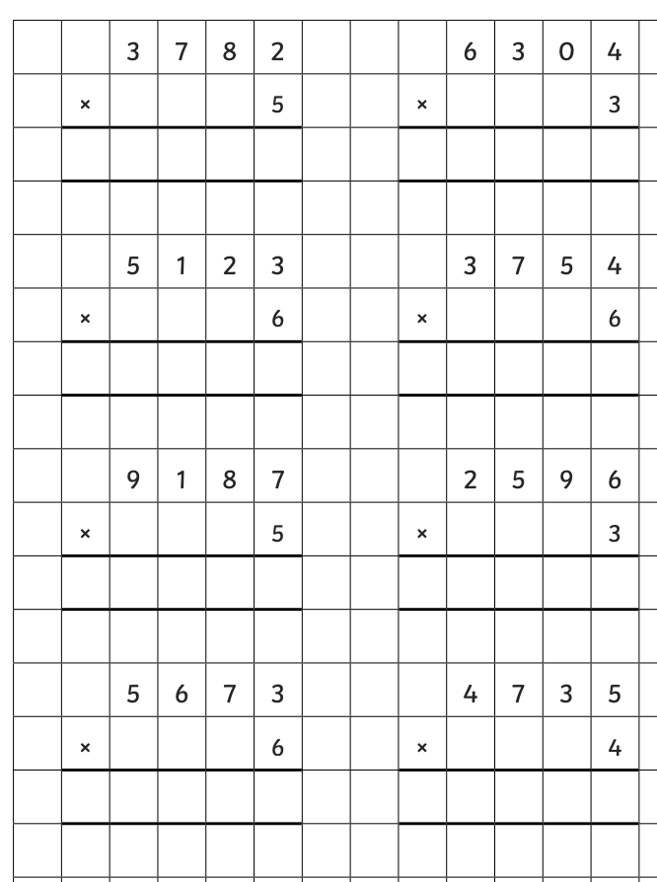

Reading Comprehension

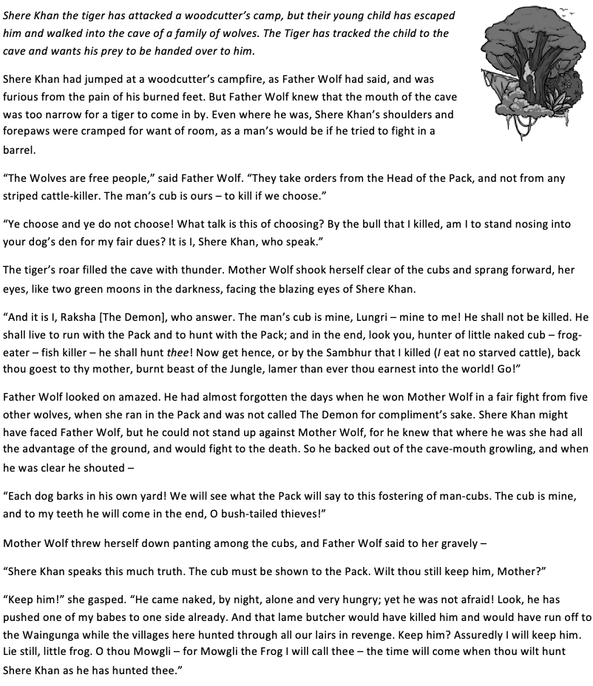
The Jungle Book

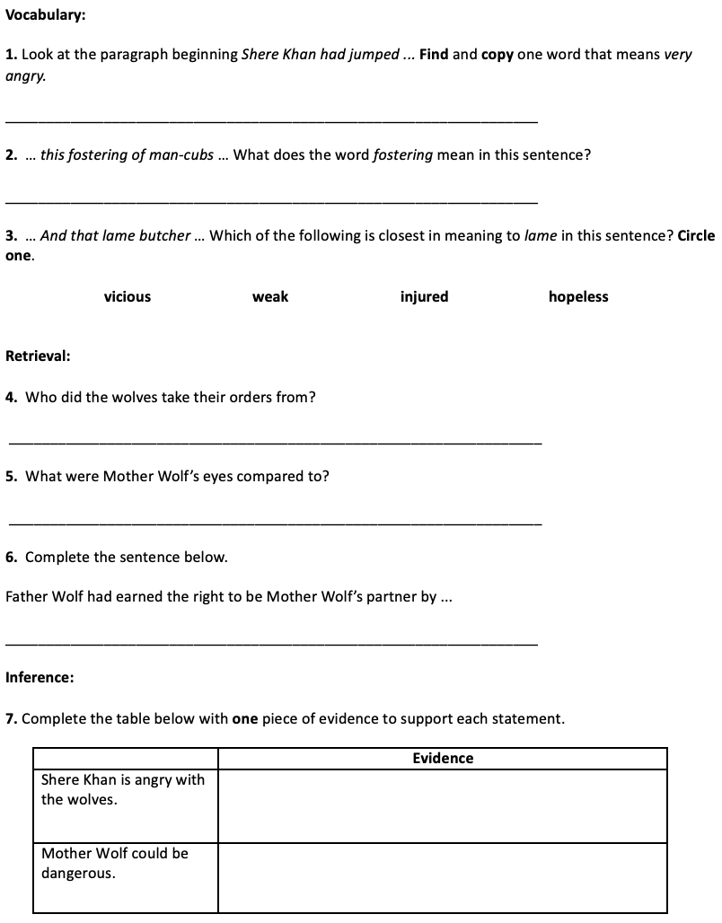

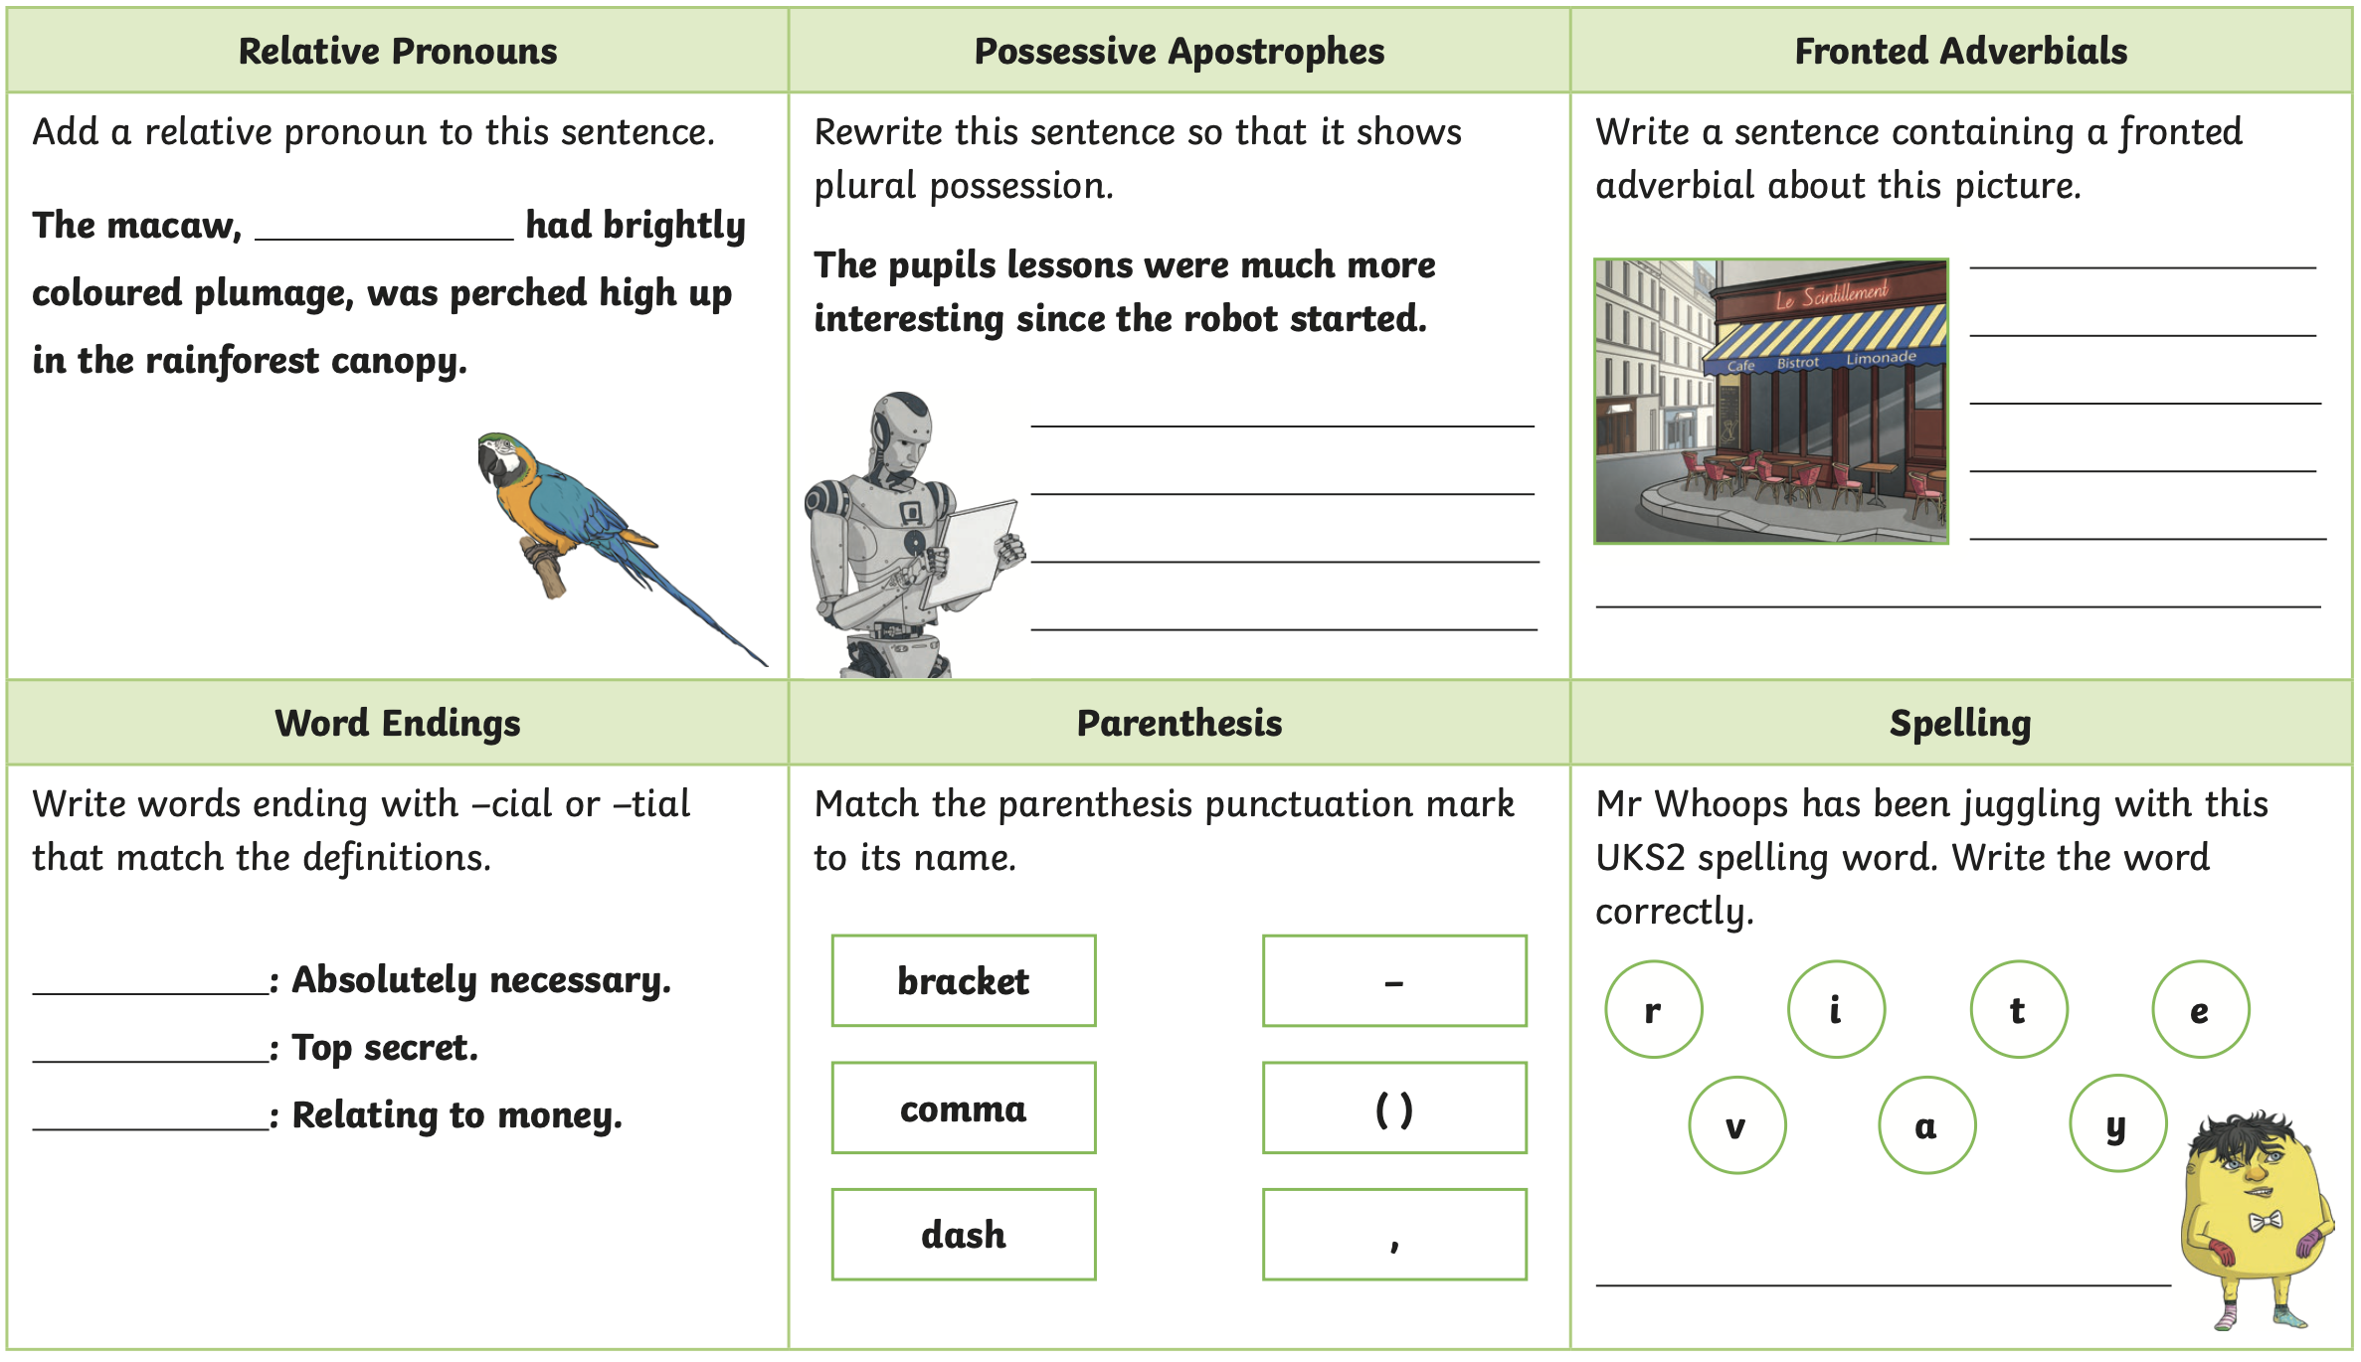
Challenge


