Rabbit Class Homework Spring 1 week 3 – Y2
Homework due: Tuesday 20th January 2026
Next week we are learning:
Maths | Literacy | Science | RE
We will be continuing our unit on multiplication and division, beginning to multiply and divide numbers by 5 and 10. | We will be continuing our topic on Castles and Dragons. We will be focussing on descriptive writing, imagining our own dragon and describing them in detail. | We will be continuing our unit of work on Everyday Materials. | We will be continuing our unit on Christianity and what God means to Christians.

Log on to timestable.com to practise your maths skills:
Purple Mash also have some lovely Maths and spellings activities
Timestable.co.uk
Or use other websites/ways that you enjoy .

We have begun practising our fast maths times tables. Please practise quick recall of times tables at home. I have sent home a multiplication grid for you to keep at home and practise using.

Spellings:
Practise spellings ready for weekly spelling test- see below for your child’s spelling group – These groups are subject to change as they are based on their current spelling ages.

Reading:
Read every day for 20 minutes. Please log this in Reading Records.

SPaG: Year 2 SPaG mat

Maths: times tables

Spellings:
Group 1 | Group 2
the  that  not  look  put  and  with  then  could  come | behind  kind  mind  child  wild  climb  children  because  floor  poor
……………………………………………………………………………………………………………………………………………………………………………………………………………………………………………………………………………………………………………………………………………………………………………………………………………………………………………………………………………………………………………………………………………………………………………………………………………………………………………………………………………………………………………………………………………………………………………………………………………………………………………………………………………………………………………………………………………………………………………………………………………………………………………………………………………………………………………………………………………………………………………………………………………………………………………………………………………………………………………………………………………………………………………………………………………………………………………………………………………………………………………..…………………………………………………………………………………………………………………………….…………………………..

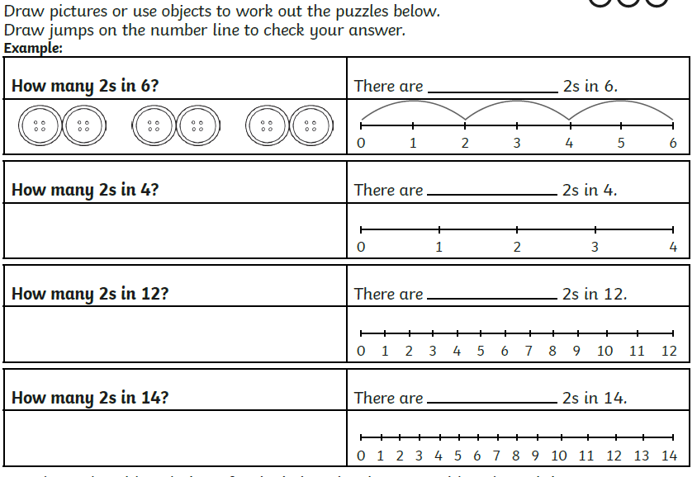
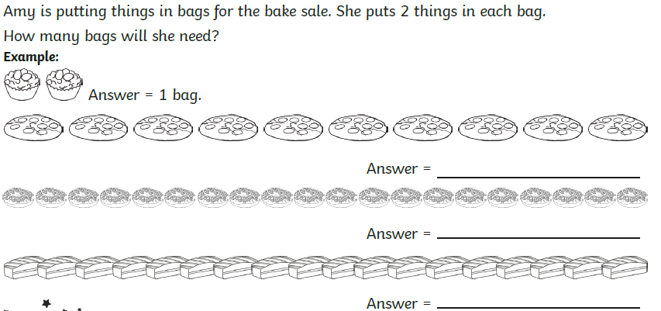
Challenge (optional)
Fill in the missing numbers
 | 8 |  |  | 14 |  | 18 |  |  |  | 26



