Eagle Class Homework Spring 1 week 3 – Y5
Homework due: Tuesday 27th January 2026
Next week we are learning:
Maths | Literacy | Science | RE
In Maths this week, Year 5 will be multiplying larger numbers, including 3- and 4-digit numbers by 2-digit numbers, and applying their skills to reasoning and problem-solving. | In English this week, Year 5 will be writing and performing play scripts, giving constructive feedback, and using inverted commas accurately to punctuate dialogue. | In Science this week, Year 5 will learn to identify the main organs in the digestive system and understand their roles. | In RE this week, Year 5 will explore different Christian interpretations of Jesus’ healing stories and consider their meaning and significance today.

Helpful Websites:
Log on to Purple Mash and practice your timetable fluency on ‘Multiplication Tables Check’.
Ask your grown up to sign your diary to record your practice and earn some class points!

Spellings:
Practise spellings ready for weekly spelling test- see below for your child’s spelling group – These groups are subject to change as they are based on their current spelling ages.

Reading:
Read every day for 30 minutes. Please log this in Reading Records.

Maths: Multiplying 3-digit numbers by 2-digit numbers

Challenges are optional – although please have a go if you can

Spellings:
Words marked with an asterisk (*) are common exception words or statutory spellings highlighted in the national curriculum.

Group 1  The /l/ or /ɘl/ sound spelt -al at the end of words | Group 2  Endings which sound like ʃɘn spelt -ssion | Group 3  Words ending in -able
metal  pedal  capital  hospital  animal | expression  possession  discussion  confession  permission  admission  impression  omission  emission  commission | dependable  comfortable  understandable  reasonable  enjoyable  reliable  excitable  preferable  adorable  believable

Challenge: Can you write two sentences that include one of your spelling words?

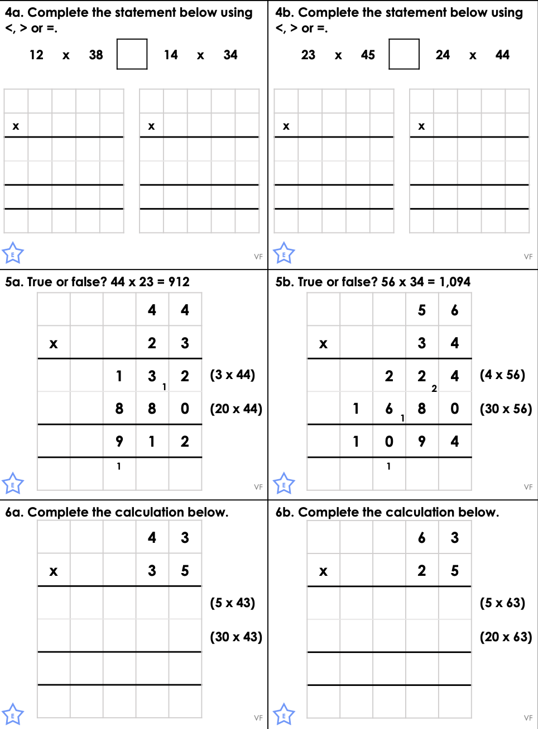
Multiplying 2-digit numbers by 2-digit numbers

Reading Comprehension

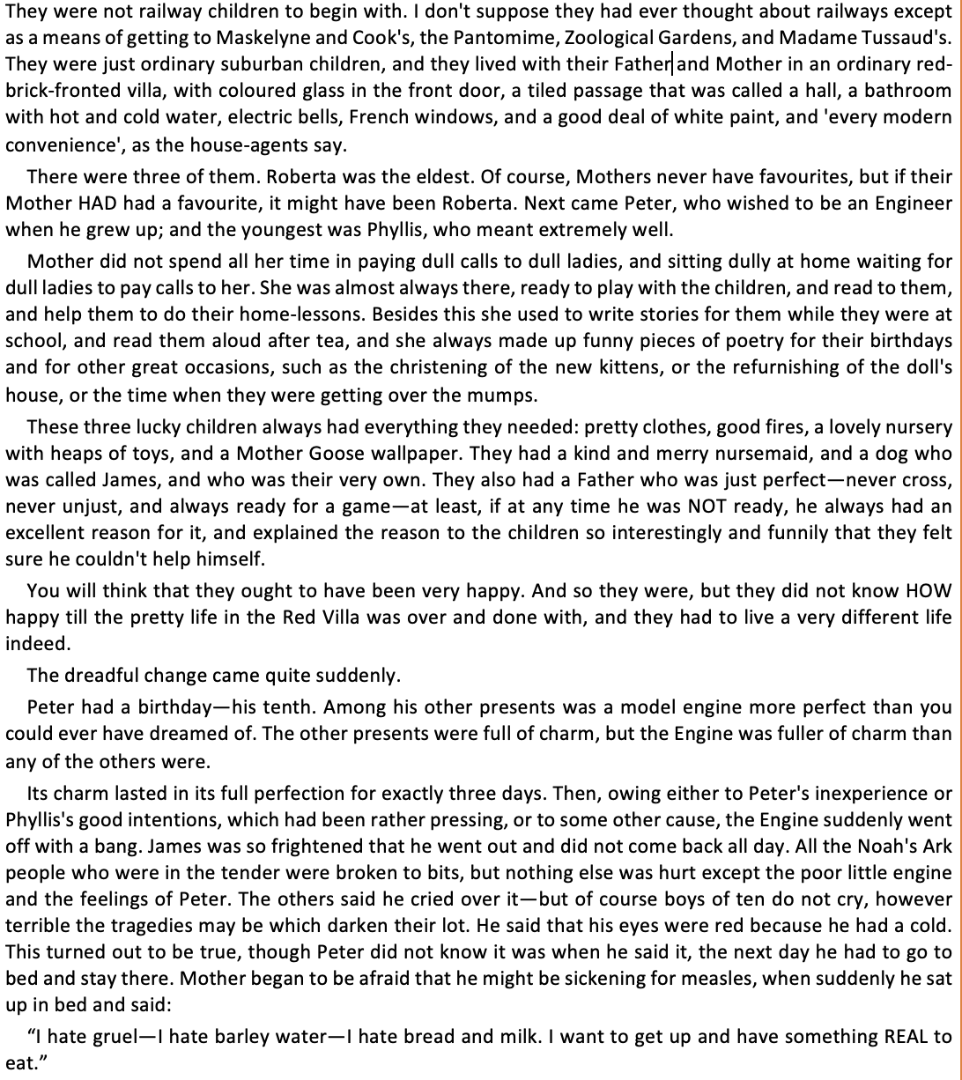
The Railway Children

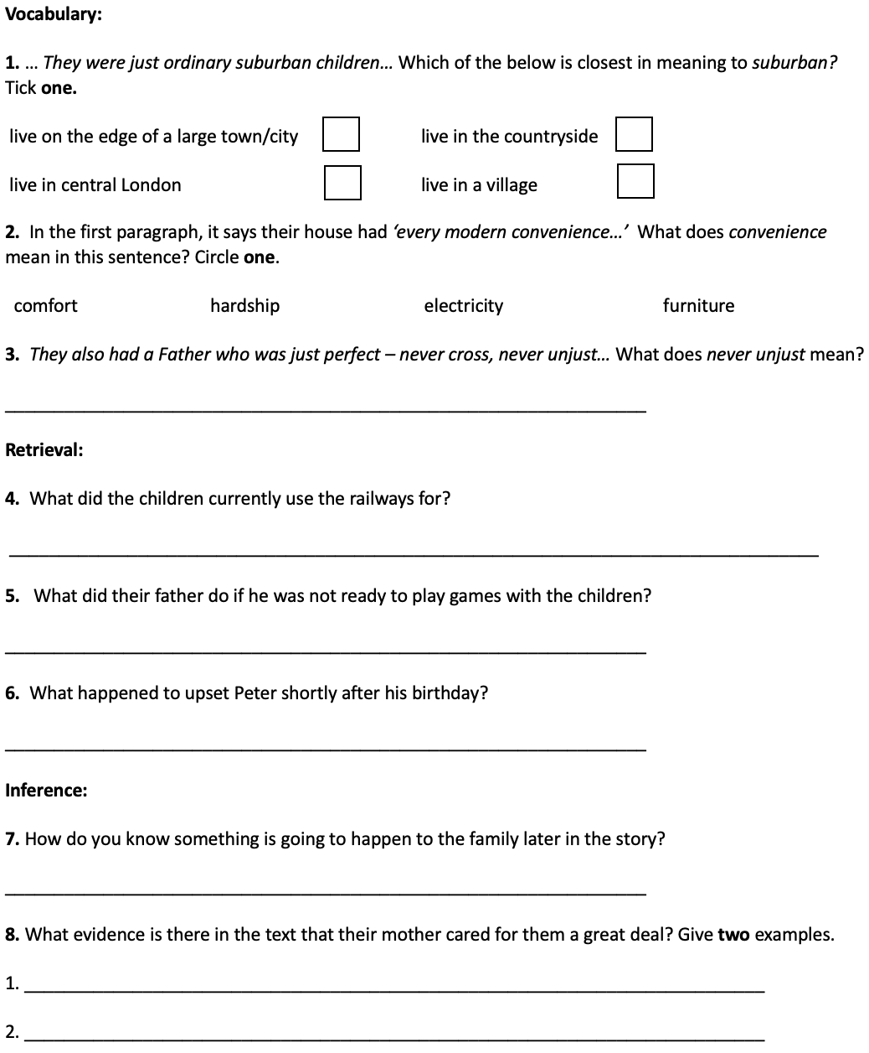

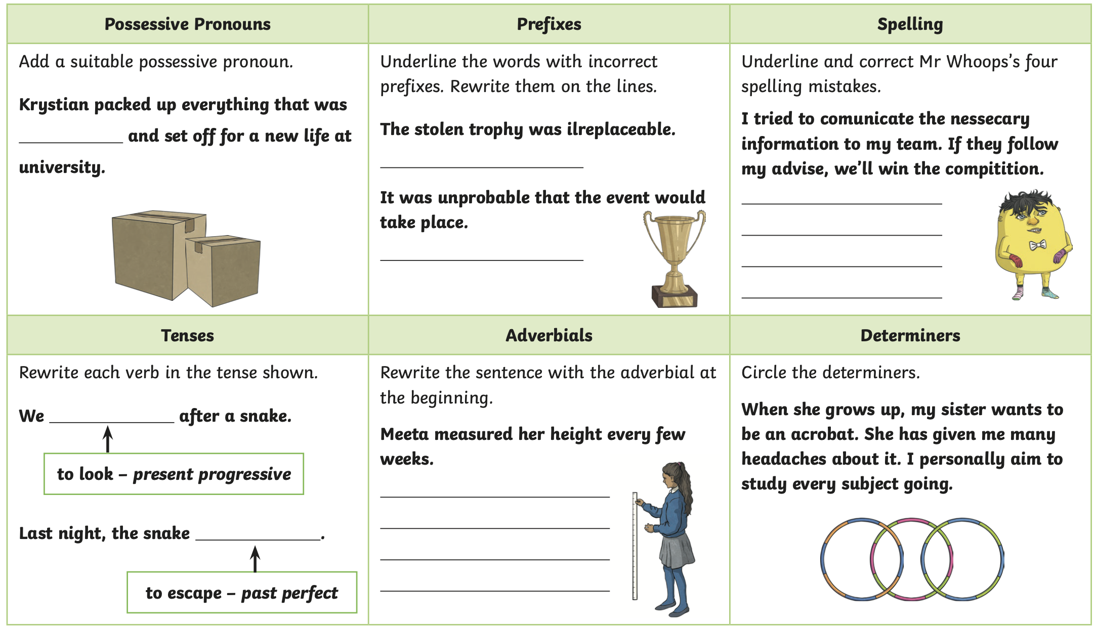
Challenge


