Rabbit Class Homework Spring 1 week 3 – Y3
Homework due: Tuesday 27th January 2026
Next week we are learning:
Maths | Literacy | Science | RE
We will be finishing off our unit on multiplication and division. We’ll be continuing to use our methods for dividing and multiplying 2 digits by 1 digit and using multiplication facts to solve problems. | We will be continuing our topic on Castles and Dragons. We will be continuing our work on descriptive writing, imagining story settings and our character within that setting. We are preparing to write our own story for storytelling week! | We will be continuing our unit of work on Everyday Materials. | We will be continuing our unit on Christianity.

Log on to timestable.com to practise your maths skills:
Purple Mash also have some lovely Maths and spellings activities
Timestable.co.uk
Or use other websites/ways that you enjoy .

We have begun practising our fast maths times tables. Please practise quick recall of times tables using the multiplication grid I sent home last week.

Spellings:
Practise spellings ready for weekly spelling test- see below for your child’s spelling group – These groups are subject to change as they are based on their current spelling ages.

Reading:
Read every day for 20 minutes. Please log this in Reading Records.

SPaG: Year 3 SPaG mat

Spellings:
Group 1  ure sound  im- prefix and -sion suffix | Group 2  ie sound spelt y  -ies endings
treasure  measure  mixture  improbable  imbalance  impeccable  impression  expression  possession  discussion | fly  cry  dry  copy  baby  flies  cries  dries  copies  babies
……………………………………………………………………………………………………………………………………………………………………………………………………………………………………………………………………………………………………………………………………………………………………………………………………………………………………………………………………………………………………………………………………………………………………………………………………………………………………………………………………………………………………………………………………………………………………………………………………………………………………………………………………………………………………………………………………………………………………………………………………………………………………………………………………………………………………………………………………………………………………………………………………………………………………………………………………………………………………………………………………………………………………………………………………………………………………………………………………………………………………………..…………………………………………………………………………………………………………………………….…………………………..
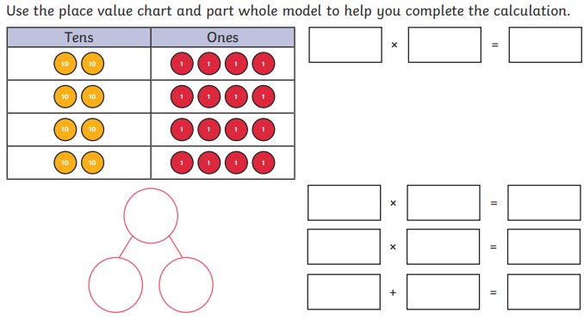

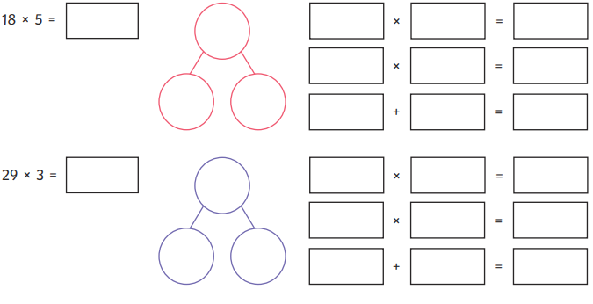
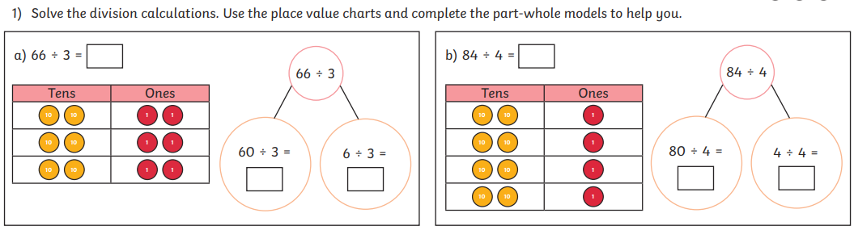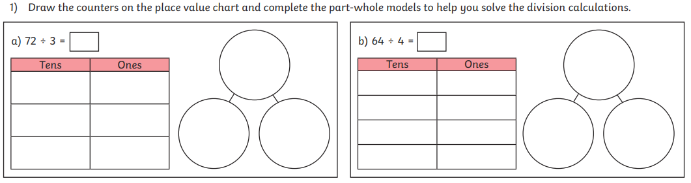

Challenge (optional)


