Tiger Reception – Homework 29th January 2026
Read Together Quick Read Comprehension
With your grown up, read the information below by sounding out and blending the words back together and then have a go at answering the questions.
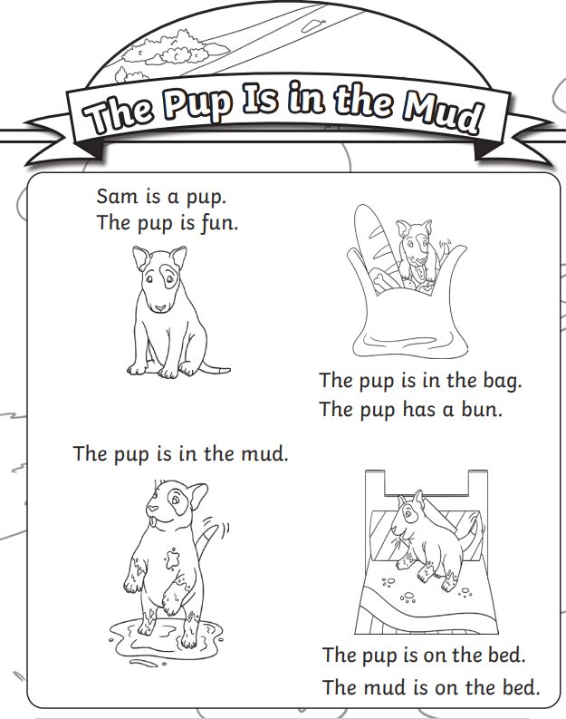
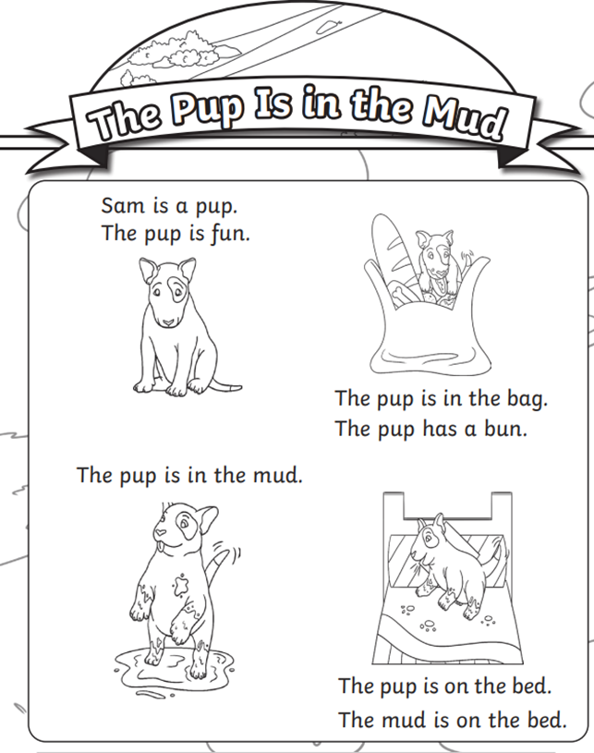

Challenge: you find a mnemonic to help remember the order of the colours of the rainbow, for example: "Rinse Out Your Granny's Boots In Vinegar” or you could even have a go at making up your own. Write your mnemonic below:

Challenge: draw a picture below of what you think the pups next adventure will be. Have a go at writing a sentence to go with your picture.



