Eagle Class Homework Spring 1 week 4 – Y5
Homework due: Tuesday 3rd February 2026
Next week we are learning:
Maths | Literacy | Science | RE
In Maths this week, Year 5 will be developing their division skills by using short division, dividing larger numbers and solving multiplication and division worded problems. | In English this week, Year 5 will be using inverted commas accurately and writing dialogue that shows character interaction and advances the action in their writing. | In Science this week, Year 5 will learn about the digestive system and describe the functions of the main organs. | In RE this week, Year 5 will explore the idea of forgiveness and discuss whether it can help repair broken relationships.

Helpful Websites:
Log on to Purple Mash and practice your timetable fluency on ‘Multiplication Tables Check’.
Ask your grown up to sign your diary to record your practice and earn some class points!

Spellings:
Practise spellings ready for weekly spelling test- see below for your child’s spelling group – These groups are subject to change as they are based on their current spelling ages.

Reading:
Read every day for 30 minutes. Please log this in Reading Records.

Maths: Multiply 3-digit numbers by 2-digit numbers

Challenges are optional – although please have a go if you can

Spellings:
Words marked with an asterisk (*) are common exception words or statutory spellings highlighted in the national curriculum.

Group 1  Homophones and near-homophones | Group 2  words with the /k/ sound spelt ch | Group 3  Homophones – words that are confused
night*  knight*  to*  too  two* | scheme  chorus  chemist  echo  character  ache  monarch  stomach  orchid  orchestra | ascent  assent  bridal  bridle  cereal  serial  compliment  complement  precede  proceed

Challenge: Can you write two sentences that include one of your spelling words?

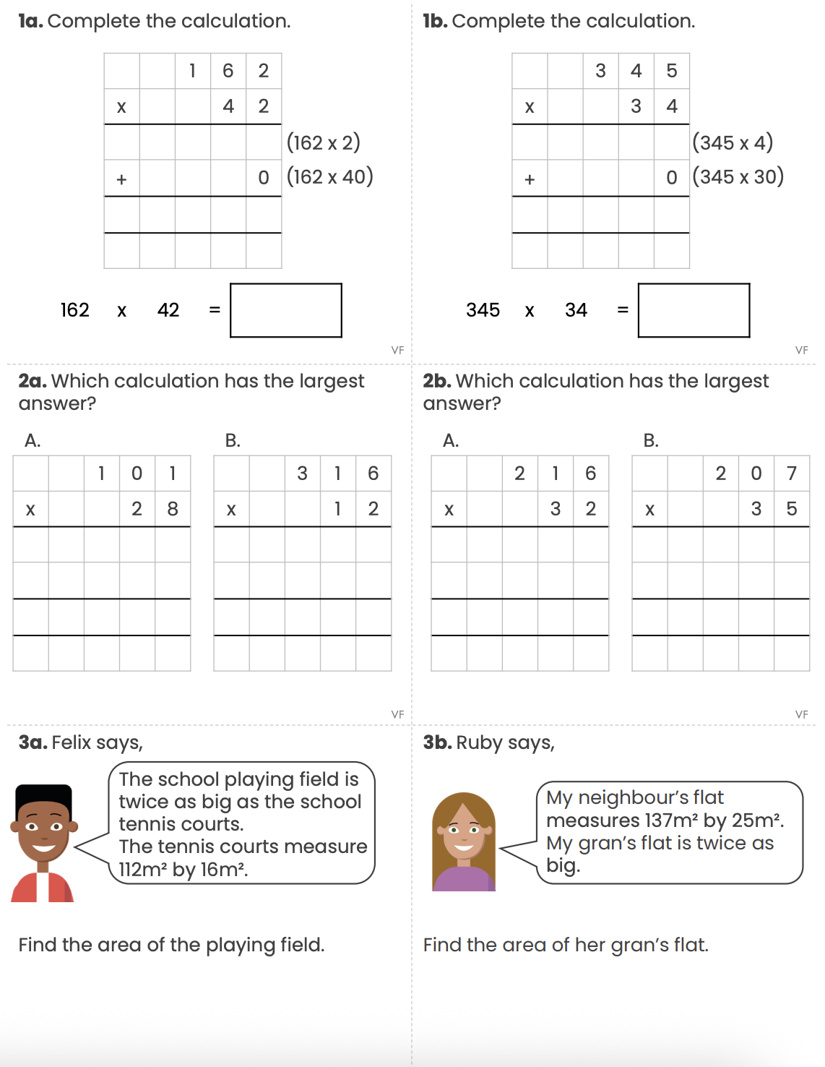
Multiple 3-digit numbers by 2-digit numbers

Reading Comprehension
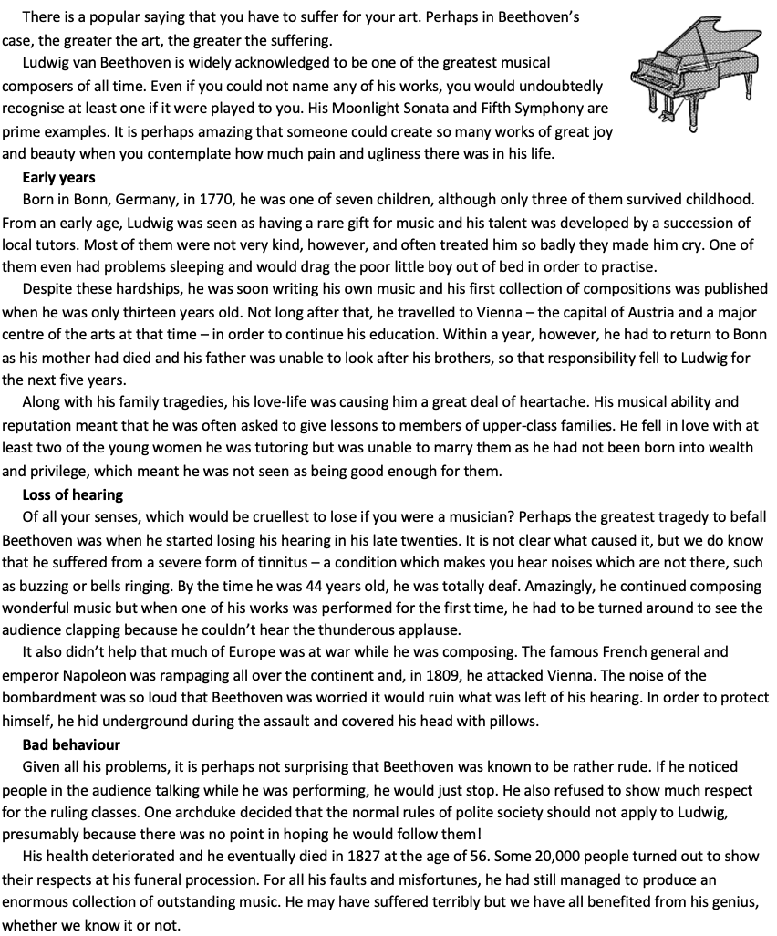
Beethoven’s Hard Life

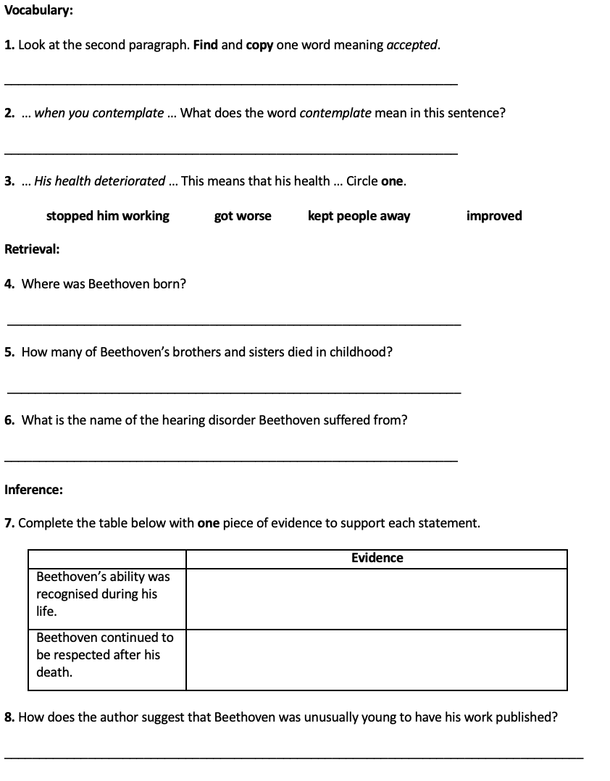

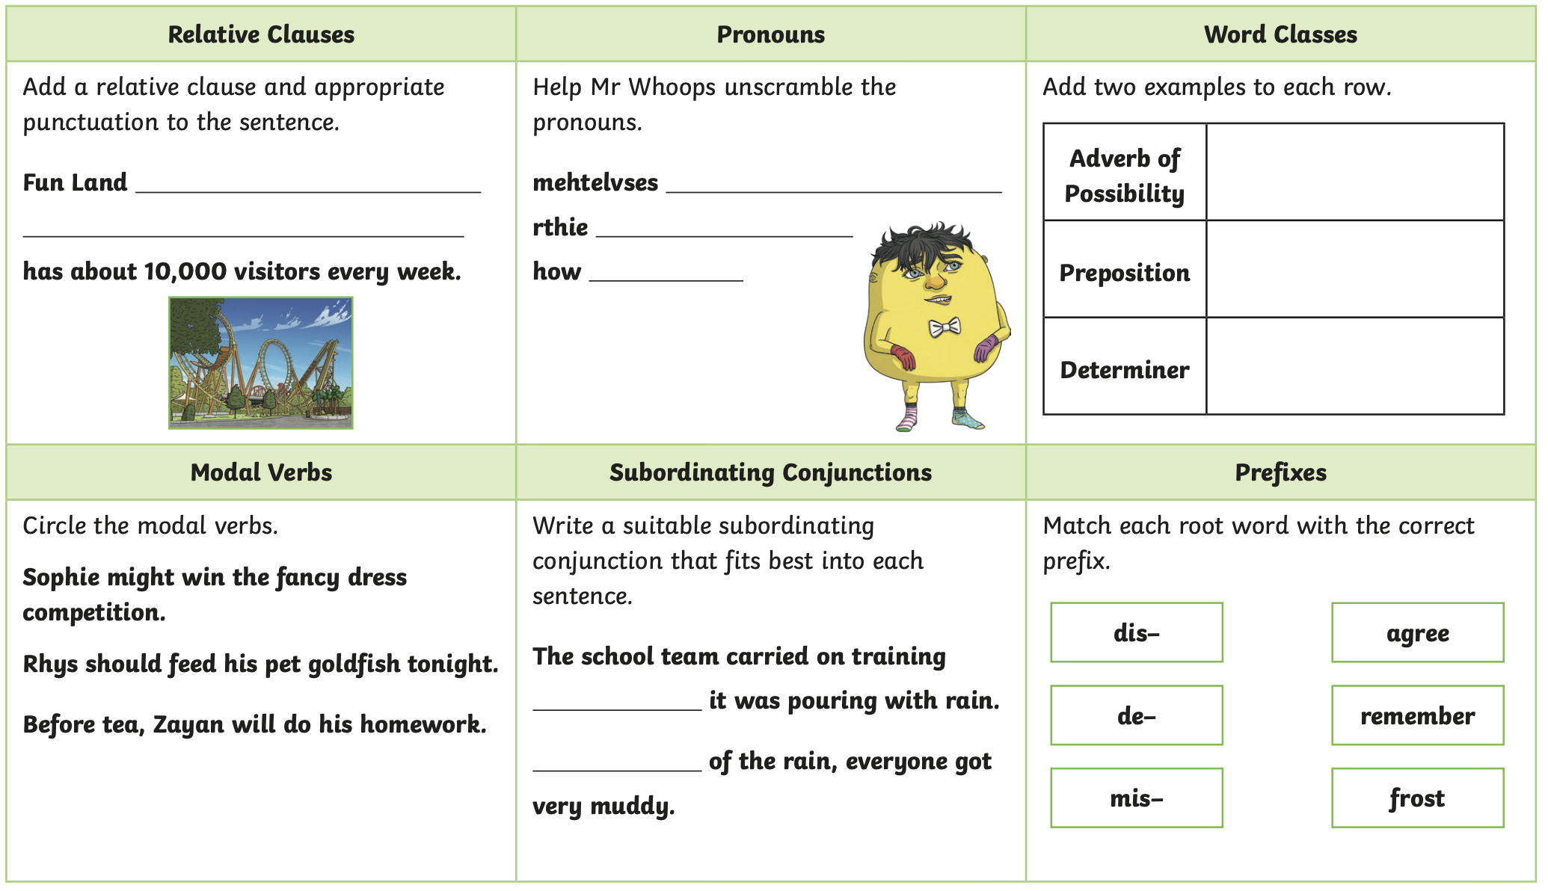

Challenge



