Axolotl Class Homework Spring 1 week 4 – Y3
Homework due: Tuesday 3rd February 2026
Next week we are learning:
Maths | Literacy | Science | RE
We will be our 2nd unit on multiplication and division focussing on larger numbers, remainders and related facts | We will be will continuing our unit from our new topic – Tombs, Torches and Timekeepers focusing on writing a non-chronological report on King Tut | We will be continuing our unit of work on Light | We will be continuing our unit on Judaism.

Log on to timestable.com to practise your maths skills:
Purple Mash also have some lovely Maths and spellings activities
Timestable.co.uk
Or use other websites/ways that you enjoy .

Times Table – I have set the children the multiplication check to have a go at it please. If they can log on regularly to complete the 25 questions in less than 6 seconds - it should repeat weekly!

Spellings:
Practise spellings ready for weekly spelling test- see below for your child’s spelling group – These groups are subject to change as they are based on their current spelling ages.

Reading:
Read every day for 20 minutes. Please log this in Reading Records.

SPaG: Year 3 SPaG mat

Maths: multiplying 3 digits by a 1 digit number

Spellings:
Group 1 | Group 2 | Group 3
annoy  dream  cried  instead  summer  blackberry  moon  hutch  fresher  sketch | appear  material  library  perhaps sentence  various  regular  bicycle  possess  caught | although  through  potatoes  enough  possess  natural  believe  different  possible  probably
……………………………………………………………………………………………………………………………………………………………………………………………………………………………………………………………………………………………………………………………………………………………………………………………………………………………………………………………………………………………………………………………………………………………………………………………………………………………………………………………………………………………………………………………………………………………………………………………………………………………………………………………………………………………………………………………………………………………………………………………………………………………………………………………………………………………………………………………………………………………………………………………………………………………………………………………………………………………………………………………………………………………………………………………………………………………………………………………………………………………………………..…………………………………………………………………………………………………………………………….…………………………..

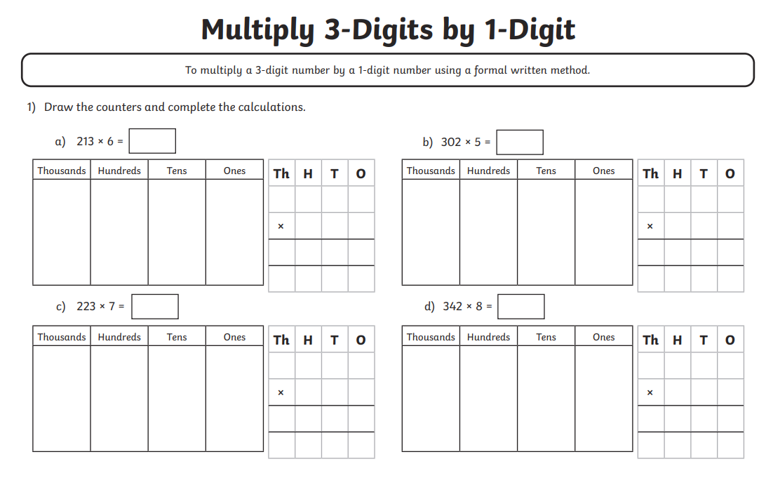
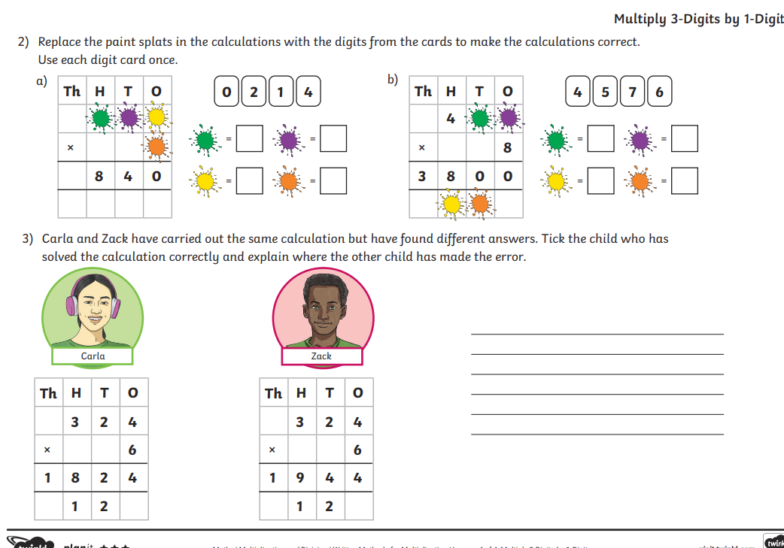
Challenge – optional
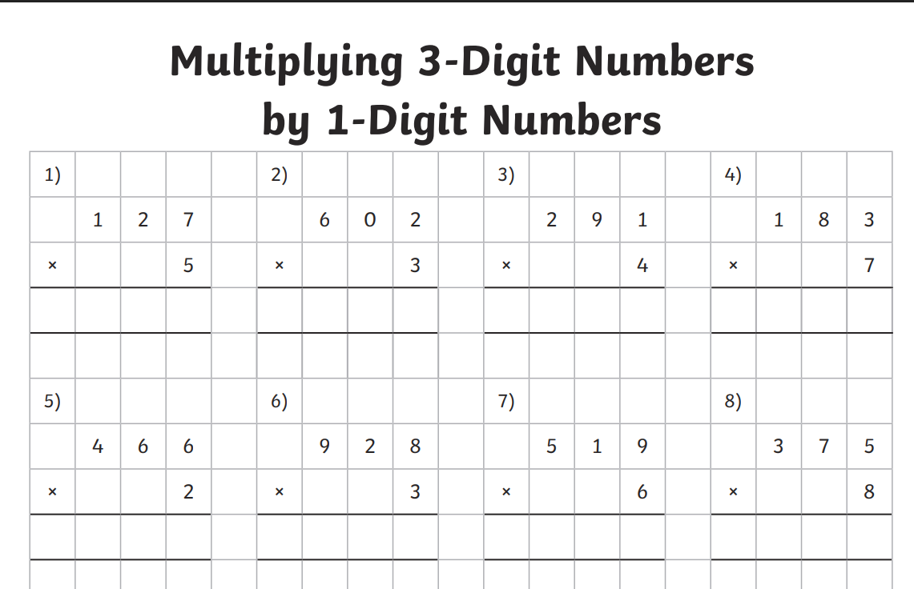

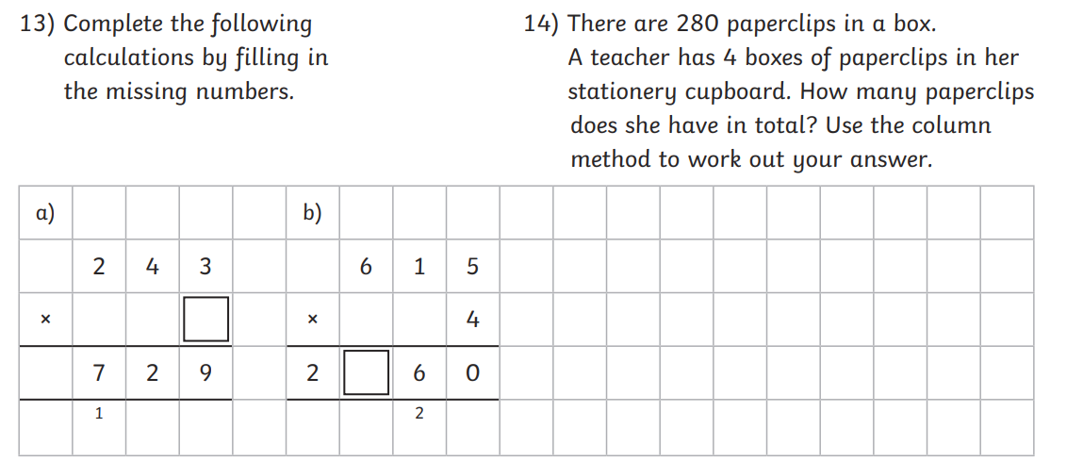

V



