Axolotl Class Homework Spring 1 week 3 – Y4
Homework due: Tuesday 27th January 2026
Next week we are learning:
Maths | Literacy | Science | RE
We will be starting our 2nd unit on multiplication and division focussing on larger numbers, remainders and related facts | We will be will continuing our unit from our new topic – Tombs, Torches and Timekeepers focusing on writing a non-chronological report on King Tut | We will be continuing our unit of work on Light | We will be continuing our unit on Judaism.

Log on to timestable.com to practise your maths skills:
Purple Mash also have some lovely Maths and spellings activities
Timestable.co.uk
Or use other websites/ways that you enjoy .

Times Table – I have set the children the multiplication check to have a go at it please. If they can log on regularly to complete the 25 questions in less than 6 seconds - it should repeat weekly!

Spellings:
Practise spellings ready for weekly spelling test- see below for your child’s spelling group – These groups are subject to change as they are based on their current spelling ages.

Reading:
Read every day for 20 minutes. Please log this in Reading Records.

SPaG: Year 3 SPaG mat

Maths: multiplying and dividing by 10 and 100 see video to help if needed.
http://youtube.com/watch?v=Y45H5aCuymg

Spellings:
Group 1  CEW | Group 2  im prefix | Group 3  ssion sufix
treasure  measure  picture  cure  injure  secure  pure  mixture  leisure  mature | immature  impossible  impatient  imperfect  immortal  impolite  immovable  improbable  imbalance  impeccable | expression possession discussion confession permission admission impression omission  emission commission
……………………………………………………………………………………………………………………………………………………………………………………………………………………………………………………………………………………………………………………………………………………………………………………………………………………………………………………………………………………………………………………………………………………………………………………………………………………………………………………………………………………………………………………………………………………………………………………………………………………………………………………………………………………………………………………………………………………………………………………………………………………………………………………………………………………………………………………………………………………………………………………………………………………………………………………………………………………………………………………………………………………………………………………………………………………………………………………………………………………………………………..…………………………………………………………………………………………………………………………….…………………………..

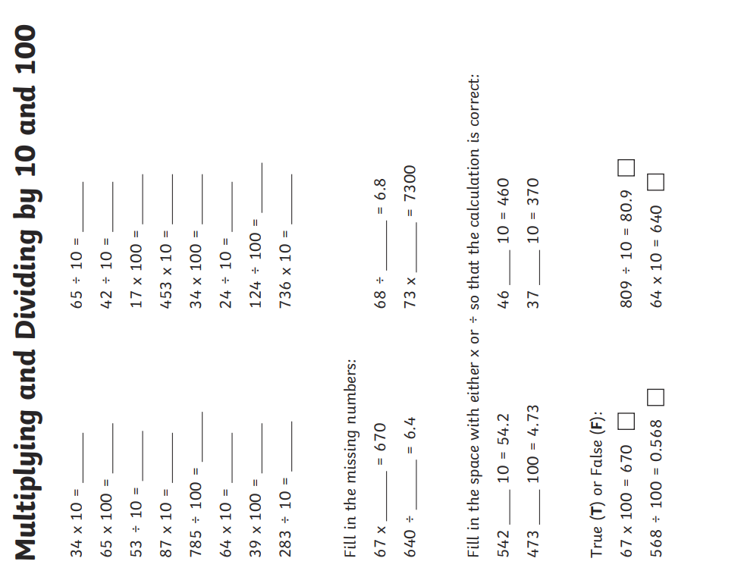

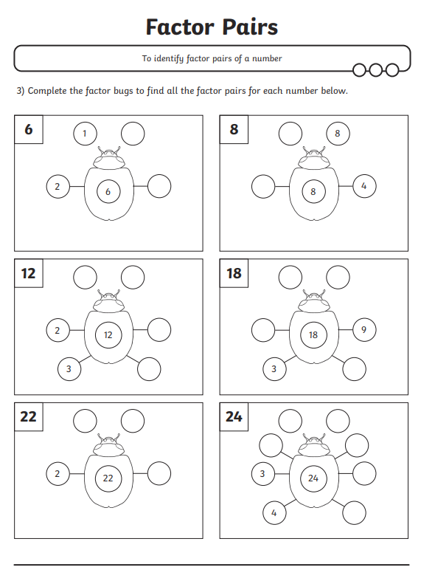
Added challenge can you multiply and divide some of these numbers by 1000 you can use the place value tool to help in your homework folders.

Challenge – optional
Can you create factor bugs for: 72, 99, 144, 7, 13 – then tell me what you notice?
Can you that prove all even numbers have an even number of factors - True or False
What do you notice at numbers like 2, 5, 11 and 19 when you create a factor bug?
Can you think of anymore of them?
Do you know what we all them?



