Axolotl Class Homework Spring 1 week 2 – Y3
Homework due: Tuesday 20th January 2026
Next week we are learning:
Maths | Literacy | Science | RE
We will be finishing our unit on multiplication and division after unpicking our results of our arithmetic and reasoning paper to see common errors and misconnections. Then starting our unit on area | We will be will continuing our unit from our new topic – Tombs, Torches and Timekeepers focusing on writing a non-chronological report on King Tut | We will be continuing our unit of work on Light | We will be continuing our unit on Judaism.

Log on to timestable.com to practise your maths skills:
Purple Mash also have some lovely Maths and spellings activities
Timestable.co.uk
Or use other websites/ways that you enjoy .

Times Table – I have set the children the multiplication check to have a go at it please. If they can log on regularly to complete the 25 questions in less than 6 seconds - it should repeat weekly!

Spellings:
Practise spellings ready for weekly spelling test- see below for your child’s spelling group – These groups are subject to change as they are based on their current spelling ages.

Reading:
Read every day for 20 minutes. Please log this in Reading Records.

SPaG: Year 4 SPaG mat

Maths: times tables

Spellings:
Group 1  CEW | Group 2  Recap | Group 3  Recap
air  fair  pair  hair  unfair  repair  chair  stairs  despair  éclair | supermarket superstar superman superhuman supersonic superfine superficial supercomputer Superdrug superstructure | league  tongue  antique  unique  fatigue  intrigue  rogue  vague  opaque  plaque
……………………………………………………………………………………………………………………………………………………………………………………………………………………………………………………………………………………………………………………………………………………………………………………………………………………………………………………………………………………………………………………………………………………………………………………………………………………………………………………………………………………………………………………………………………………………………………………………………………………………………………………………………………………………………………………………………………………………………………………………………………………………………………………………………………………………………………………………………………………………………………………………………………………………………………………………………………………………………………………………………………………………………………………………………………………………………………………………………………………………………………..…………………………………………………………………………………………………………………………….…………………………..
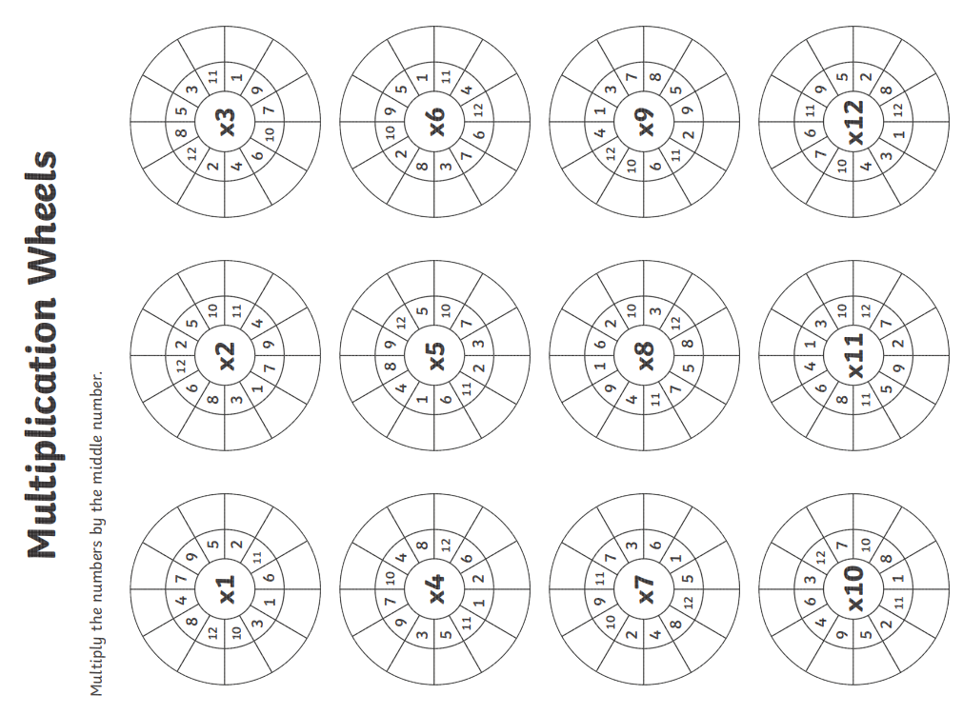
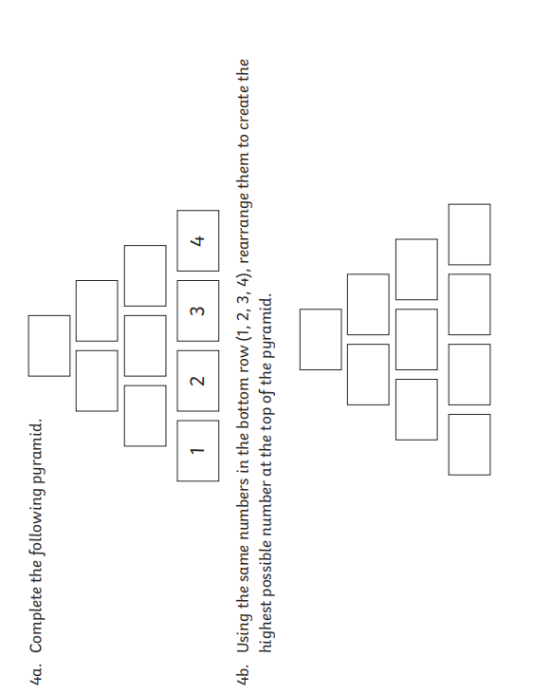
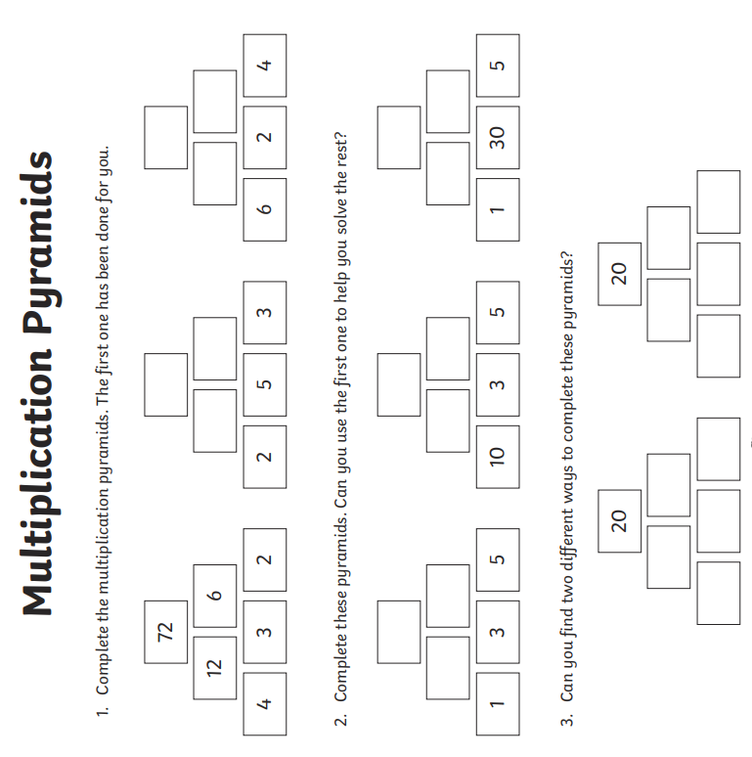

To work out the very top of try and partition the numbers out eg. 35 x 13 is 30 and 5 times by the other numbers partitioned out eg 10 and 3. Then add all the numbers together. 30 x 10 =300, 5x10= 50, 30x3=90, 5x3 =15 = 455


