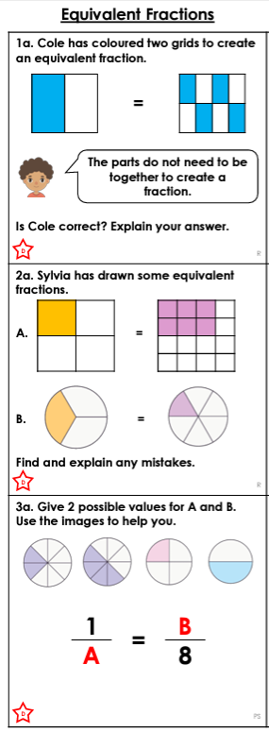
Hedgehog Class Homework Spring 1 week 1
Homework due: Tuesday 13TH January 2026
Next week we are learning:
Maths | Literacy | Science | RE
Consolidation work with arithmetic. | We will be exploring different writing genres | We will look at the Kingdom of life | We are starting out new topic: Hinduism.

Reading: Daily for 30 minutes.
Comprehension: WW2
Spelling: see below
Times tables: Log onto purple mash and practice the multiplication check.
Maths: Equivalent fractions below. Use the boxes to write your answers.

Spellings:
Spelling for all groups
deceive
conceive
receive
perceive
ceiling
receipt
protein
caffeine
seize
neither
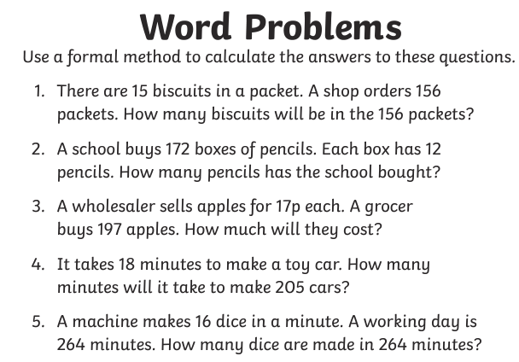
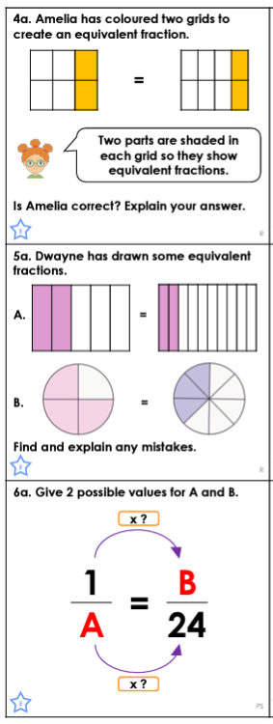
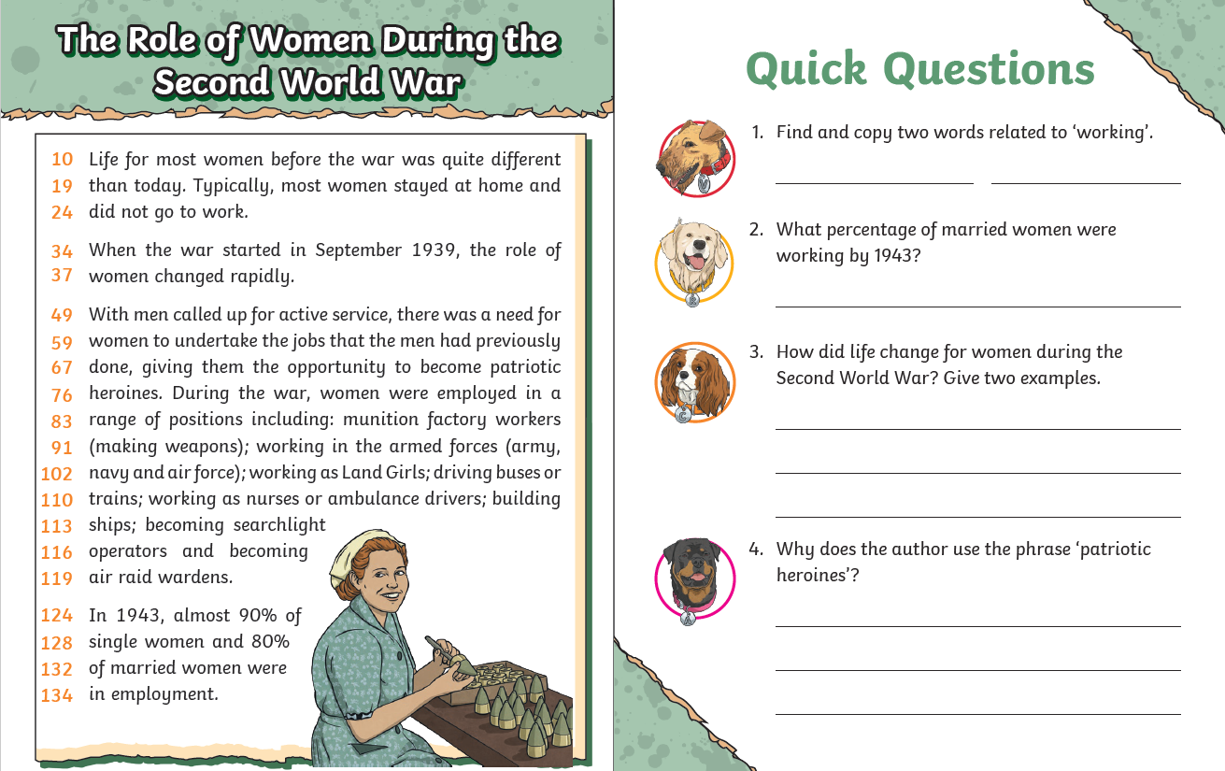

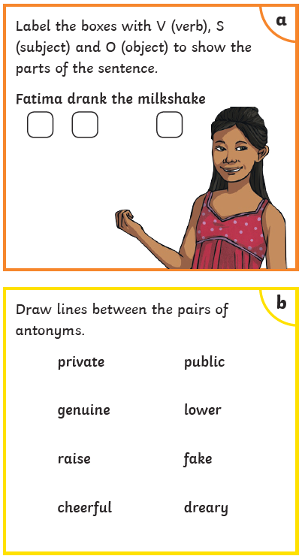
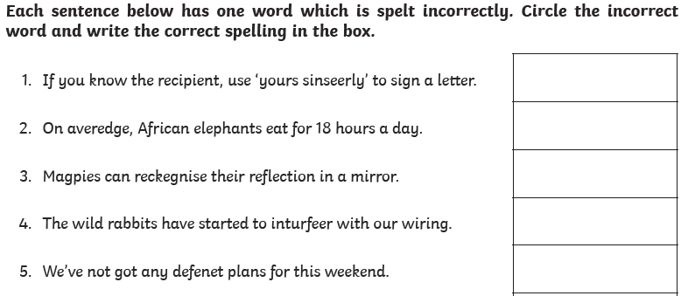
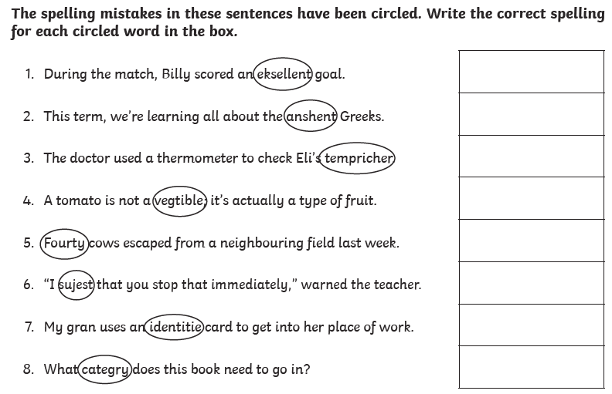
SPAG

