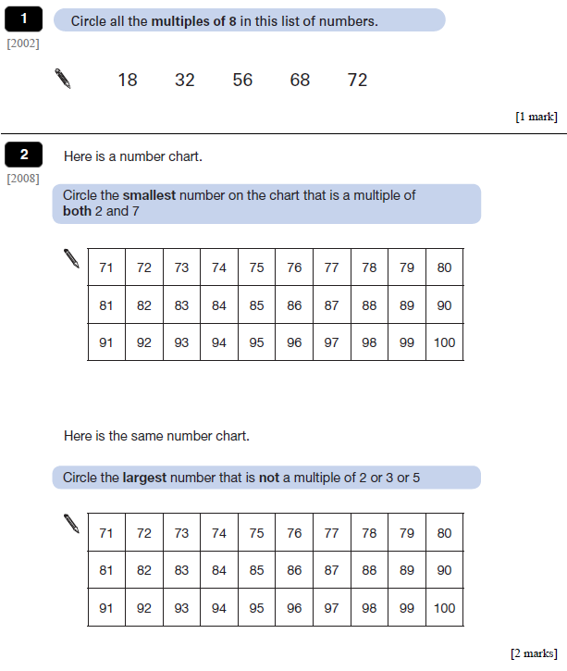
Hedgehog Class Homework Spring 1 week 2
Homework due: Tuesday 20th January 2026
Next week we are learning:
Maths | Literacy | Science | RE
We are starting our topic on decimals. | We will be exploring poets and poetry genres. | Looking at the Linnaean theory. | We will be looking at

Reading: Daily for 30 minutes.
Comprehension: looking at a different genre: instructions. Read and answer the questions
Spelling: see below
Grammar: correct the punctuation.
Maths: SATs style questions and multiplication riddles.
Times tables: Practice the multiplication check on purple mash
Spellings:
Common spelling mistakes:
because
witch
which
reversible
irreversible
were
where
beautiful
special
accepted



