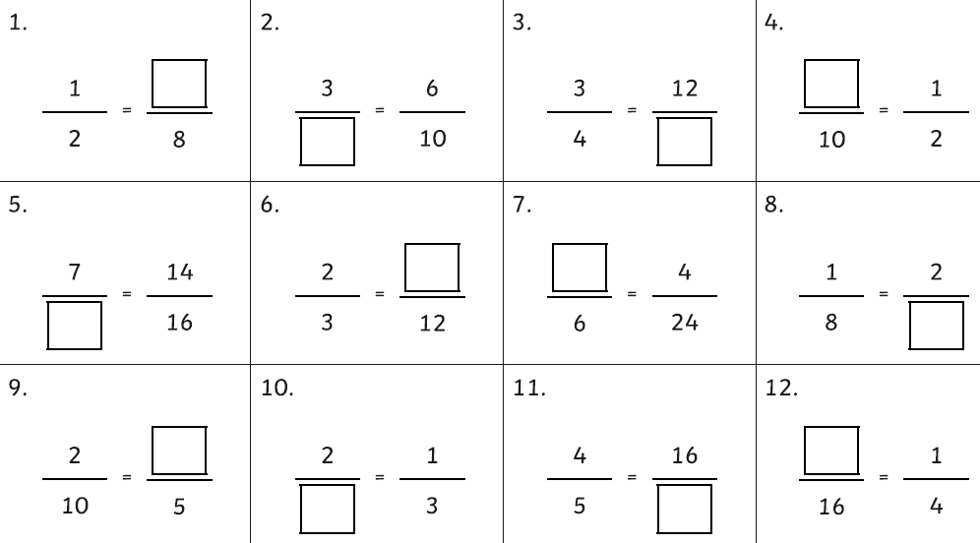
Hedgehog Class Homework Spring 1 Week 3
Homework due: Tuesday 27th January 2026

Reading: Daily for 30 minutes remember our class challenge!
Spelling: see below
Grammar: SATs style Q’s.
Maths: fractions – make the fractions equivalent. E.g. ½ is equivalent to 4/8
Spellings:
Group 1 | Group 2
community  curiosity  ability  visibility  captivity  activity  eternity  flexibility  possibility  sensitivity | referring  referred  referral  reference  referee  preferring  preferred  preference  transferring  transference

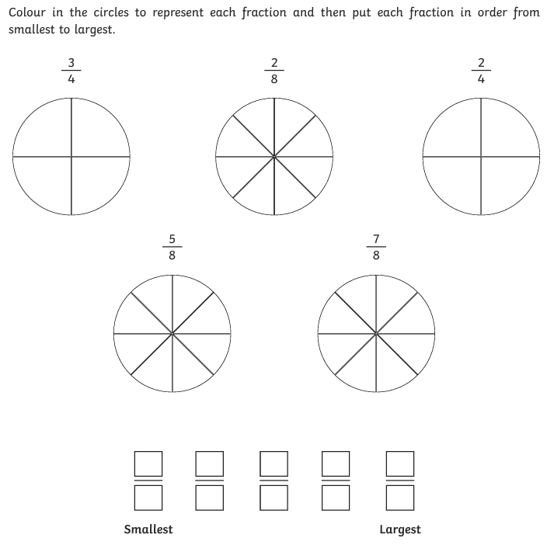

Times

tables
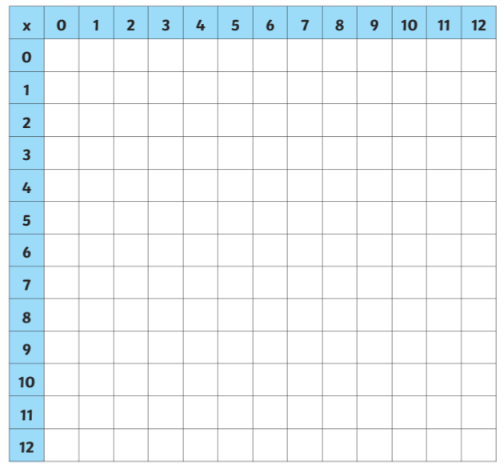

Grammar:
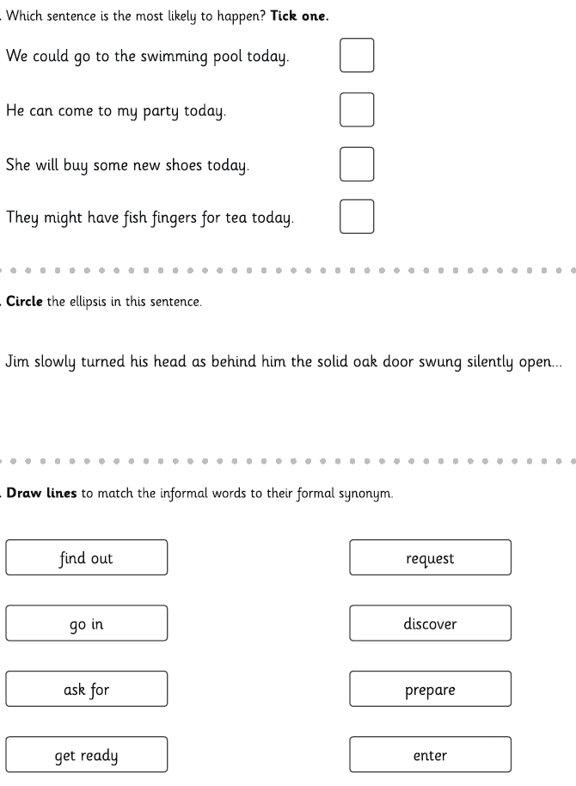
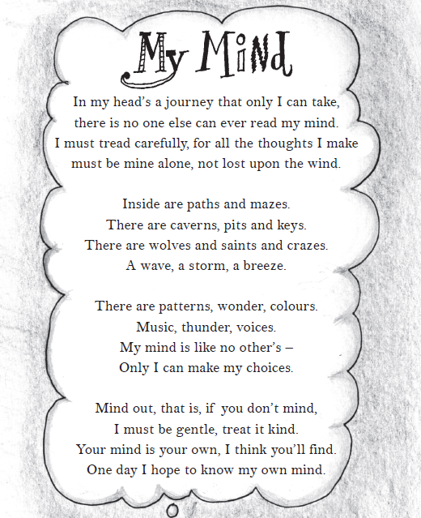
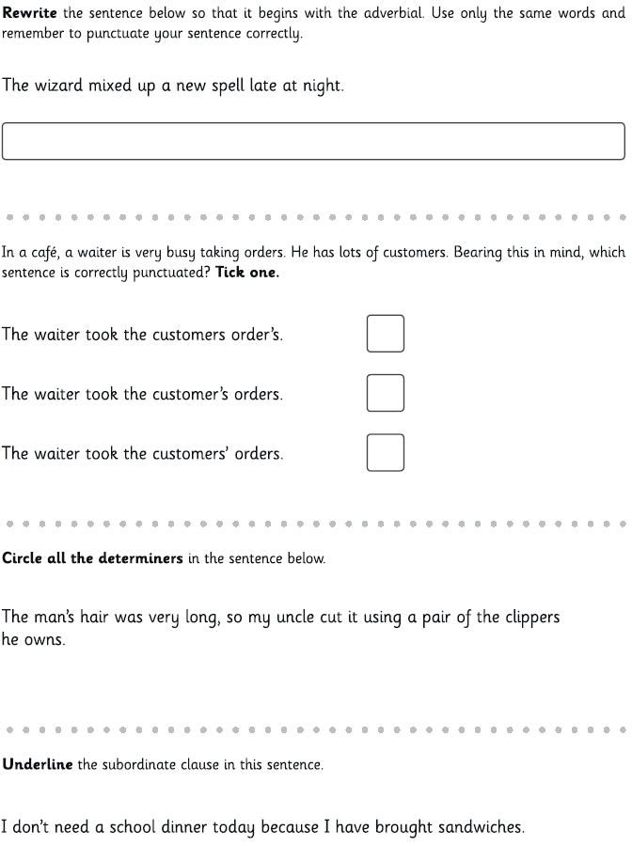
Comprehension:

Retrieving Information
- What word does the poet use as a synonym for ‘hole’?

- How does the poet say she must behave towards her mind?

- The poet uses the word ‘mind’ in different ways so that it has different meanings. Give two examples from the poem.

Making Inferences
- Do you think the poet is a young person or an older person? Explain why using evidence from the text.

- Why do you think the poet wants their thoughts to “be mine alone”?

Writer’s choices
- Why do you think the writer compares her mind to “paths and mazes”?

- Why has the poet chosen to talk about “wolves” in her mind?

Challenge question (extended question)
- Do you think the poet’s mind is a happy, sad or angry place? Support your answer with examples from the text.

