Rabbit Class Homework Spring 1 week 4 – Y3
Homework due: Tuesday 3rd February 2026
Next week we are learning:
Maths | Literacy | Science | RE
We will be moving on to look at multiples, factors and problem solving. | We will be will continuing our work on storytelling. We will be beginning to plan out a story using story maps. | We will be continuing our unit of work on Everyday Materials. | We will be continuing our unit on Christianity.

Log on to timestable.com to practise your maths skills:
Purple Mash also have some lovely Maths and spellings activities
Timestable.co.uk
Or use other websites/ways that you enjoy 😊.

Times Table – Please remember to use the multiplication grid to practise times tables!

Spellings:
Practise spellings ready for weekly spelling test- see below for your child’s spelling group – These groups are subject to change as they are based on their current spelling ages.

Reading:
Read every day for 20 minutes. Please log this in Reading Records.

SPaG: Year 3 SPaG mat

Maths: 4 times table problem solving

Spellings:
Group 1  ‘ough’ ‘augh’ | Group 2  a-e, i-e and o-e
tough  rough  enough  ought  thought  bought  fought  caught  taught  naughty | mistake  shake  flake  nice  while  smile  broke  slope  nose  wrote
……………………………………………………………………………………………………………………………………………………………………………………………………………………………………………………………………………………………………………………………………………………………………………………………………………………………………………………………………………………………………………………………………………………………………………………………………………………………………………………………………………………………………………………………………………………………………………………………………………………………………………………………………………………………………………………………………………………………………………………………………………………………………………………………………………………………………………………………………………………………………………………………………………………………………………………………………………………………………………………………………………………………………………………………………………………………………………………………………………………………………………..…………………………………………………………………………………………………………………………….…………………………..
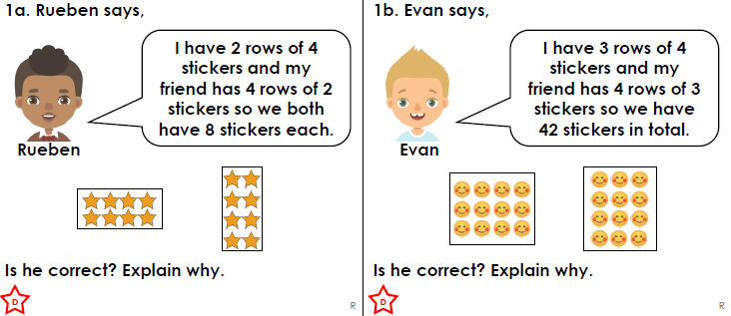

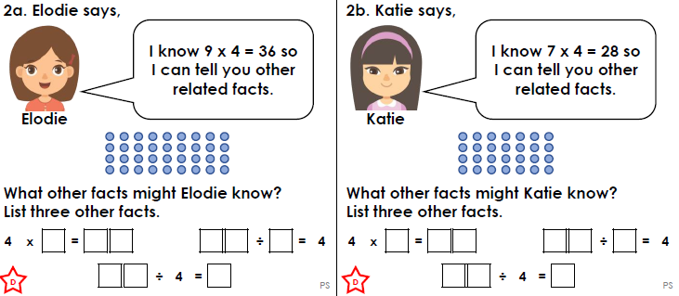
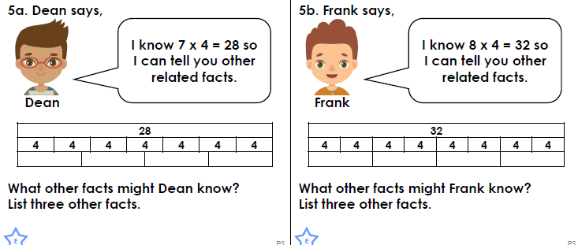

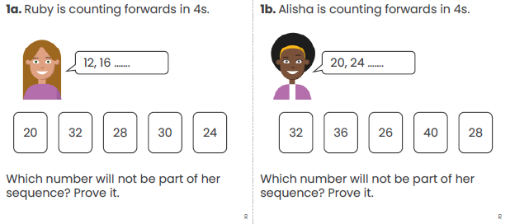

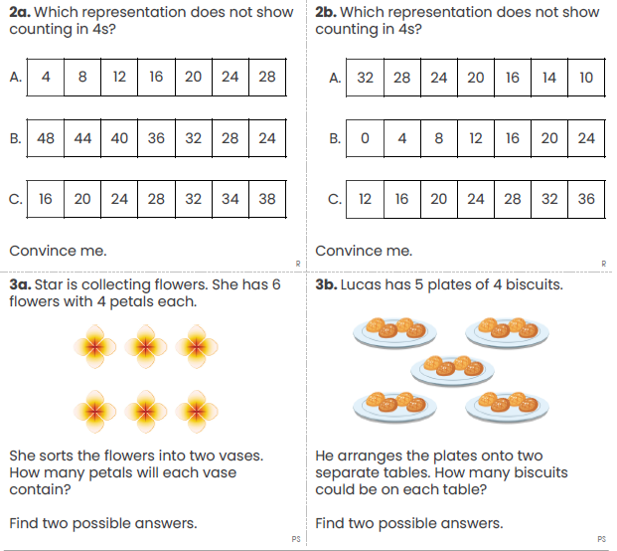
Challenge (optional)
Maths investigations


