Eagle Class Homework Spring 1 week 5 – Y4
Homework due: Tuesday 10th February 2026
Next week we are learning:
Maths | Literacy | Science | RE
In Maths this week, Year 4 will be focusing on multiplying efficiently and developing their understanding of fractions, including recognising the whole and counting beyond one. | In English this week, Year 4 will take part in activities for National Storytelling Week, exploring stories through reading, discussion and creative tasks. | In Science this week, Year 4 will identify the different types of human teeth and learn about their functions. | In RE this week, Year 4 will explore what Christians believe are important foundations for living a good life, reflecting on values and choices.

Helpful Websites:
Log on to Purple Mash and practice your timetable fluency on ‘Multiplication Tables Check’.
Ask your grown up to sign your diary to record your practice and earn some class points!

Spellings:
Practise spellings ready for weekly spelling test- see below for your child’s spelling group – These groups are subject to change as they are based on their current spelling ages.

Reading:
Read every day for 30 minutes. Please log this in Reading Records.

Maths: Fractions

Challenges are optional – although please have a go if you can

Spellings:
Words marked with an asterisk (*) are common exception words or statutory spellings highlighted in the national curriculum.

Group 1 | Group 2  Statutory word list | Group 3  Statutory word list
measure  treasure  pleasure  leisure  pressure | although*  through*  potatoes*  enough*  possess*  natural*  believe*  different*  possible*  probably* | especially*  neighbour*  determined*  accommodate*  interfere*  committee*  apparent*  harass*  aggressive*  communicate*

Challenge: Can you write two sentences that include one of your spelling words?

Fractions of amounts

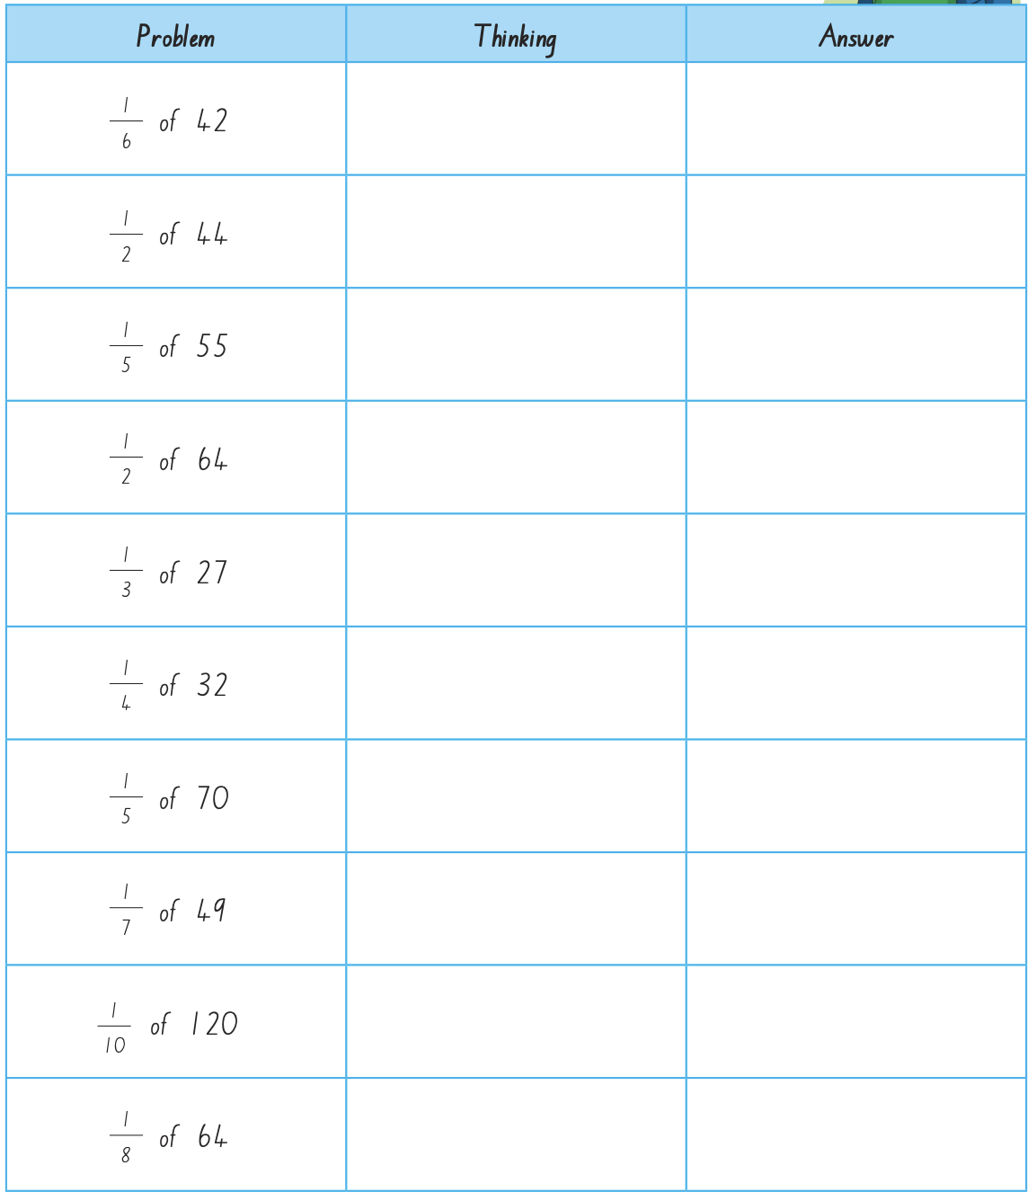
Draw a bar model in the thinking section to represent the problem.

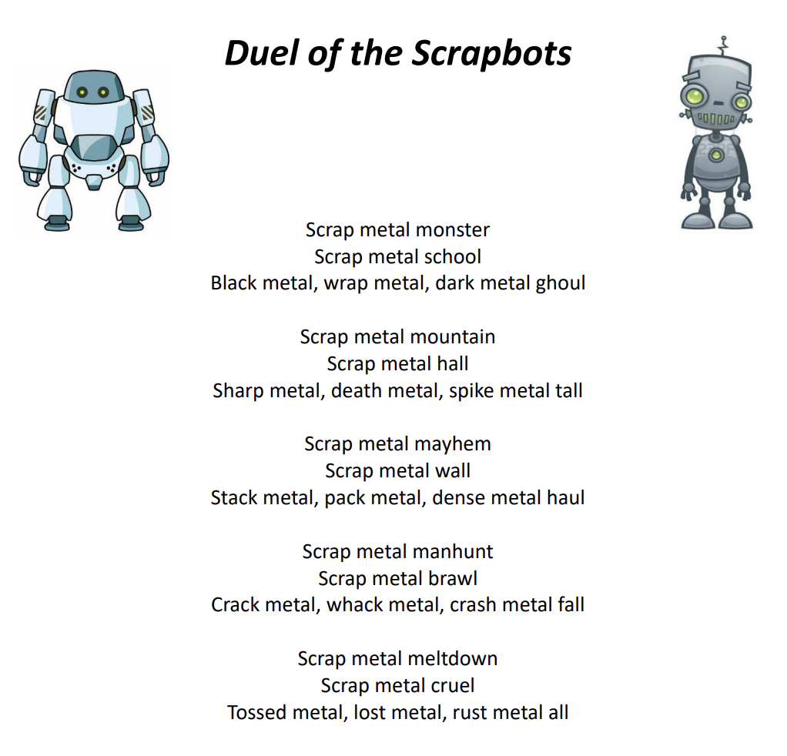
Reading Comprehension

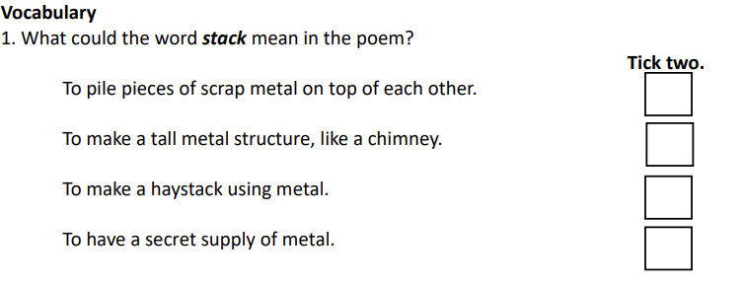

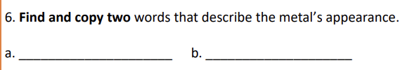
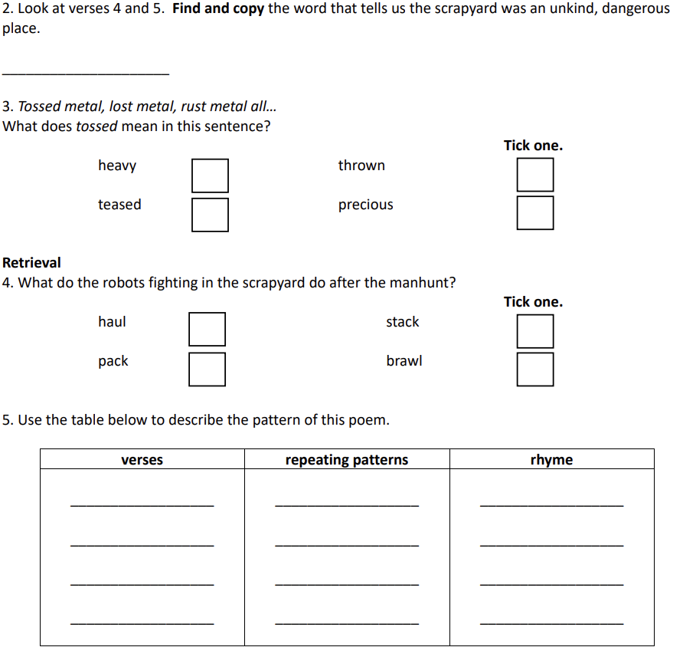

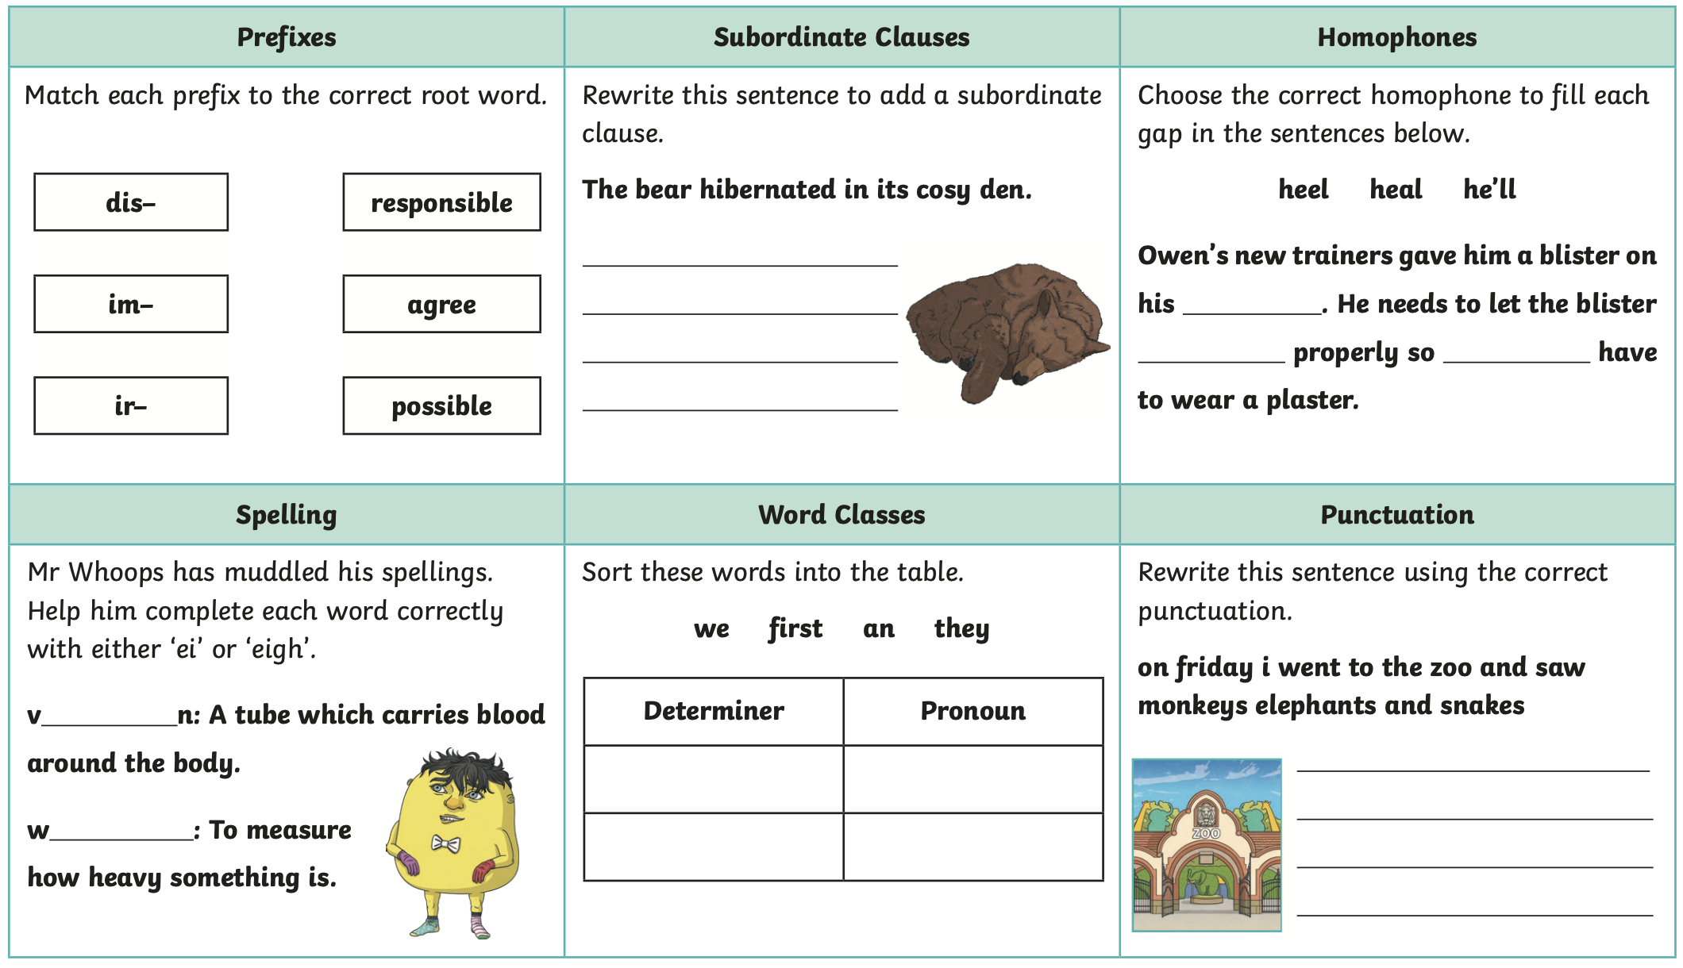
Challenge



