Eagle Class Homework Spring 1 week 5 – Y5
Homework due: Tuesday 10th February 2026
Next week we are learning:
Maths | Literacy | Science | RE
In Maths this week, Year 5 will be working efficiently with division and developing their understanding of fractions, including finding equivalent fractions. | In English this week, Year 5 will take part in National Storytelling Week, exploring and analysing stories through reading, discussion and creative writing tasks. | In Science this week, Year 5 will identify the different types of human teeth and learn about their functions. | In RE this week, Year 5 will explore Christian beliefs about the foundations of a good life and reflect on how these values can influence choices and behaviour.

Helpful Websites:
Log on to Purple Mash and practice your timetable fluency on ‘Multiplication Tables Check’.
Ask your grown up to sign your diary to record your practice and earn some class points!

Spellings:
Practise spellings ready for weekly spelling test- see below for your child’s spelling group – These groups are subject to change as they are based on their current spelling ages.

Reading:
Read every day for 30 minutes. Please log this in Reading Records.

Maths: Fractions

Challenges are optional – although please have a go if you can

Spellings:
Words marked with an asterisk (*) are common exception words or statutory spellings highlighted in the national curriculum.

Group 1 | Group 2  Statutory word list | Group 3  Statutory word list
measure  treasure  pleasure  leisure  pressure | although*  through*  potatoes*  enough*  possess*  natural*  believe*  different*  possible*  probably* | especially*  neighbour*  determined*  accommodate*  interfere*  committee*  apparent*  harass*  aggressive*  communicate*

Challenge: Can you write two sentences that include one of your spelling words?

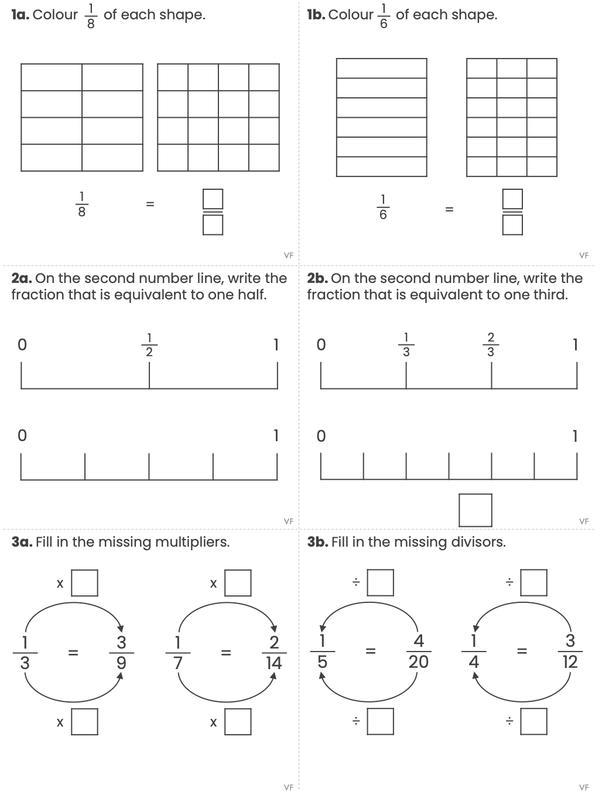
Equivalent Fractions

Reading Comprehension

My Shadow

By Robert Louis Stevenson

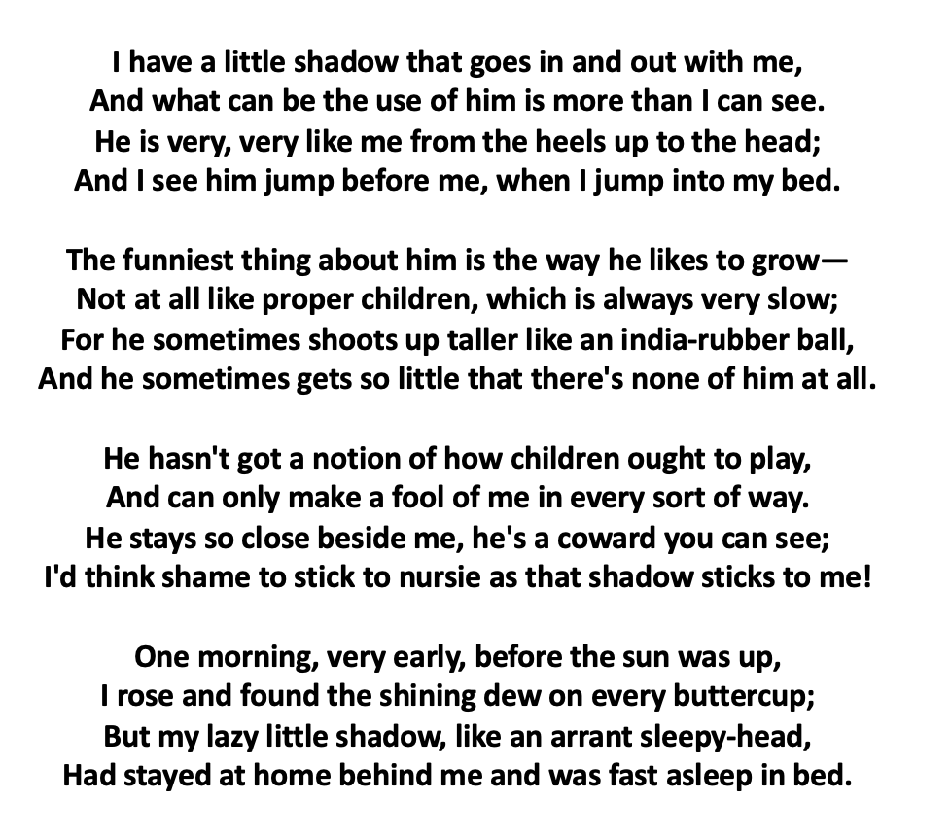

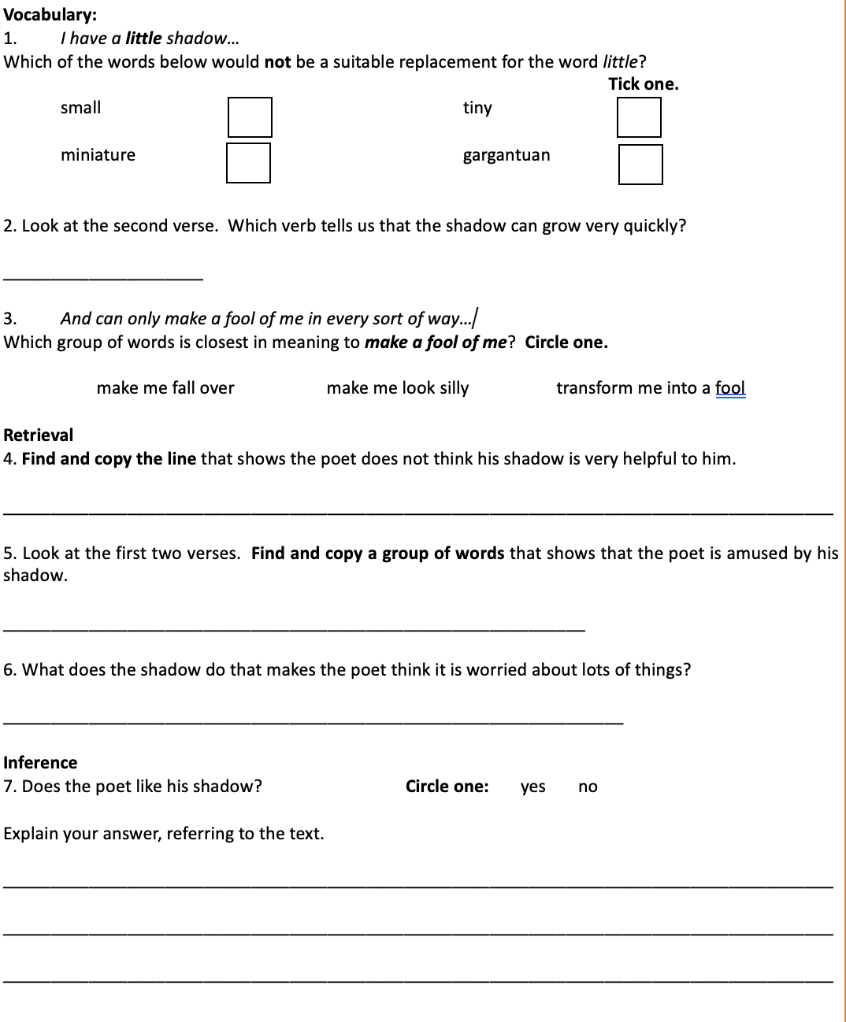

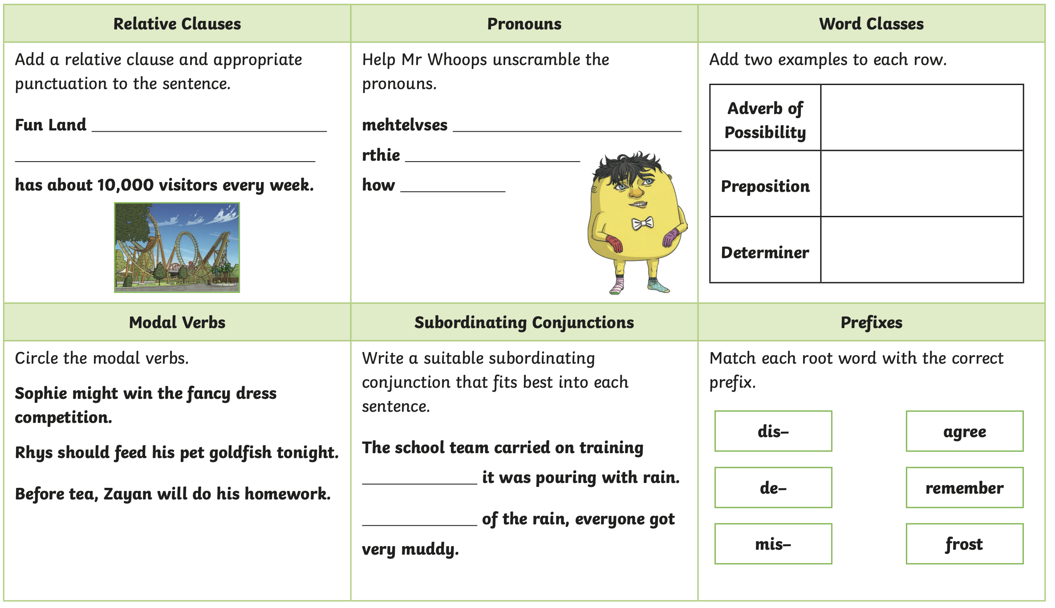
Challenge



