Rabbit Class Homework Spring 1 week 5 – Y3
Homework due: Tuesday 10th February 2026
Next week we are learning:
Maths | Literacy | Science | RE
We will be learning how to record, read and interpret data presented in a range of ways. | We will be will continuing our work on storytelling. We will learn the story of St George and re-tell it with drama. | We will be continuing our unit of work on Everyday Materials. | We will be continuing our unit on Christianity.

Log on to timestable.com to practise your maths skills:
Purple Mash also have some lovely Maths and spellings activities
Timestable.co.uk
Or use other websites/ways that you enjoy .

Times Table – Please remember to use the multiplication grid to practise times tables!

Spellings:
Practise spellings ready for weekly spelling test- see below for your child’s spelling group – These groups are subject to change as they are based on their current spelling ages.

Reading:
Read every day for 20 minutes. Please log this in Reading Records.

SPaG: Year 3 SPaG mat

Maths: multiples and factors

Spellings:
Group 1  -ally -ly suffixes | Group 2  ‘air’ ‘ear’ ‘ure’
accident  accidentally  actual  actually  occasion  occasionally  total  totally  different  differently | hair  fair  stairs  chair  near  gear  fear  sure  cure  mixture
……………………………………………………………………………………………………………………………………………………………………………………………………………………………………………………………………………………………………………………………………………………………………………………………………………………………………………………………………………………………………………………………………………………………………………………………………………………………………………………………………………………………………………………………………………………………………………………………………………………………………………………………………………………………………………………………………………………………………………………………………………………………………………………………………………………………………………………………………………………………………………………………………………………………………………………………………………………………………………………………………………………………………………………………………………………………………………………………………………………………………………..…………………………………………………………………………………………………………………………….…………………………..
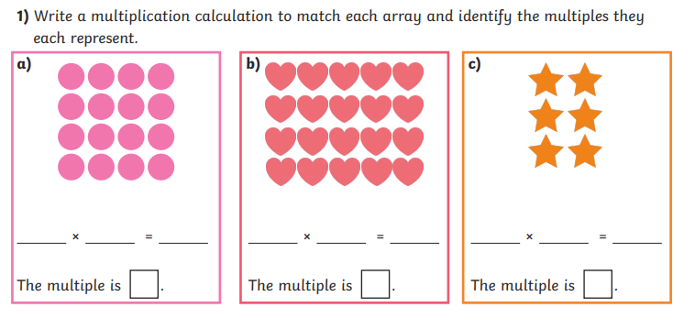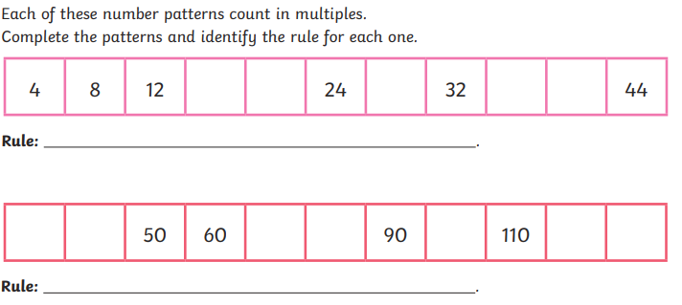
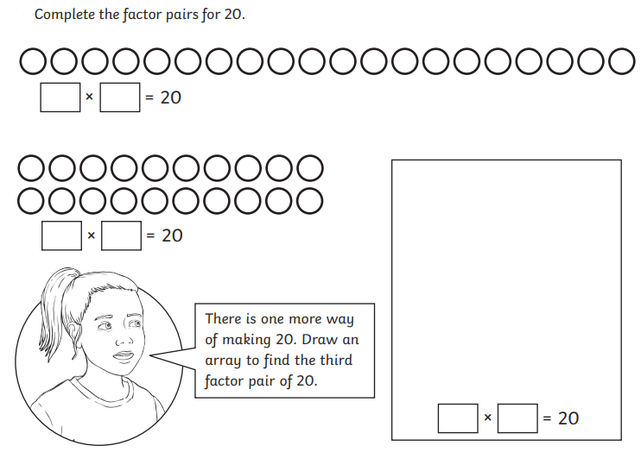
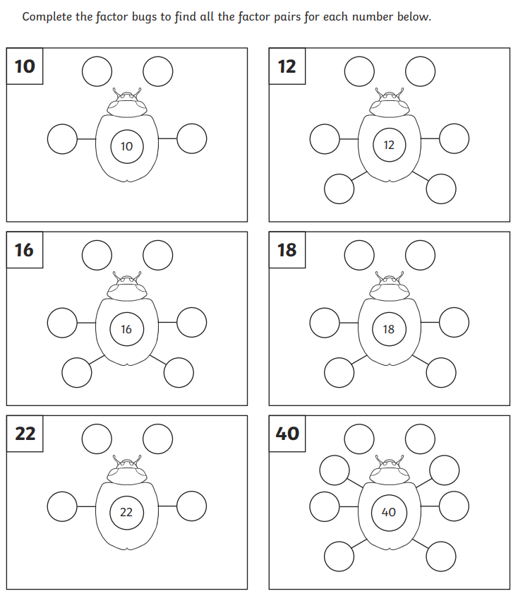
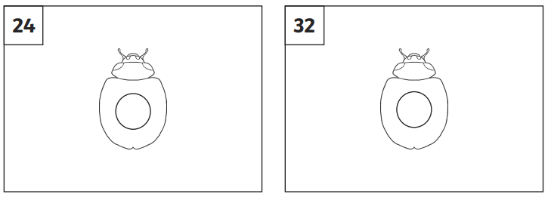
Challenge (optional)


