Name: ………………………………………………………..
Hedgehog Class Homework Spring 2 week 1 – Y6
Homework due: Tuesday 1st March 2026
Next week we are learning:
Maths | Literacy | Science | RE
We are covering shapes | We will be writing non-fiction texts | We will be investigating living things and their habitats. | We will be exploring Salvation.

Log on to timetables.com OR Hit the Button to practise your maths skills:
Purple Mash also have some lovely Maths and spellings activities

Or use other websites/ways that you enjoy .

Spellings:
Practise spellings ready for weekly spelling test- see below for your child’s spelling group – These groups are subject to change as they are based on their current spelling ages.

Reading:
ALL children should be reading every single day and recording this in our reading records. This has not been happening with most children – Even if you just read to yourselves, make sure you write this down!
Reading makes up to 50% extra progress each year!

Remember to look after yourself over the weekend and stay safe. If you are feeling overwhelmed, here are some great sites to help you feel a little better!

https://www.bbcchildreninneed.co.uk/schools/primary-school/mindfulness-hub/ ---------- https://www.gonoodle.com/ ----------- Smiling Mind (App)
Spellings:
Group A | Group B | Group C
answer  build  caught  phone  early  earth  enough  height  island  knowledge | answer  build  believe  average  communicate  height  desperate  leisure  shoulder  tough | determined  foreign  secretary  community  fallacy  conscious  twelfth  stomach  action  muscle
……………………………………………………………………………………………………………………………………………………………………………………………………………………………………………………………………………………………………………………………………………………………………………………………………………………………………………………………………………………………………………………………………………………………………………………………………………………………………………………………………………………………………………………………………………………………………………………………………………………………………………………………………………………………………………………………………………………………………………………………………………………………………………………………………………………………………………………………………………………………………………………………………………………………………………………………………………………………………………………………………………………………………………………………………………………………………………………………………………………………………………………………………………………………………………………………………………………………………………………………………………………………..……………………………………………………………………………………………………………………………..
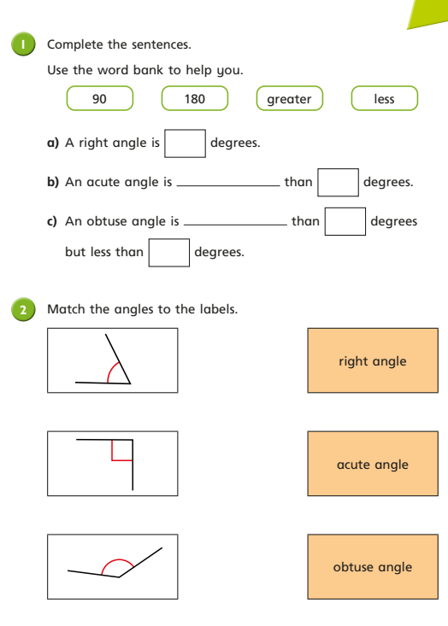
Task 1:

See next page

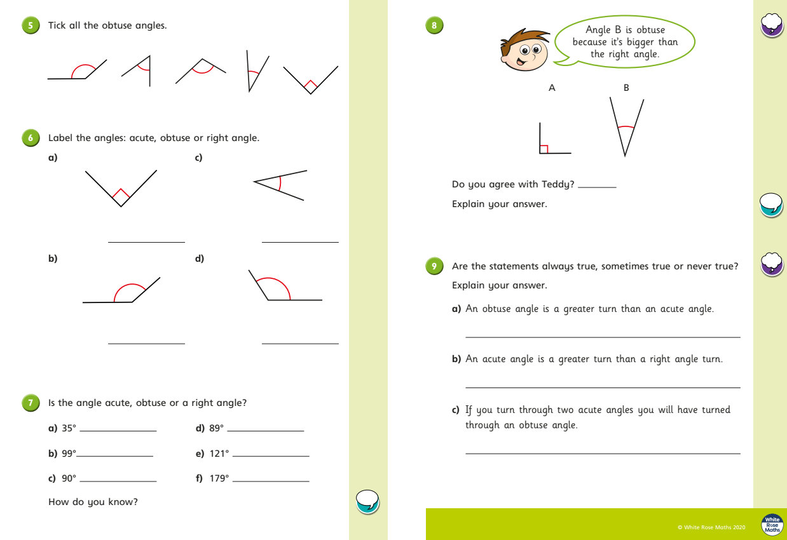
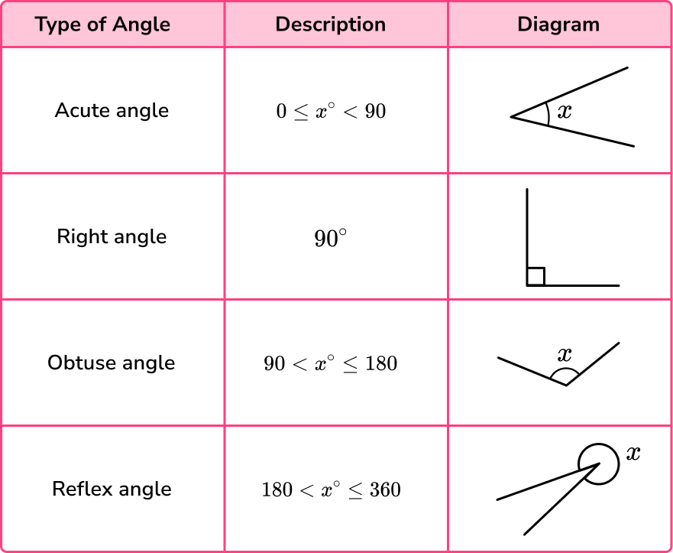
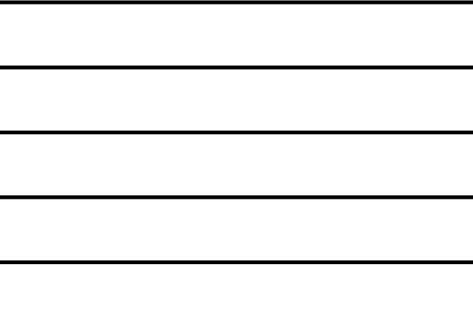
Helpful Resources:
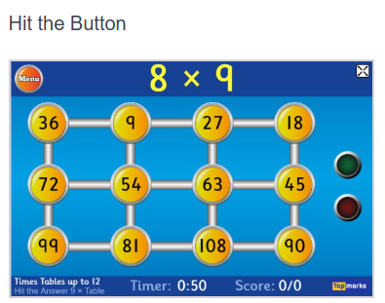

Remember – You can do this! If you are struggling, ask an adult or mark this on your work and we can go over it together in class.

