Amber Class Homework Summer term 1 week 2
Homework due: Tuesday ^{6th} May 2025

Reading: Daily for 30 minutes, write up in your Reading Record with a comment about what was read/discussed.
Spelling: see below
Maths Games:
https://www.topmarks.co.uk/times-tables/coconut-multiples
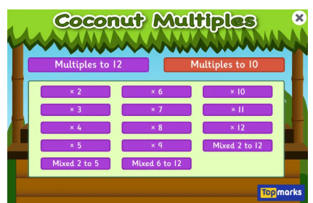
https://mathsframe.co.uk/en/resources/resource/306/Maths-Fishing-Multiplication
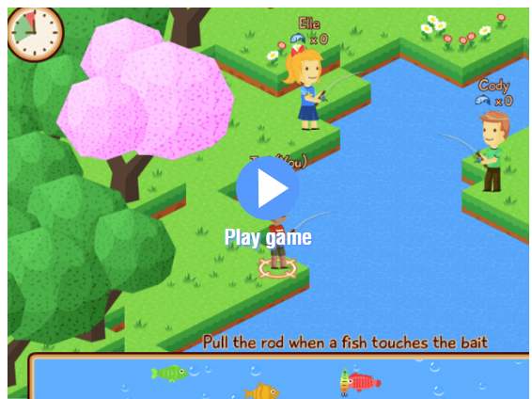

Spellings:
Group 1 | Group 2 | Group 3
particular  material  grammar  disappear  early  earth  business  separate | guide  certain  fruit  complete  describe  believe  breath  busy | child  people  plant  poor  half

Use this space to practice your spellings!

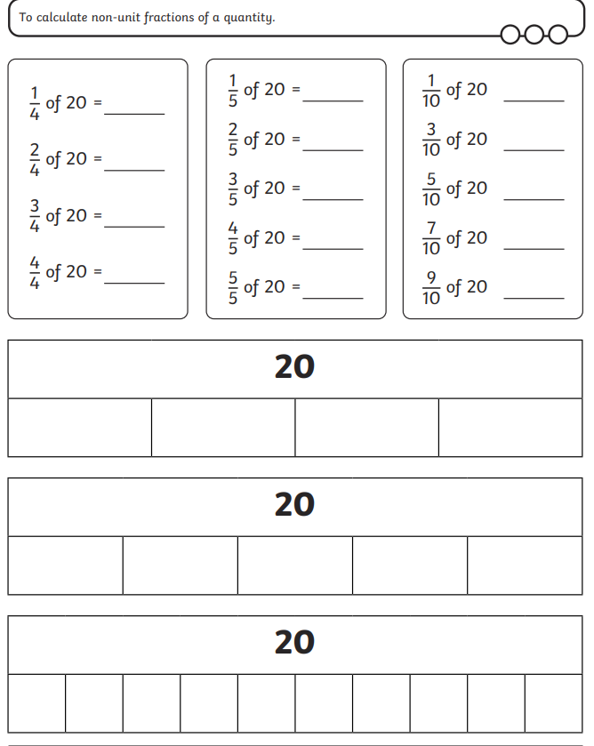
Maths Challenge:
Complete the math’s activities
Use the bar models to help you work out the questions.

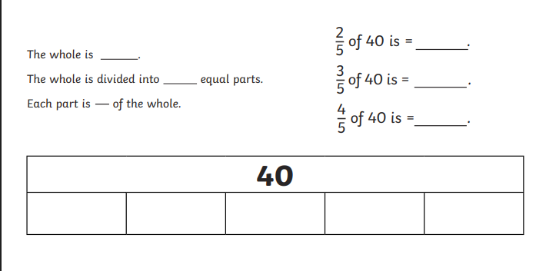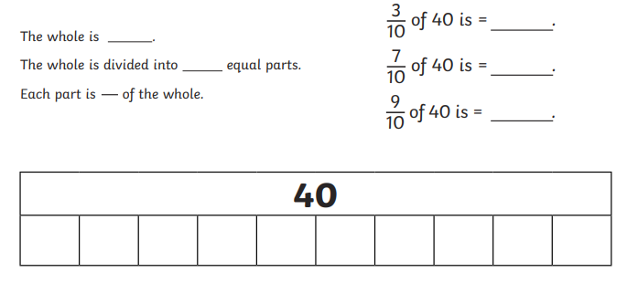

English: Write a diary entry on your week at school:
Remember to write in first person “ I “ and start with “Dear Diary”.

