Rabbit Class Homework Spring 2 week 2– Y3
Homework due: Tuesday 10th March 2026
Next week we are learning:
Maths | Literacy | Science | RE
We will be adding, subtracting, ordering and comparing fractions. | We will be using some features of non-fiction texts to write a recount of our trip to Colchester Castle | We will be continuing our unit on forces and magnets. | We will be exploring the Easter story and why and how Christians celebrate Easter.

Log on to timestable.com to practise your maths skills:
Purple Mash also have some lovely Maths and spellings activities
Timestable.co.uk
Or use other websites/ways that you enjoy 😊.

Reading:
Please make sure you are reading with your child daily and record this in reading records!

Times Tables – I have set a times table activity on Purple Mash for children to practise.

Spellings:
Practise spellings ready for weekly spelling test- see below for your child’s spelling group – These groups are subject to change as they are based on their current spelling ages.

SPaG: Year 3 SPaG mat

Maths: finding fractions of an amount

Spellings:
Group 1  ‘ch’ as k  ‘y’ as i | Group 2  ‘ar’ ‘or’
scheme  chorus  echo  character  ache  myth  mystery  gym  symbol  crystal | car  star  farmer  alarm  harm  born  short  fork  thorn  morning
……………………………………………………………………………………………………………………………………………………………………………………………………………………………………………………………………………………………………………………………………………………………………………………………………………………………………………………………………………………………………………………………………………………………………………………………………………………………………………………………………………………………………………………………………………………………………………………………………………………………………………………………………………………………………………………………………………………………………………………………………………………………………………………………………………………………………………………………………………………………………………………………………………………………………………………………………………………………………………………………………………………………………………………………………………………………………………………………………………………………………………..…………………………………………………………………………………………………………………………….…………………………..

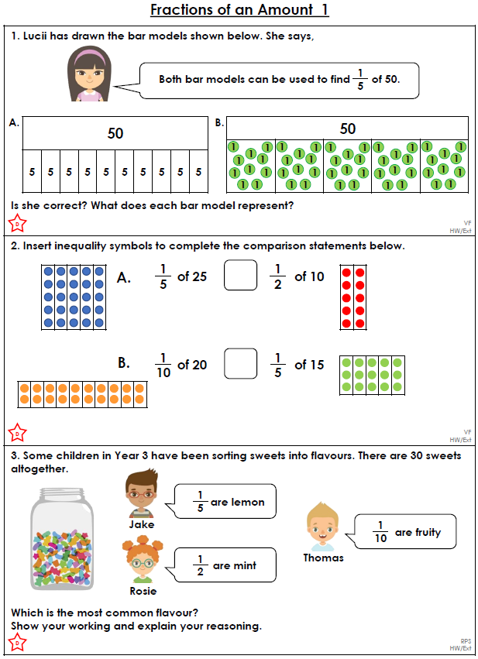

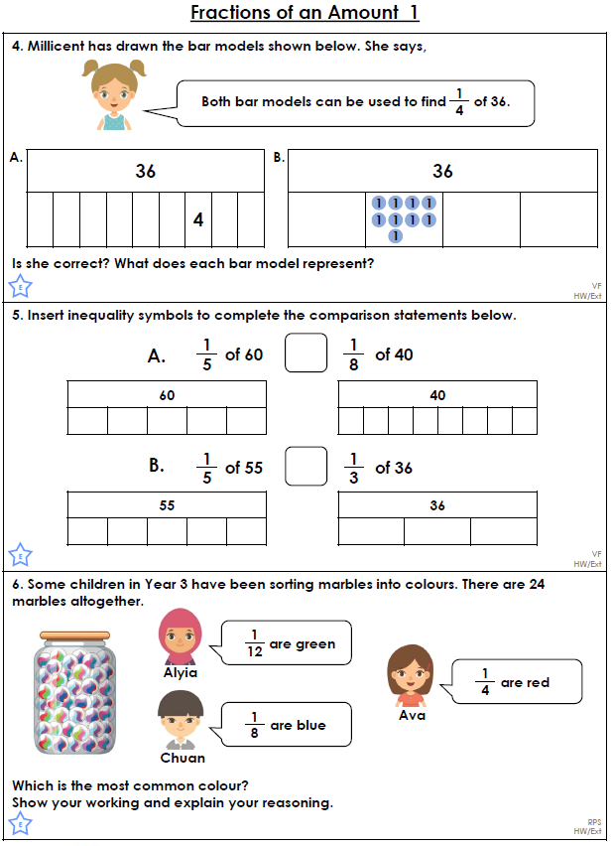

Challenge (optional)


