Rabbit Class Homework Spring 2 week 1 – Y3
Homework due: Tuesday 3rd March 2026
Next week we are learning:
Maths | Literacy | Science | RE
We will be continuing to learn about fractions. We will be finding fractions of an amount and recognising equivalent fractions. | We will be using some features of poems to write a descriptive poem. | We will be learning about the properties of magnets and magnetic materials as part of our new unit on Forces and Magnets. | We will be learning and comparing creation stories from different religions.

Log on to timestable.com to practise your maths skills:
Purple Mash also have some lovely Maths and spellings activities
Timestable.co.uk
Or use other websites/ways that you enjoy .

Times Tables – I have set a times table activity on Purple Mash for children to practise.

Spellings:
Practise spellings ready for weekly spelling test- see below for your child’s spelling group – These groups are subject to change as they are based on their current spelling ages.

Reading:
Read every day for 20 minutes. Please log this in Reading Records.

SPaG: Year 3 SPaG mat

Maths: unit and non-unit fractions

Spellings:
Group 1  -gue and -que | Group 2  ‘ay’ ‘oe’
league  tongue  rogue  vague  plague  unique  plaque  antique  opaque  technique | stay  play  player  playing  today  tray  toe  goes  tomatoes  heroes
……………………………………………………………………………………………………………………………………………………………………………………………………………………………………………………………………………………………………………………………………………………………………………………………………………………………………………………………………………………………………………………………………………………………………………………………………………………………………………………………………………………………………………………………………………………………………………………………………………………………………………………………………………………………………………………………………………………………………………………………………………………………………………………………………………………………………………………………………………………………………………………………………………………………………………………………………………………………………………………………………………………………………………………………………………………………………………………………………………………………………………..…………………………………………………………………………………………………………………………….…………………………..
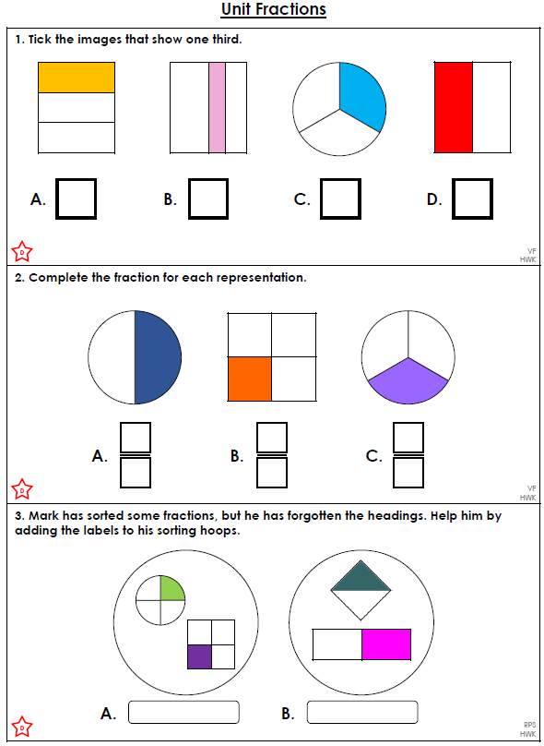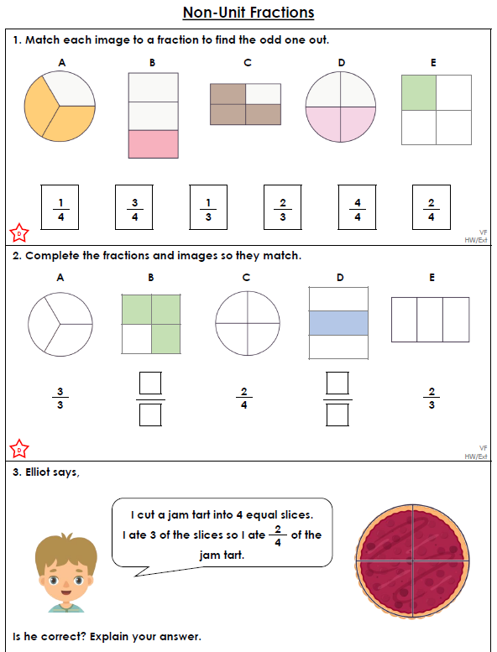

Challenge (optional)


