Rabbit Class Homework Spring 2 week 3– Y3
Homework due: Tuesday 17th March 2026
Next week we are learning:
Maths | Literacy | Science | RE
We will be starting to investigate the properties of shapes. | We will be using instructional language to create and follow instructions. | We will be continuing our unit on forces and magnets. | We will be exploring the Easter story and why and how Christians celebrate Easter.

Log on to timestable.com to practise your maths skills:
Purple Mash also have some lovely Maths and spellings activities
Timestable.co.uk
Or use other websites/ways that you enjoy .

Reading:
Please make sure you are reading with your child daily and recording this in reading records!

Times Tables – I have set a times table activity on Purple Mash for children to practise.

Spellings:
Practise spellings ready for weekly spelling test- see below for your child’s spelling group – These groups are subject to change as they are based on their current spelling ages.

SPaG: Year 3 SPaG mat

Maths: adding and subtracting fractions

Spellings:
Group 1  -ture -sure | Group 2  ‘ee’ ‘igh’
adventure  picture  creature  furniture  nature  future  treasure  leisure  closure  measure | green  cheep  teeth  feeling  steep  slight  tight  bright  might  right
……………………………………………………………………………………………………………………………………………………………………………………………………………………………………………………………………………………………………………………………………………………………………………………………………………………………………………………………………………………………………………………………………………………………………………………………………………………………………………………………………………………………………………………………………………………………………………………………………………………………………………………………………………………………………………………………………………………………………………………………………………………………………………………………………………………………………………………………………………………………………………………………………………………………………………………………………………………………………………………………………………………………………………………………………………………………………………………………………………………………………………..…………………………………………………………………………………………………………………………….…………………………..
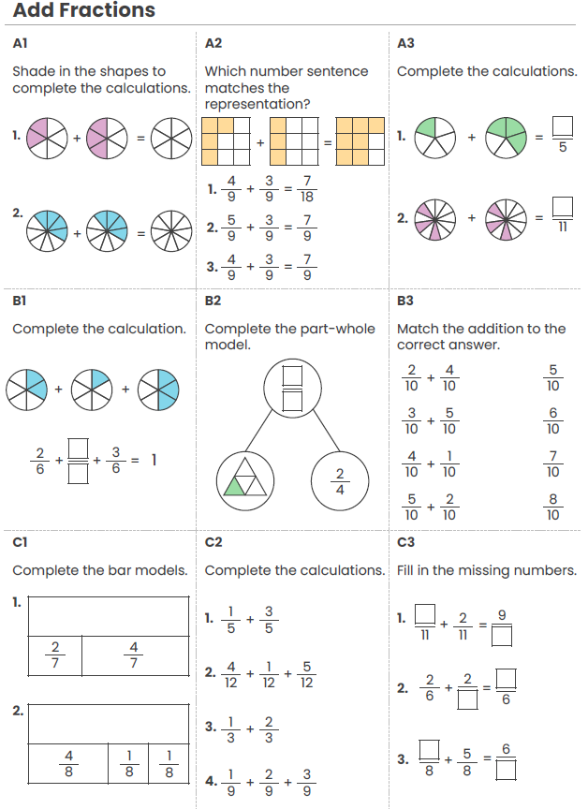

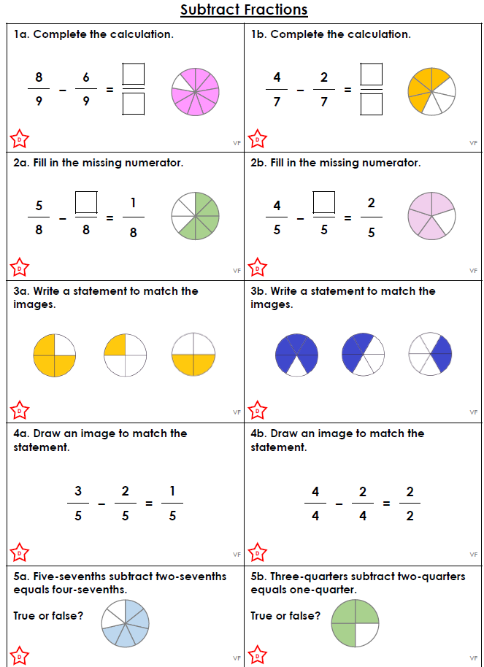

Challenge (optional)


