Amber Class Homework Summer term 1 week 1
Homework due: Tuesday ^{29th} April 2025

Reading: Daily for 30 minutes, write up in your Reading Record with a comment about what was read/discussed.
Spelling: see below
Maths Games – Record your score
https://www.topmarks.co.uk/maths-games/hit-the-button
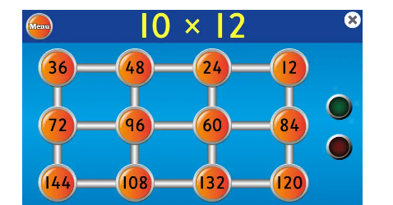
Complete sequence snake game on purple mash.
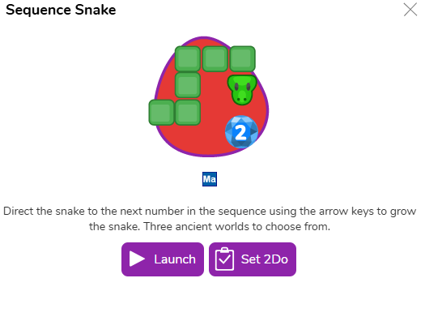
Spellings:
Group 1 | Group 2 | Group 3
experience  island  particular  natural  guide  probably  material  eight | arrive  address  although  breath  imagine  thought  appear  actual | bath  floor  gold  steak  sugar

Use this space to practice your spellings!

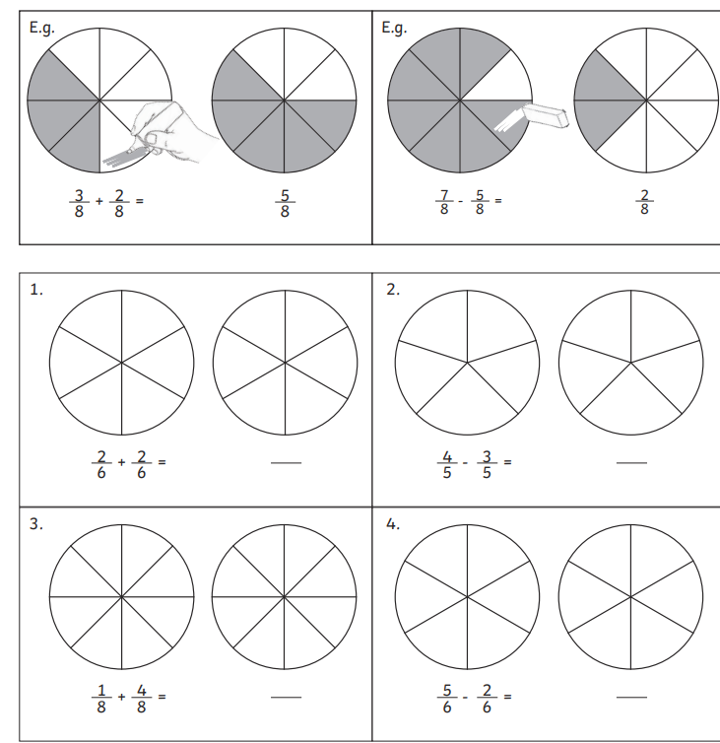
Maths Challenge:
Complete the math’s activities
An example has been shown below.

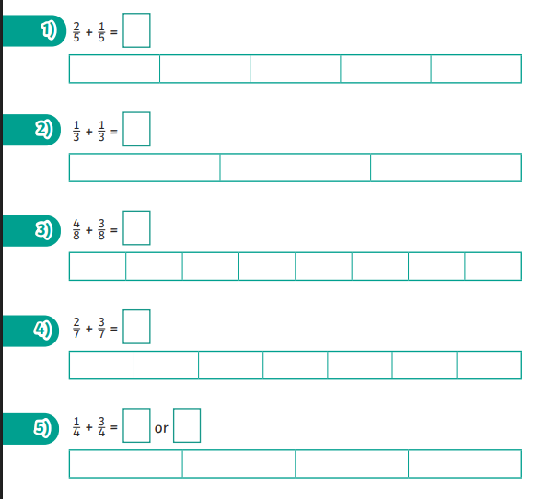

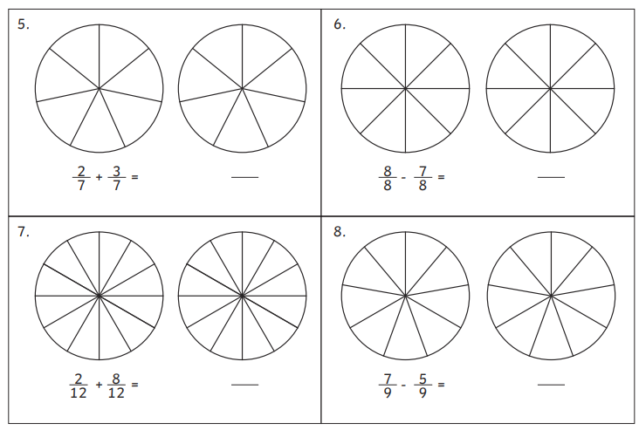


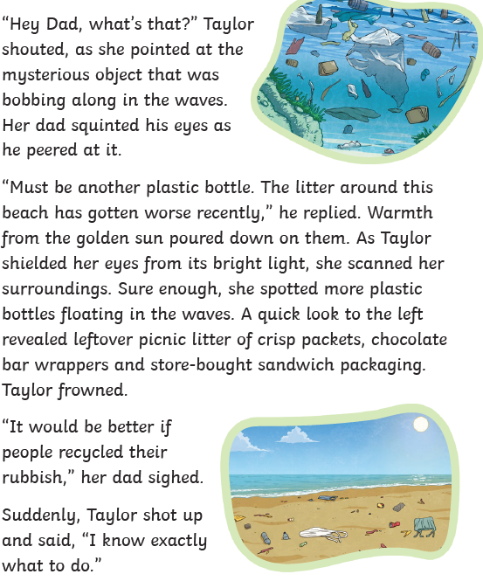
Complete the English comprehension questions. Underline parts of the text to help you.



