Tiger – Reception Class Homework
Weekly homework
Week 4– 19th March 2026
Dear parents,
Another busy week has flown by, with the children continuing to work hard. Well done everyone. This will be the last homework for this term, however, it would be really beneficial if your child would continue revising their phonics and times tables over the Easter holidays. Obviously make time for lots of fun, relaxation and maybe a couple of chocolate treats too!

Maths – addition (within 10)
In class the children have been working on solving single digit addition sentences. The children know that when two numbers are added together the answer will be bigger. For their homework this week I would like your child to complete the adding number challenge. To find the answer your child can use concrete resources e.g. counters, Lego bricks etc. or a number track/ number line (remembering to start on the first number and then bounce forward up the track the number of hops represented by the second number) Please encourage your child to form their numbers accurately.

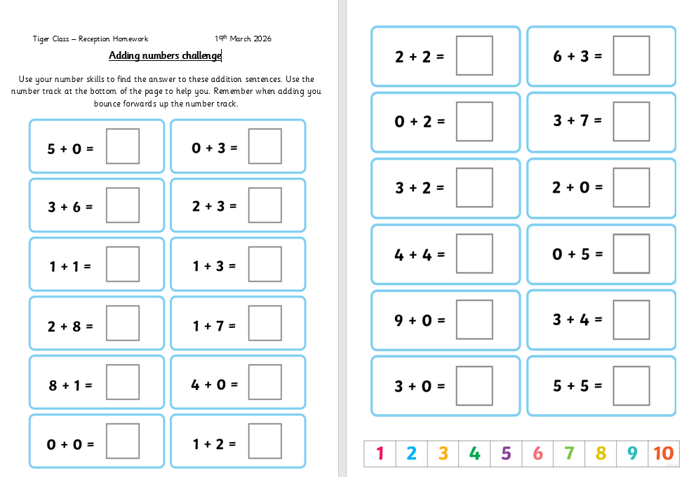

Phonics – Tricky words
Please continue to revise these with your child. Once they are confident reading each one, please encourage them to try and write them. Initially your child can copy each word and then progress to writing them independently from memory.

Reading
Your child will continue to bring home their Little Wandle Phonics book and their sharing book. When reading together please encourage your child to spot familiar graphemes and develop their comprehension skills by answering questions about the story. Please do comment in their reading record every time you listen to your child read, or share a story together.
Please remember to return all books on Monday so they can be used during group teaching reading sessions. Many thanks for your support with this.

As always, if you have any questions about your child’s learning, please do not hesitate to contact me via the school office.
Many thanks,

Mrs Allan

Next week in class we will learning
Reading – continuing developing listening and comprehension skills
Phonics – phonemes, digraphs and tricky words
Writing – Grapheme formation –cross curricular topic writing
Speaking – using descriptive/new vocabulary/ topic related vocab
Maths – addition (within 10)
Understanding the World R.E. – The Easter Story –
How does the story still have meaning today?
Art and DT – Wooden Easter Bunnies
Physical Development – Outdoor PE Team Building

