Explorer Class

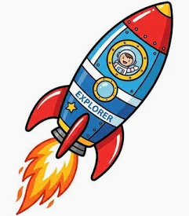

Next week we will learning…
Reading
Year One: Little Wandle class reading sessions focusing on Decoding, Prosody and Comprehension
Reception: Introducing Little Wandle wordless books focusing on oracy in story telling
Writing
Year One: Applying phonic knowledge, using accurate grapheme formation
Reception: Fine motor skills, early mark making and Christian name writing
Maths
Year One: place value – ordering numbers, counting forwards and backwards, writing numbers using accurate formation (0-20)
Reception: Number recognition (0-5), singing number songs to 10

Understanding the World/ R.E.
The Creation Story – The Book of Genesis (The Old Testament) Focus: how do some Christians believe the world was created?
Where do we see wonder and beauty in the World?
Year One: cross-curricular sentence writing
Reception: beauty in nature treasure hunt
Expressive Arts and Design
Self-portraits – focus on observational skills and colour mixing
Physical Development
Outdoor PE Introduction to PE:– Following instructions and learning how to stop!
Indoor PE – Fundamentals - I can explore how my body moves differently when running at different speeds
Story focus of the week: The Creation Story

