Emerald Class Homework Summer 1 week 1 – Y4
Homework due: Tuesday 6th May 25
Next week we are learning:
Maths | Literacy | Science | RE
We will be briefly recapping Fractions before moving onto decimals. | We will be will be working on | We will be our unit on Forces | We will be starting our unit on

Some Useful Websites:
Nrich.maths.org - https://nrich.maths.org/
Coolmath-games.com - https://www.coolmathgames.com/
Woodlands Junior School - https://www.primaryhomeworkhelp.co.uk/
BBC Bitesize - https://www.bbc.co.uk/bitesize/primary
Counton.org - https://count-on.co.uk/
https://www.topmarks.co.uk/
https://www.tomscott.com/usvsth3m/maths/

Purple Mash also have some lovely Maths and spellings activities
Or use other websites/ways that you enjoy .

Spellings:
Practise spellings ready for weekly spelling test- see below for your child’s spelling group – These groups are subject to change as they are based on their current spelling ages.

Reading:
Read every day for 30 minutes. Please log this in Reading Records.

Maths – fraction of an amounts and times tables speed practise

English – SPaG practise

Spellings:
group 1 -  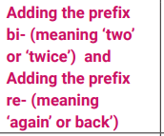 | group 2-  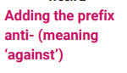 | group 3 –  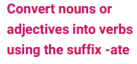
bicycle  biplane  bisect  bilingual  biannual  reappear  redecorate  reapply  repay  rebuild | antiseptic anticlockwise  antisocial  antidote  antibiotic  antivenom  anti-ageing  antifreeze antiperspirant antigravity | pollinate  captivate  activate  motivate communicate medicate elasticate hyphenate alienate  validate
Please write your spellings in sentences to show a correct understanding of the words
………………………………………………………………………………………………………………………………………………………………………………………………………………………………………………………………………………………………………………………………………………………………………………………………………………………………………………………………………………………………………………………………………………………………………………………………………………………………………………………………………………………………………………………………………………………………………………………………………………………………………………………………………………………………………………
Fractions of an amount
¼ of 20 can completed by using your multiplication and division.
20 divided 4 = 5
5 + 5 + 5 + 5 = 20
One quarter = 5
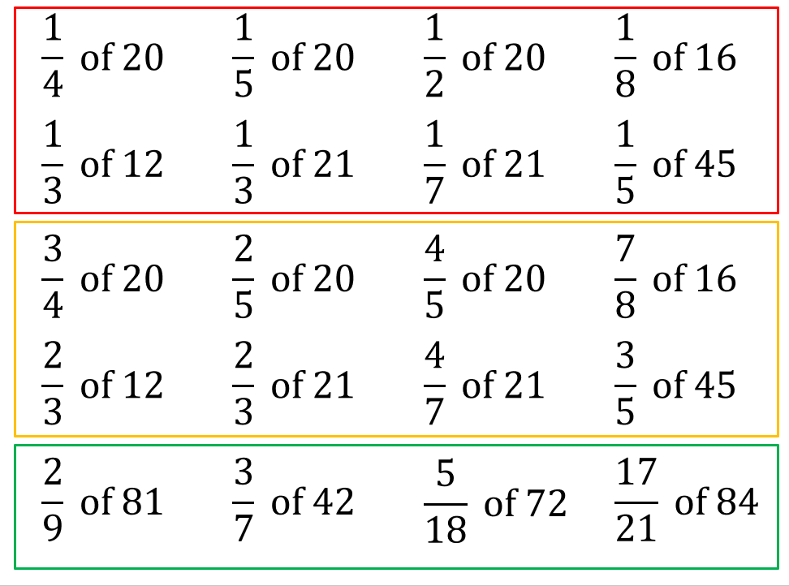

Times table practise


