Emerald Class Homework Summer 1 week 2 – Y5
Homework due: Tuesday 6th May 25
Next week we are learning:
Maths | Literacy | Science | RE
We will be briefly recapping Fractions before moving onto decimals. | We will be will be working on | We will be our unit on Forces | We will be starting our unit on

Some Useful Websites:
Nrich.maths.org - https://nrich.maths.org/
Coolmath-games.com - https://www.coolmathgames.com/
Woodlands Junior School - https://www.primaryhomeworkhelp.co.uk/
BBC Bitesize - https://www.bbc.co.uk/bitesize/primary
Counton.org - https://count-on.co.uk/
https://www.topmarks.co.uk/
https://www.tomscott.com/usvsth3m/maths/
https://www.timestables.co.uk/multiplication-tables-check/

Purple Mash also have some lovely Maths and spellings activities
Or use other websites/ways that you enjoy .
Spellings:
Practise spellings ready for weekly spelling test- see below for your child’s spelling group – These groups are subject to change as they are based on their current spelling ages.

Reading:
Read every day for 30 minutes. Please log this in Reading Records.

Maths – adding and subtracting mixed number fractions try as many as you can.
Remember to make the denominator the same
What you multiply the denominator you do the numerator
This video is extremely helpful to watch to help – please use this if you need to
https://www.youtube.com/watch?v=yWoKa9cQjN8
English – SPaG practise
Spellings:
group 1 -  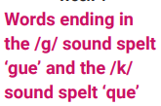 | group 2-  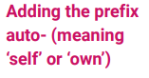 | group 3 –  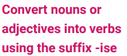
league  plague  rogue  vague  fatigue  unique  antique  mosque  cheque  technique | autograph autobiography automatic  autofocus autocorrect autopilot  autopsy  automobile autonomy  autocue | criticise advertise capitalise  finalise  equalise  fertilise  terrorise socialise visualise vandalise
Please write your spellings in sentences to show a correct understanding of the words
………………………………………………………………………………………………………………………………………………………………………………………………………………………………………………………………………………………………………………………………………………………………………………………………………………………………………………………………………………………………………………………………………………………………………………………………………………………………………………………………………………………………………………………………………………………………………………………………………………………………………………………………………………………………………………

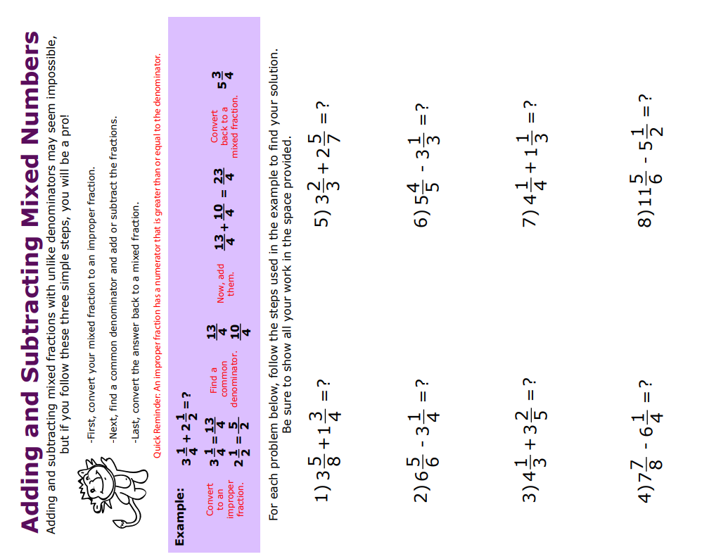
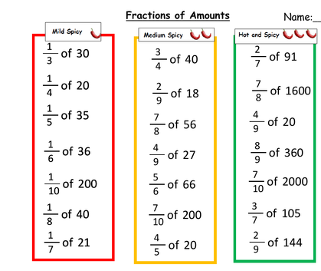
Challenge



