Emerald Class Homework Summer 1 week 3– Y5
Homework due: Tuesday 13th May 25
Next week we are learning:
Maths | Literacy | Science | RE
We will be briefly recapping Fractions before moving onto decimals. | We will be will be working on our Newspaper report on the Titanic | We will be our continuing our unit on Forces | We will be starting our unit on other religions starting with Buddhism
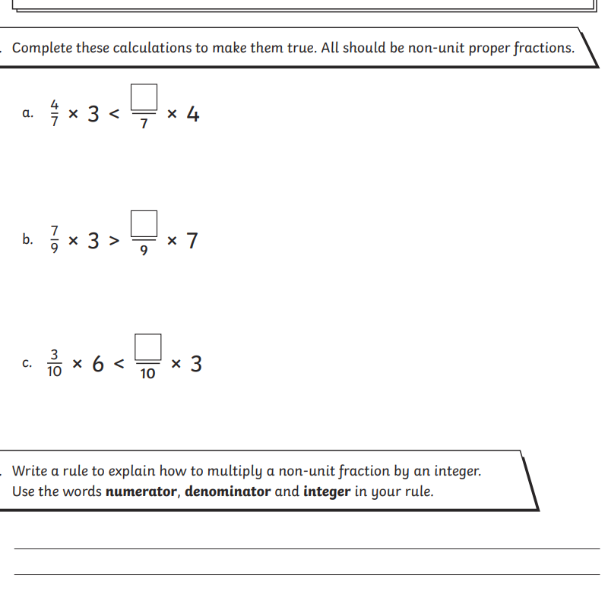
Some Useful Websites:
Nrich.maths.org - https://nrich.maths.org/
Coolmath-games.com - https://www.coolmathgames.com/
Woodlands Junior School - https://www.primaryhomeworkhelp.co.uk/
BBC Bitesize - https://www.bbc.co.uk/bitesize/primary
Counton.org - https://count-on.co.uk/
https://www.topmarks.co.uk/
https://www.tomscott.com/usvsth3m/maths/
https://www.timestables.co.uk/multiplication-tables-check/

Purple Mash also have some lovely Maths and spellings activities
Or use other websites/ways that you enjoy .
Spellings:
Practise spellings ready for weekly spelling test- see below for your child’s spelling group – These groups are subject to change as they are based on their current spelling ages.

Reading:
Read every day for 30 minutes. Please log this in Reading Records.

Maths – multiplying fractions by an integer
When you multiply - you multiplying the numerator only the denominator the stay the same

English – SPaG practise
Spellings:
group 1 -  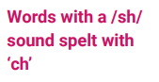 | group 2-  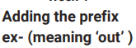 | group 3 –  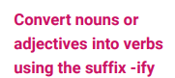
chef  chalet  machine  brochure  crochet  ricochet  parachute  moustache champagne  chute | exit  extend  explode  excursion  exchange  export  exclaim  expel  external  exterior | amplify  solidify  signify  falsify  glorify  notify  testify  purify  intensify  classify
Please write your spellings in sentences to show a correct understanding of the words
………………………………………………………………………………………………………………………………………………………………………………………………………………………………………………………………………………………………………………………………………………………………………………………………………………………………………………………………………………………………………………………………………………………………………………………………………………………………………………………………………………………………………………………………………………………………………………………………………………………………………………………………………………………………………………
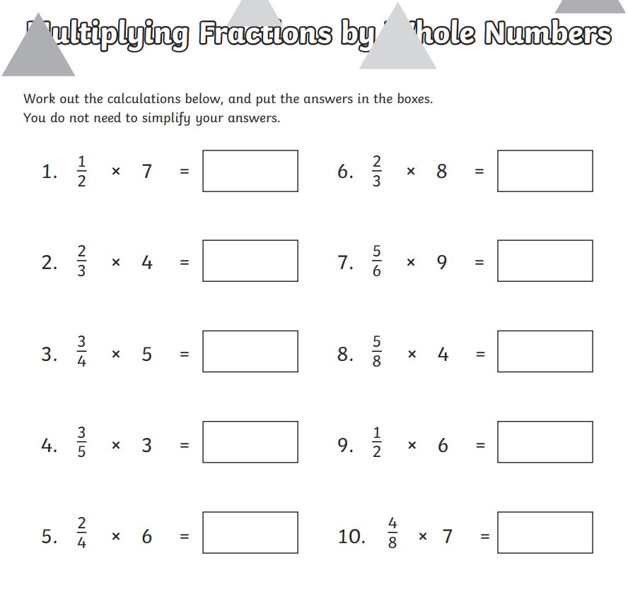

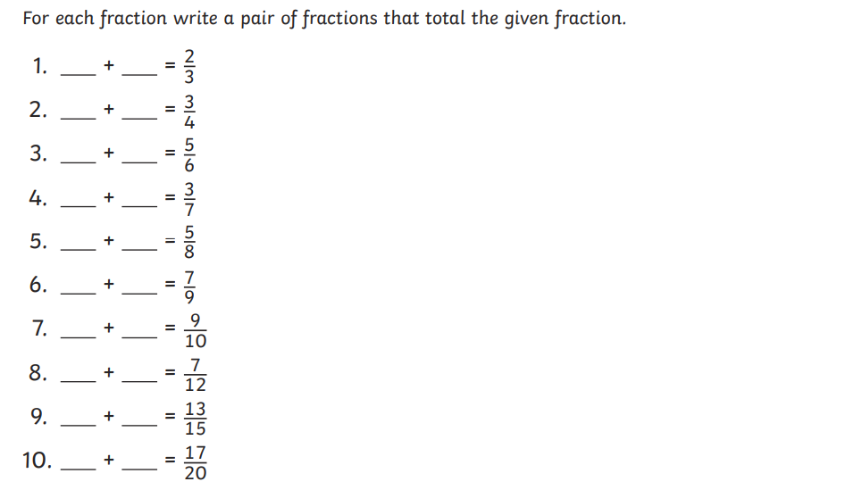

Challenge



