Amber Class Homework Summer term 1 week 3
Homework due: Tuesday ^{13th} May 2025

Reading: Daily for 30 minutes, write up in your Reading Record with a comment about what was read/discussed.
Spelling: see below
Maths Games:

https://www.timestables.co.uk/multiplication-tables-check/
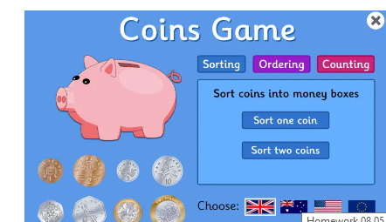

https://www.topmarks.co.uk/money/coins-game

Spellings:
Group 1 | Group 2 | Group 3
different  mention  perhaps  library  although  bicycle  forwards  material | strange  often  arrive  increase  recent  woman  thought  strength | pretty  fast  everybody  many  should

Use this space to practice your spellings!

Math’s Challenge:
Complete the math’s activities

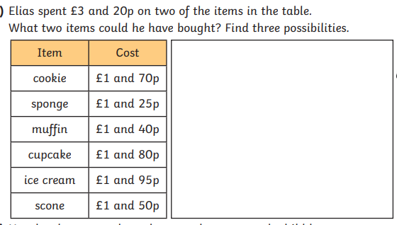

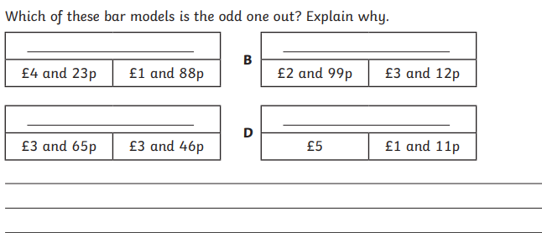
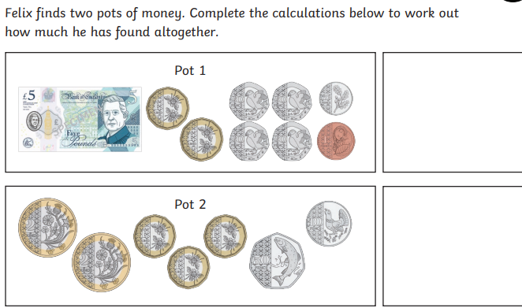

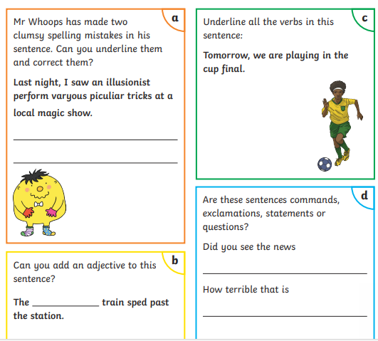
English

