Topaz – Year One Homework 1st May 2025
Two times table challenge
Use your two times table skills to find the answers to the questions below.
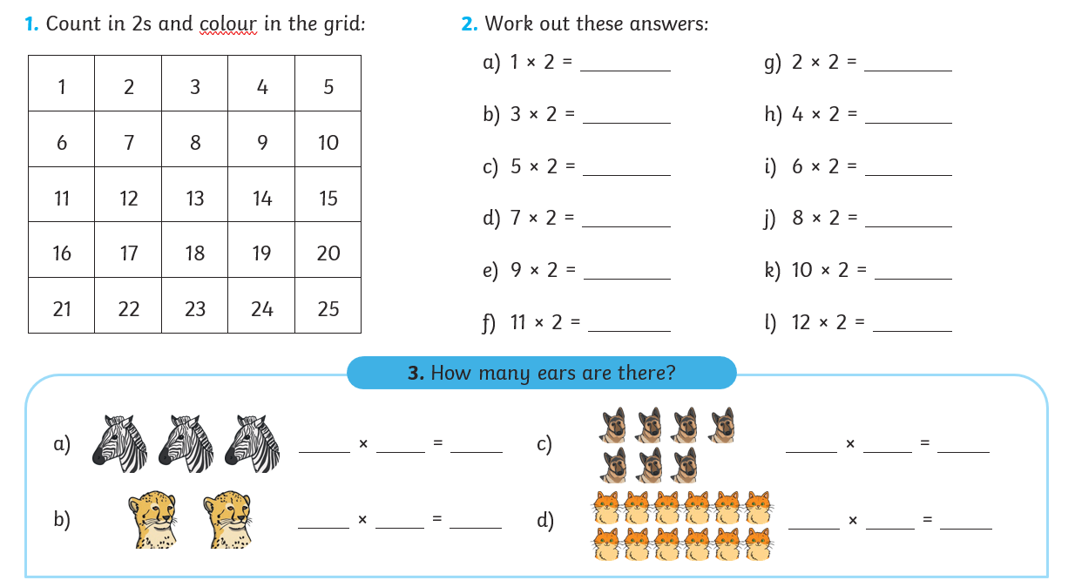

To help get really confident with your two times tables, have a go at joining in with this fun song!
https://www.youtube.com/watch?v=Uav8id2JXD4

