Phonics Screening Check – Information Guide for Parents
Topaz – Year One
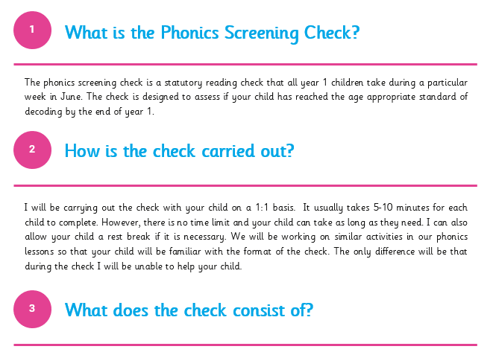

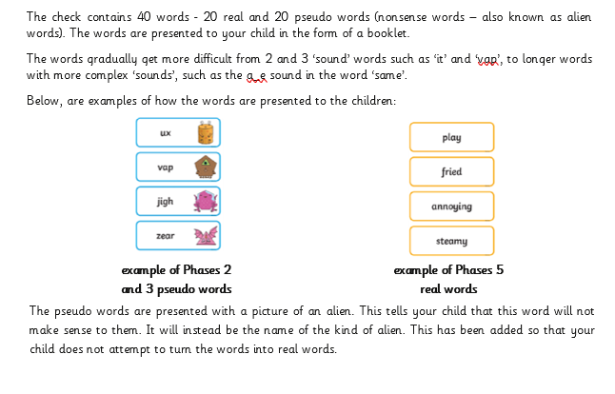

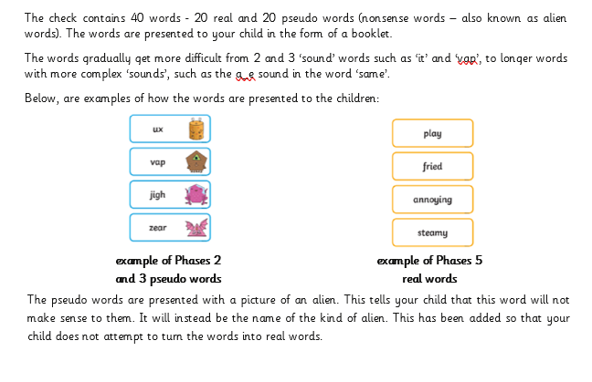

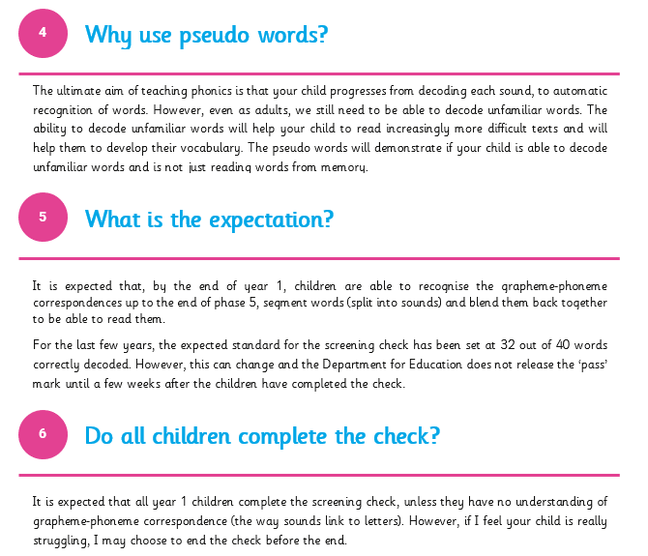

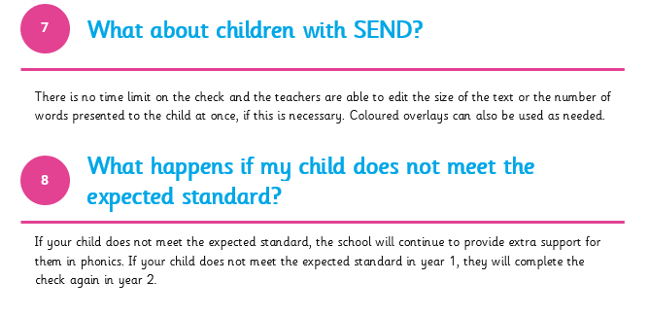

Over the next few weeks, for their homework, your child will be bringing home a set of practice words. Please encourage your child spend 5-10 minutes everyday reading the words. This will help them to build fluency and their confidence.
If you have any further questions, then please do not hesitate to contact me via the office.
Best wishes,

Mrs. Allan



