Topaz Year One homework 15th May 2025
Phonics Screening Practice List 3
t
h
Real Words
zoo | coin
sight | photo
cloud | skate
whip | flute
oyster | straw
burger | first
text | graph
handshake | script
shelf | glass
drawing | haircut

s

b

l

a
e

h
r

Topaz Year One homework 15th May 2025
Phonics Screening Practice List 3
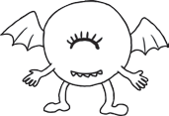

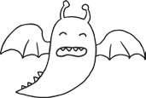

Nonsense Alien Words
woid  | shrop 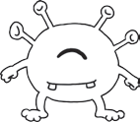
ump | quape 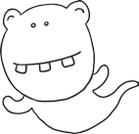
proy 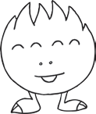 | smizz 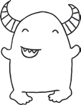
yaup 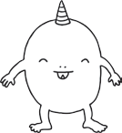 | blinch 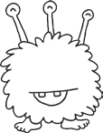
thisk | snoul 
phode | luft
scund | whunkey
femb | prinker
spirl | thunk
cobweeb | grelt

