Topaz Year One homework 1st May 2025
Phonics Screening Practice List 1
Real Words
chill | blank
start | scribe
best | phone
grit | whisk
shin | dentist
gang | starling
week | day
hooks | slide
strap | newt
trains | finger



Phonics Screening Practice List
Topaz Year One homework 1st May 2025
Phonics Screening Practice List 1

Nonsense Alien Words
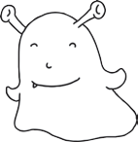  steck | 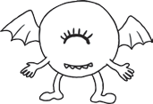  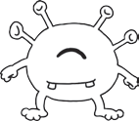  bim
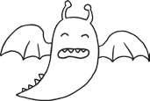  hild | 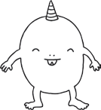  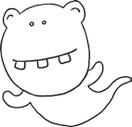  vap
quemp | 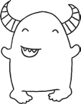  spron
geck | 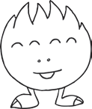  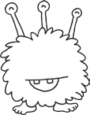  blurst
ulf |   voo
chom | snemp
tord | fape
thazz | jound
blan | stroft
tox | terg

