Topaz – Reception homework 8th May 2025
Under the sea – missing number challenge – complete the seashell number lines by adding the missing numbers.
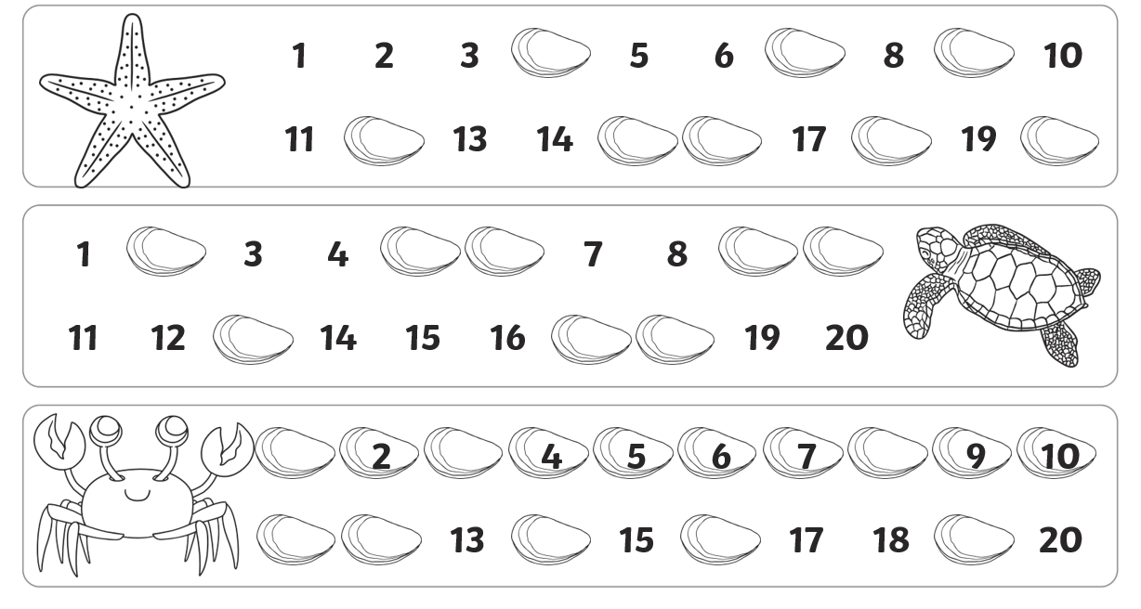
Challenge: write your own number line from 0-20 taking care to make sure each number is neatly written in the right order

