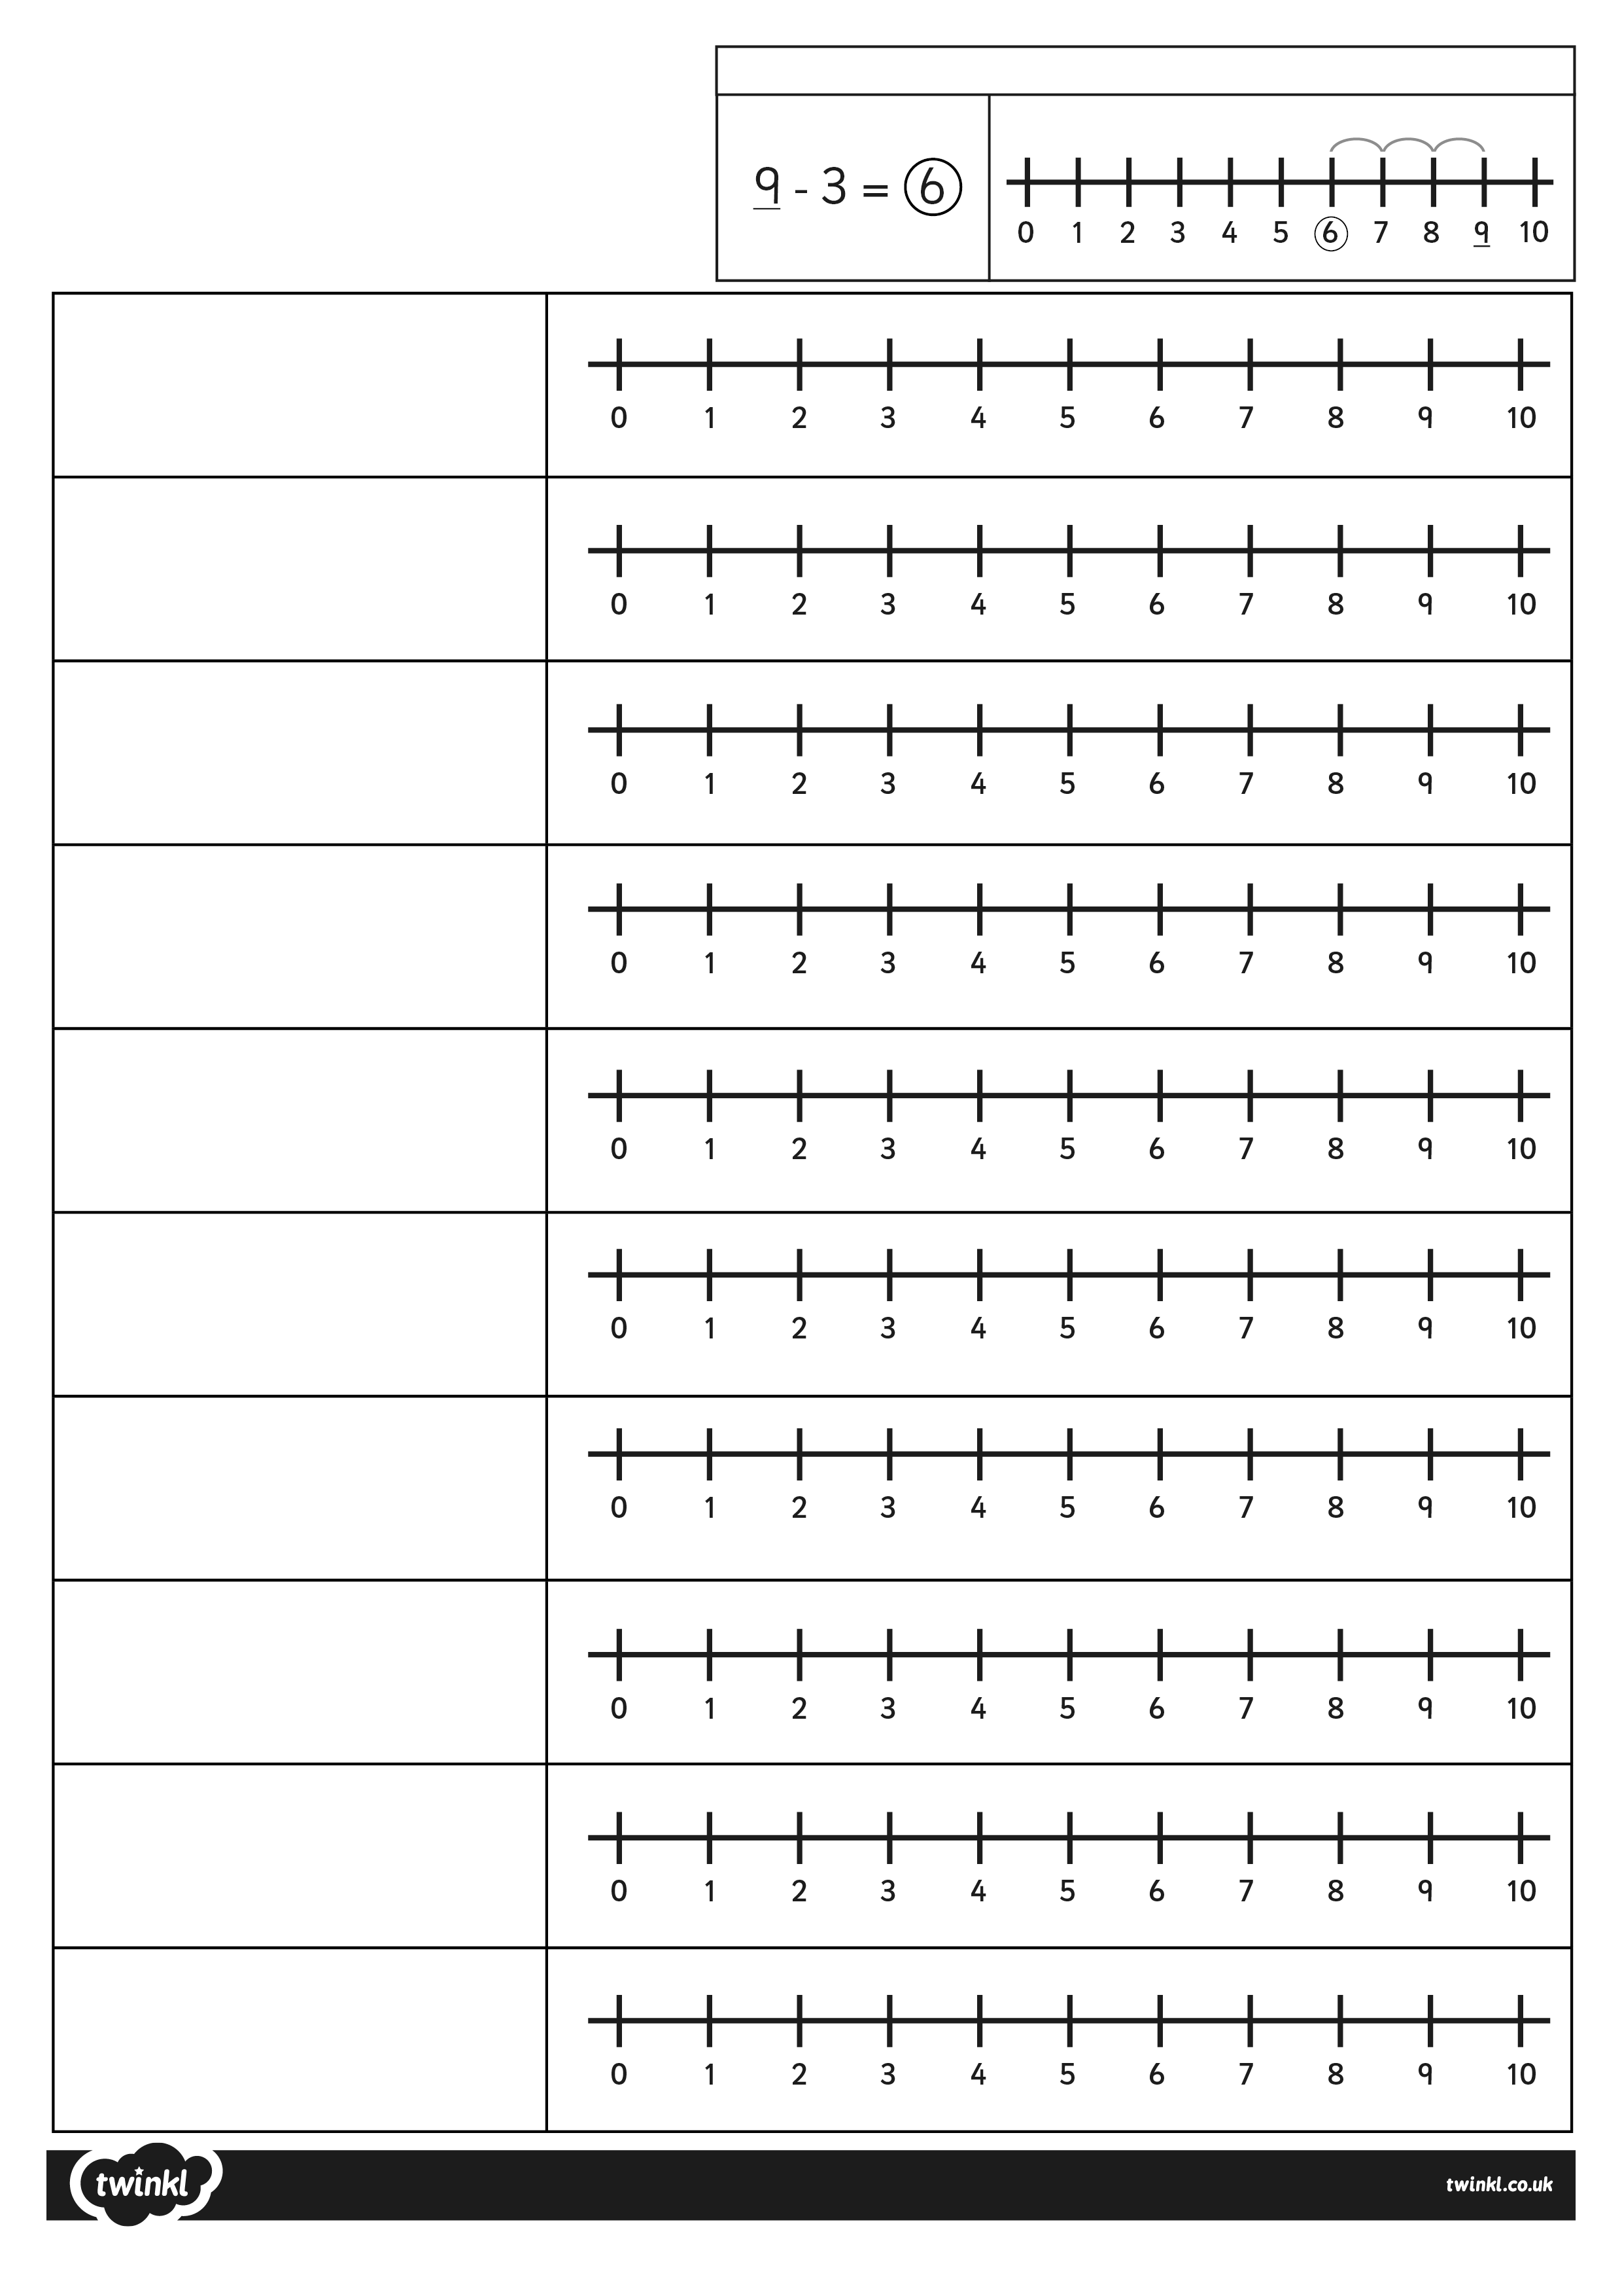




-3
L.O. I can solve single digit subtraction
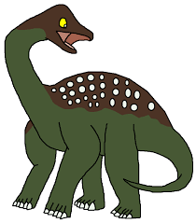
Sid Saltasaurus - Subtraction Challenge
10 – 9 =
8 – 5 =
5 – 3 =
9 – 2 =
10 – 6 =
7 – 4 =
10 – 3 =
9 – 4 =
8 – 6 =
10 – 5 =
Example:
9-
Sid the Saltasaurus is an unusual dinosaur, he loves to gobble up sweets. Can you find out how many he has eaten? Remember to start with the number in yellow and bounce BACKWARDS, down the number line.
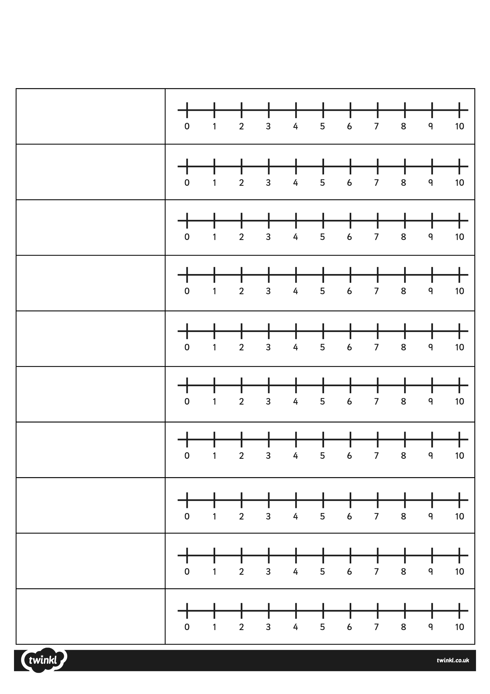
L.O. I can solve single digit subtraction Sid Saltasaurus - Subtraction Challenge- have a go at answering these questions all by yourself!

9 – 5 =
7 – 3 =
8 – 4 =
10 – 2 =
2 – 1 =
5 – 4 =
9 – 9 =
5 – 0 =
8 – 8 =
10 – 10 =

